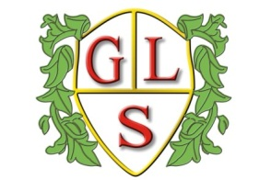
Class Daffodil Topics Summer 2023

Science
Natural and Man-made Light
Staying Alive

(Topic Day Theme – A Long Time Ago)

History
Inventors – Leonardo da Vinci and Tim Berners-Lee

Geography
School and the Local Area

ICT
Pictograms, Branching Databases
Programming & Algorithms

Spanish
Months of the year – Mi cumpleanos (My Birthday)
Spanish Greetings : Emotions

RE
Judaism
Buddhism

Art
Create a Scene!

Design Technology
Mechanisms-(Wheels and Axles) – moving toys

PSHE
Personal hygiene – Keeping Clean
Environment – Junk and Rubbish/Recycling

PE
Wolves Foundation

