Spring Summer 2019 MENU – WEEK 3
OPTION | MONDAY |  | TUESDAY |  |  | WEDNESDAY |  |  | THURSDAY |  |  | FRIDAY
1 | Selection of wholemeal Pizza with various toppings  served savoury rice, sweetcorn and peas |  | Roast turkey, sage & onion stuffing served with gravy, roast potatoes & creamed potatoes, fresh broccoli and carrot | 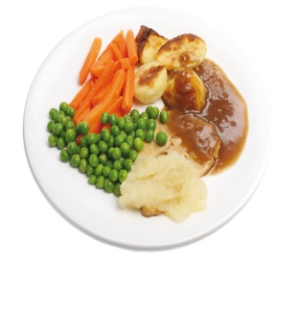 |  | Assorted paninis/wraps served with rice salad, fresh crisp salad and coleslaw |  |  | Pork meatballs in homemade tomato and basil sauce  served with wholemeal pasta and peas |  |  | Oven baked, crumb coated chicken served with chunky chipped potatoes and garden peas
2 |  |  |  |  |  | Chicken, ham and leek pie served with creamed potatoes, cauliflower, peas and carrots
V | Wholemeal pasta in a homemade tomato sauce | 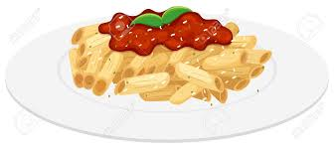 | Veggie tikka masala  served with 50/50 rice |  |  | Assorted paninis/wraps served with crisp salad and coleslaw |  |  | Tuna and cheese puffs with herby diced potatoes and garden peas |  |  | Oven baked fish fingers served with chunky chipped potatoes and garden peas
JP | Jacket Potato with cheese |  | Jacket Potato with tuna and mayonnaise |  |  | Jacket Potato with cheese and coleslaw |  |  | Jacket Potato with tuna mayonnaise and sweetcorn |  |  | Jacket Potato with beans
PL | Available daily as an alternative: - Sandwiches served with vegetables, a dessert and drink
DESSERTS
 | Fruit yoghurt oat pot |  | Yoghurt or fruit salad |  | Toffee Apple streusel cake |  |  | Jelly or homemade ginger biscuit |  |  | Homemade flapjack
Available daily as an alternative:- Fruit yoghurt, a selection seasonal fresh fruit, soreen and cheese & biscuits available everyday
Unlimited fresh salad and unlimited wholemeal bread
LUNCH WILL BE SERVED WITH FRESH MILK OR WATER
Menu Cycle Week 3: 29th Apr, 20th May, 10th June, 1st July, 22nd July, 16th Sept, 7th Oct

