Autumn/Winter 2021-2022 MENU – WEEK 2
OPTION | MONDAY |  | TUESDAY |  |  | WEDNESDAY |  |  | THURSDAY |  |  | FRIDAY
1 | Margarita Pizza with herby diced potatoes and sweetcorn |  | Roast turkey,  roast & mashed potatoes, carrots, broccoli & gravy | 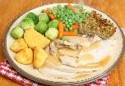 |  | Cheese and onion pie, mashed potatoes and veg | 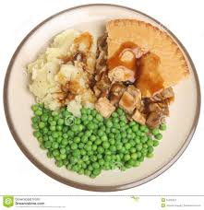 |  | Italian chicken with saute potatoes and vegetables | 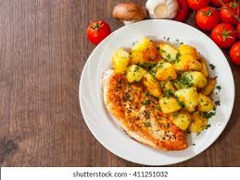 |  | Oven baked battered salmon and chips, with peas or beans
2 |  |  |  |  |  |  |  |  |  |  |  | Chicken Poppers and chips with peas or beans
JP | Jacket Potato |  | Jacket Potato |  |  | Jacket Potato |  |  | Jacket Potato |  |  | Jacket Potato
DESSERTS
 | Vanilla ice cream |  | Piece of Fruit |  | Jelly and fruit |  |  | Fruit crumble & custard |  |  | Homemade cookie
Available daily as an alternative:- Fruit yoghurt, a selection seasonal fresh fruit, soreen and cheese & biscuits available everyday
Unlimited fresh salad and unlimited wholemeal bread
LUNCH WILL BE SERVED WITH FRESH MILK OR WATER
Menu Cycle Week 2: 13th Sept, 4th Oct, 25th Oct, 15th Nov,6th Dec,27th Dec 17th Jan, 7th Feb, 28th Feb,21st Mar, 14th Apr

