Spring Summer 2019 MENU – WEEK 1
OPTION | MONDAY |  | TUESDAY |  |  | WEDNESDAY |  |  | THURSDAY |  |  | FRIDAY
1 | Tuna pasta bake served with garden peas |  | Roast turkey served with sage and onion stuffing, yorkshire pudding, creamed & roast potatoes, carrots and broccoli, gravy |  |  | Pork sausage with creamed potatoes served with carrots, peas and gravy | 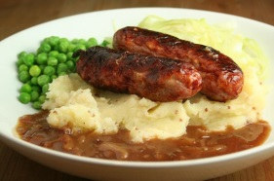 |  | Gammon served with sauté potatoes, carrots and peas |  |  | Crumb coated chicken served with chunky chipped potatoes, peas or baked beans
2 | Assorted panini or wrap with savoury rice and sweetcorn
V | Assorted panini or wrap with savoury rice and sweetcorn |  | Homemade macaroni cheese topped with tomatoes served with broccoli |  |  | Quorn korma  served with 50/50 rice and naan bread |  |  | Veggie spaghetti bolognaise served with garlic bread, carrots and peas | 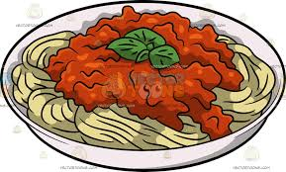 |  | Oven baked tempura battered fish served with chunky chipped potatoes, peas or baked beans
JP | Jacket Potato with cheese |  | Jacket Potato with tuna and mayonnaise |  |  | Jacket Potato with cheese and coleslaw |  |  | Jacket Potato with tuna mayonnaise and sweetcorn |  |  | Jacket Potato with beans
PL | Available daily as an alternative: - Sandwiches served with vegetables, a dessert and drink
DESSERTS
 | Pancake topped with fruit or ice cream |  | Fruit segments or yoghurt |  | Blueberry cake |  |  | Fruit jelly or oat & fruit biscuit |  |  | Homemade shortbread biscuit
Available daily as an alternative:- Fruit yoghurt, a selection seasonal fresh fruit, soreen and cheese & biscuits available everyday
Unlimited fresh salad and unlimited wholemeal bread
LUNCH WILL BE SERVED WITH FRESH MILK OR WATER
Menu Cycle Week 1: 6th May, 27th May, 17th June, 8th July, 2nd Sept, 23rd Sept, 14th Oct

