On Thursday 19th October Classes 5, 6, P1, P2, P3 & P4 were recently entertained by Alter Ego who came into school to perform a play called ‘In the Net’ which gave some very important messages about E-Safety & cyber bullying. All of the children & staff enjoyed the show.
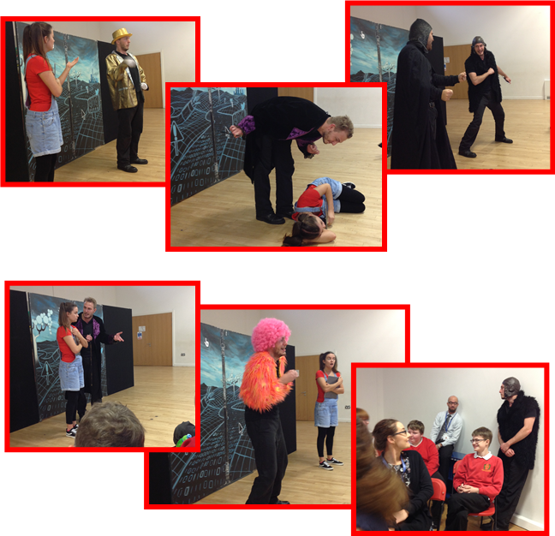Thank you Alter Ego for helping us to stay safe online.

