Topics

Data handling

Shapes

Number

Maths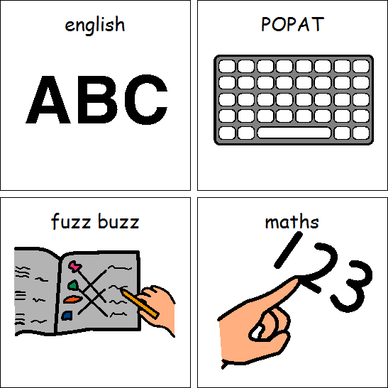

Languages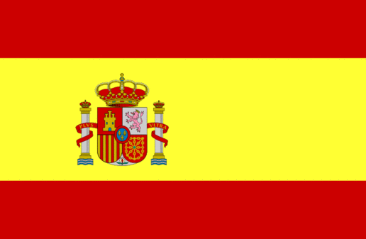

Topics

*Taught through Spanish themed afternoons*

Spanish dancing and instruments

The Spanish flag

Games

Core skills

PE

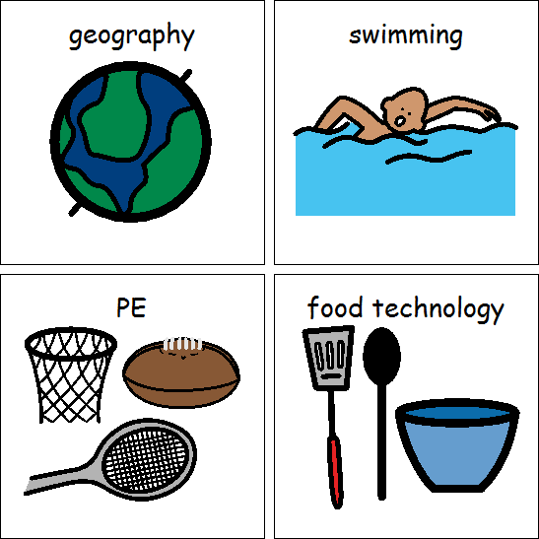

Computing

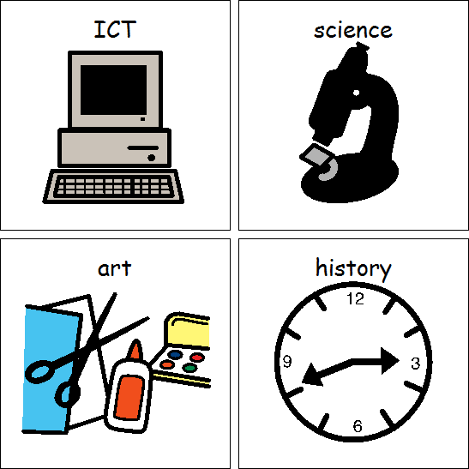

Topics

*Taught cross-curricular*

Data: Counting

Multimedia: Photographs

Topic/SCERTS (Covers English, Science, DT, RE, Art, Geography and History)

**Habitats**

English: Stories by the same author and we’re going on a bear hunt

Science: Changes in materials and habitats

Art: Weaving

DT: Textiles: Puppets

FT: Biscuits

RE: Islam- Places of worship and how and why are some religious stories important?

Geography: Forests

History: What was life like on the beach hundreds of years ago?

*PSHE is taught through SCERTS*

Class 2BA Summer 2022