Amazing Fact
An Amazing Fact a Day
An Awesome Advert
In Sweden and Norway, advertising to children under the age of 12 is illegal.
When a company wants to sell their products, they advertise it to the people
who might be interested in buying it.

Challenge
Think about your favourite toy, object or computer game. Think about why you like it, what makes you want to keep using it and if you would recommend it to your friends. If so, why?
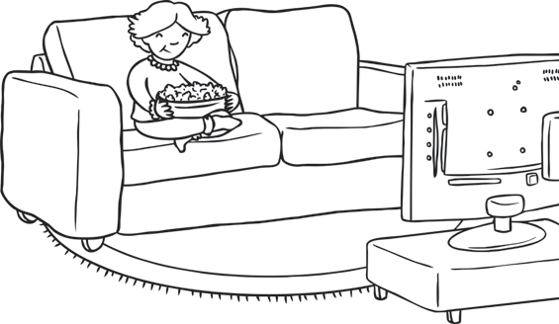
Design an advert to encourage others to buy your favourite item. Make it clear what is great about it and why children might want to get one. Make your advert bold and colourful.

You could also try to find out:
- what the first advert shown on TV was for;
- how much TV advertising costs;
- what the most expensive TV advert ever was.

An Amazing Fact a Day
An Awesome Advert

