Class 3G Autumn topic overview (year 3)

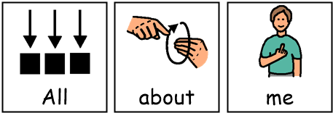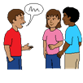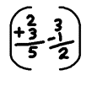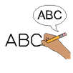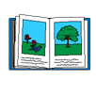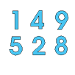2022 Spring topic theme – ALL ABOUT ME

**Topic / SCERTS / ASDAN (KS4)**

**History** – All about me – Schools, then and now.

**Geography** – All about me – Warrington (my local area)

**Art** – All about me – Portraits

**RE** – All about me – Celebrations

**Design Technology** – All about me – Levers / Greeting cards

**Food Technology** – All about me – Healthy snacks

**Computing** – All about me – Multimedia sound / algorithms

**MFL** – Numbers to 10 / All about Spain

**PE** – Circuits / Gymnastics

Speech and Language therapy – Use of PECS & communication books

Occupational Therapy – Self and emotional regulation & Sensory awareness skills

**English**

All about me - Stories by the same author

All about me - Instructions

Phonics / POPAT

Letters & Sounds

Reading books

Handwriting

**Science**

All about me – Humans & Animals

All about me – Life cycles & Human development

**Maths**

Number

Money

Shape and Measure