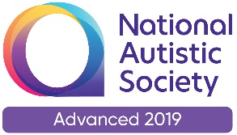 |  | Paul King  Headteacher  Joanne Mullineux  Deputy Headteacher

8th October 2020

Dear Parents / Carers

Parents’ Evening / IEPs / Annual Reviews

At this time of year we would normally be holding our face to face Parents’ Evening. Given the situation we find ourselves in, face to face meetings will not be possible. Therefore I am proposing that for the next three weeks, starting next week and going up to Friday 30th October, your child’s class teacher will be contacting you either by telephone, email, text or some other means to set up a conversation.

These conversations will not last long, about 10-15 minutes, but should enable you to get a ‘feel’ for how your child is getting on since starting back in school and also enable you to pass on any concerns to the member of staff concerned.

The Annual Review meetings will also be either held over the coming year. Some of these meetings will be face to face but the majority will be over the telephone. If any parents/carers are comfortable using Zoom or Teams then we will be able to use either of those platforms. We will contact parents a few weeks before the scheduled meeting to consult on how the meeting should be organised.

Individual Education Plans (IEPs) will be coming out shortly. Please contact your child’s class teacher if you need to discuss anything on the IEP.

We are in very strange times at the moment. We will face some difficult challenges in the coming months but I am confident that with your support we will continue to provide an outstanding education for your child.

Paul King
Headteacher

