Autumn/Winter 2018 MENU – WEEK 2
OPTION | MONDAY |  | TUESDAY |  |  | WEDNESDAY |  |  | THURSDAY |  |  | FRIDAY
1 |  |  | Roast turkey with sage and onion stuffing with potatoes. Fresh broccoli, carrots and gravy | 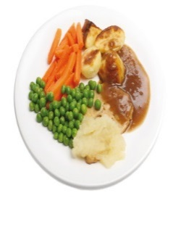 |  |  |  |  | Pork sausage with sauté potatoes and seasonal vegetables | 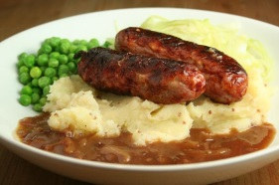
2 | Chicken, leek and ham pie served with seasonal vegetables |  |  |  |  | Baked gammon, creamed potatoes, gravy and seasonal vegetables | 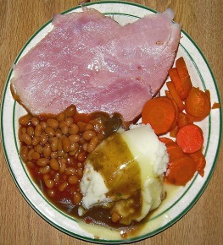 |  |  |  |  | Crumb coated chicken served with chunky chipped potatoes, peas or baked beans
V | Tortilla boat filled with homemade mild chilli quorn mince served with 50/50 rice and sweetcorn |  | Tomato and mascarpone wholemeal pasta bake  served with garlic bread and broccoli | 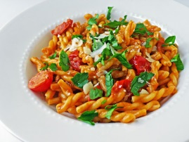 |  | Cooks vegetarian curry with 50/50 rice |  |  | Vegetarian spaghetti bolognaise served with broccoli | 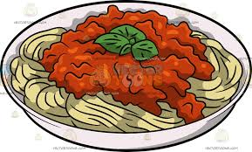 |  | Oven baked battered fish served with chunky chipped potatoes, peas or baked beans
JP | Jacket Potato with cheese |  | Jacket Potato with tuna and mayonnaise |  |  | Jacket Potato with cheese and coleslaw |  |  | Jacket Potato with tuna mayonnaise and sweetcorn |  |  | Jacket Potato with beans
PL | Available daily as an alternative: - Sandwiches served with vegetables, a dessert and drink
DESSERTS
 | Apple and blackberry crumble, custard or strawberry ice cream |  | Fresh fruit salad  yoghurt |  | Cooks choice warm sticky toffee pudding, caramel sauce |  |  | Homemade flapjack |  |  | Cookie
Available daily as an alternative:- Fruit yoghurt, a selection seasonal fresh fruit, soreen and cheese & biscuits available everyday
Unlimited fresh salad and unlimited wholemeal bread
LUNCH WILL BE SERVED WITH FRESH MILK OR WATER
Menu Cycle Week 2: 5th Nov, 26th Nov, 17th Dec, 7th Jan, 28th Jan, 18th Feb, 11th Mar, 2nd Apr, 22nd Apr

