P2 Autumn Term 2019/20

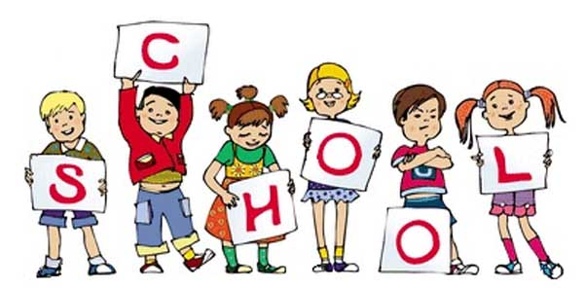

**Topics**

**Autumn 1**

Number:

Place value

Addition and subtraction

**Autumn 2**

Geometry: shape 2D and 3D

Measurement:

Length and mass

Number: multiplication and division

P2 staff Ms K.White

Mrs K.Dickson

Mrs L. Stewart

Mrs J.Farrington

**Topics**

Stories by Roald Dahl.

Autobiography

Explanations

Spelling and Phonics, Guided Reading, Guided Writing, Handwriting.

Speech and language work.

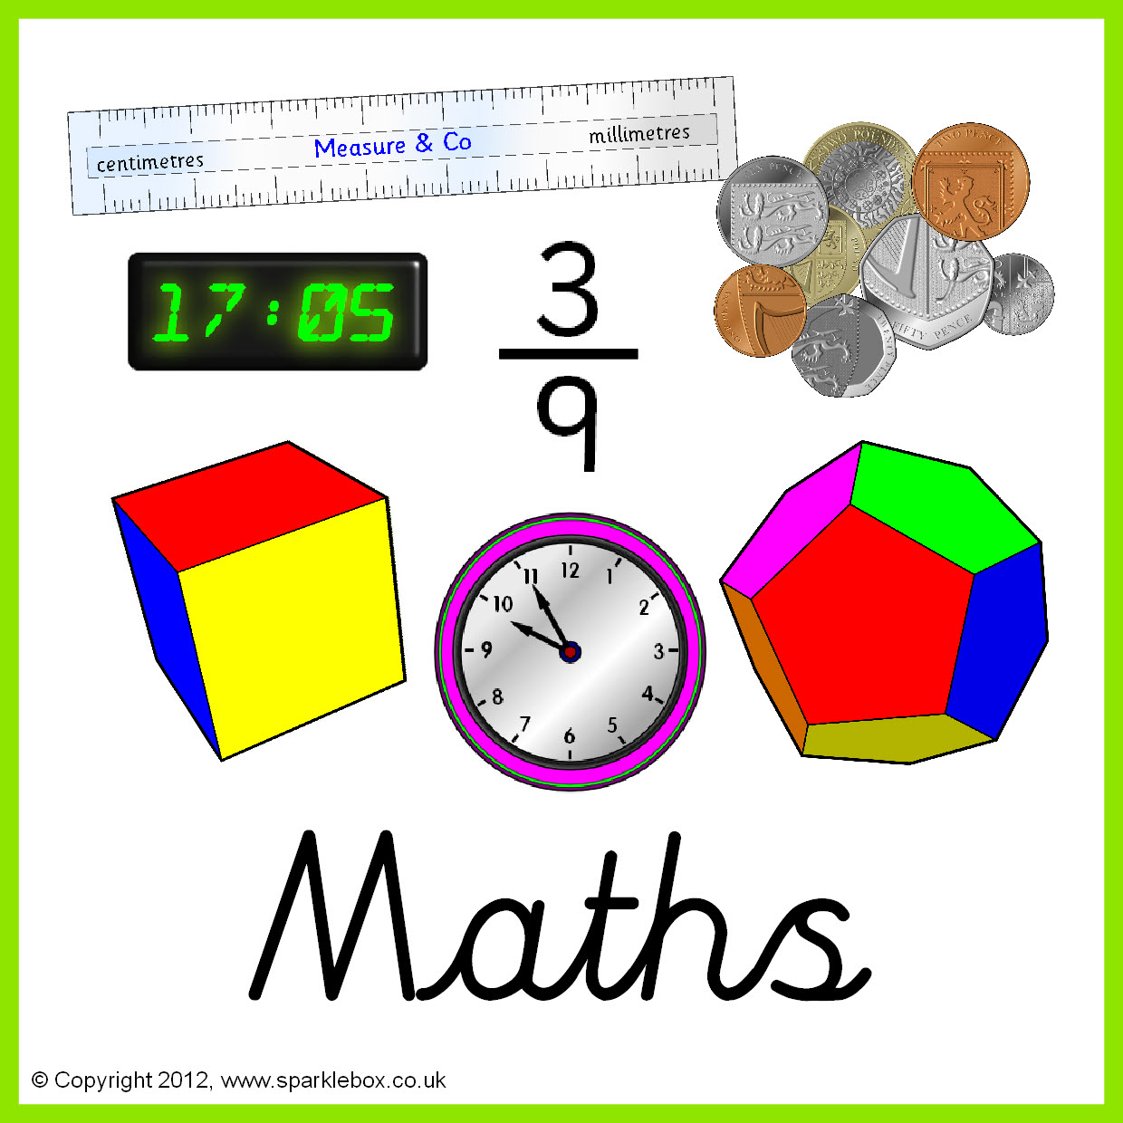

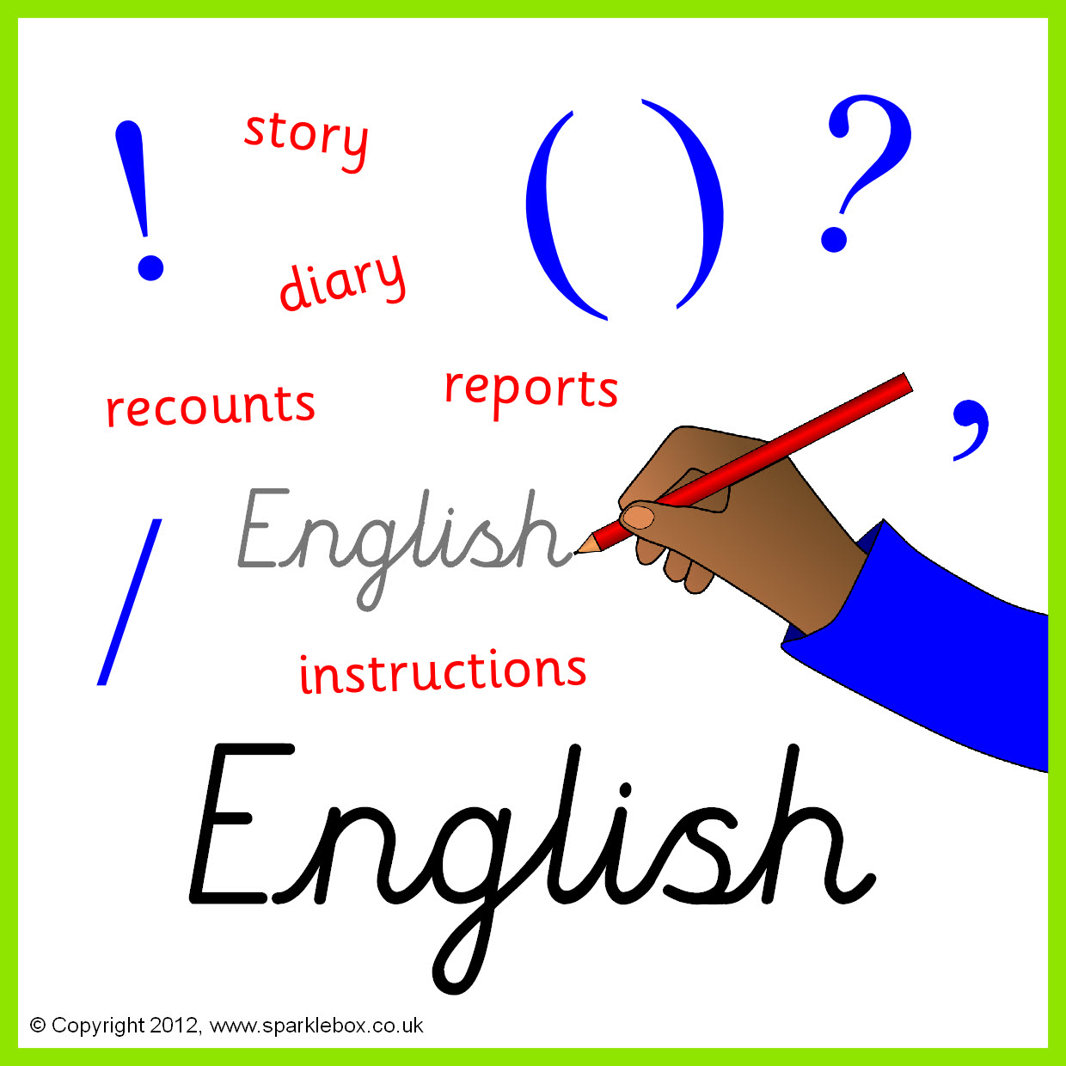

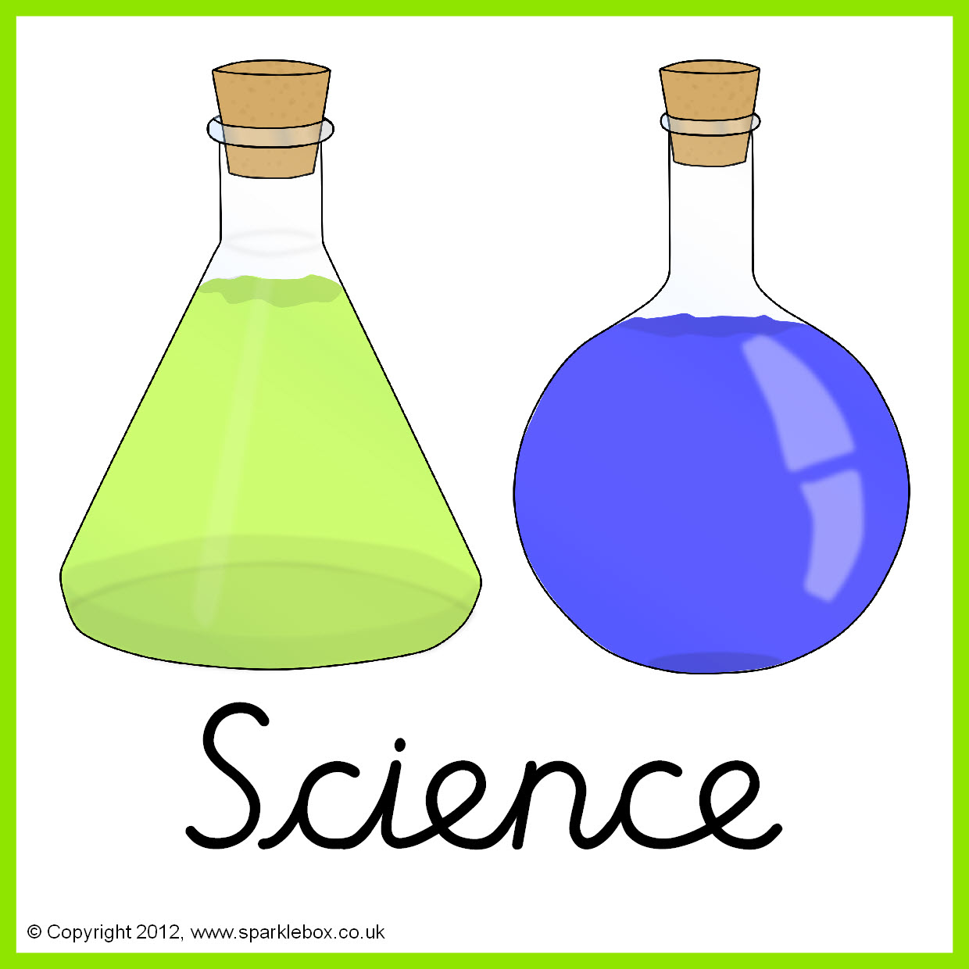

**Topics**

How humans change – From birth to old age

Animals including humans

Everyday materials and their properties -*Properties and changes in materials*

**Topics -** Taught by D. Taylor

E Safety

Algorithms & Programming



**Topics**

Elements of Art

Weird and wonderful – Fantasy theme

**Topics** - Taught by L. Fernyhough

Investigating Biomes

Tourism

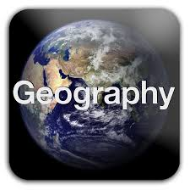



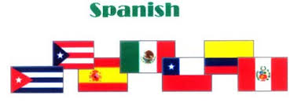

**Topics** - Taught by L. Fernyhough

Chile – Facts, currency, history

Days of the week, Christmas, celebrations

**Topic** -Taught by L. Fernyhough

The Viking and Anglo Saxon struggle for the kingdom of England



**Topics**

What does it mean to have team spirit? What helps to build a community?

Christmas and celebrations

**Topics** - Taught by M.King

Health related fitness





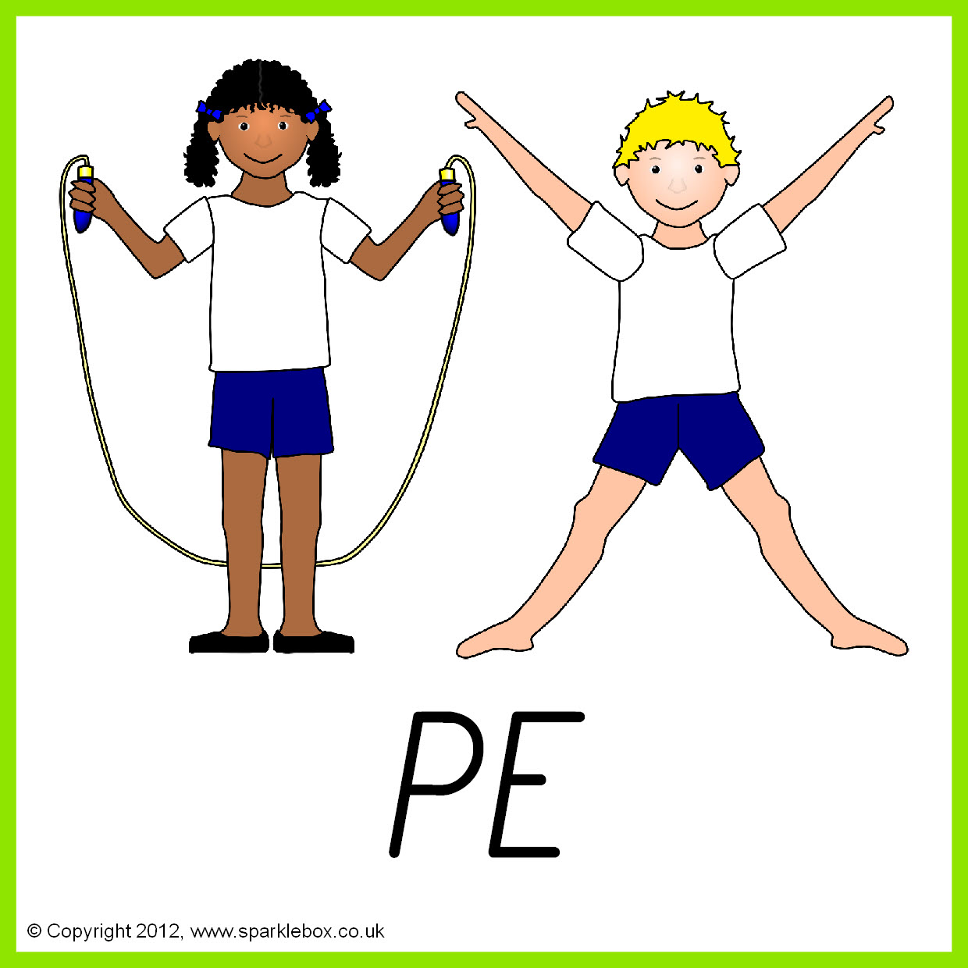

**Topics**

Bullying and Online safety.

World environmental issues.

.

**Topics** - Taught by A.Davey

Basic food hygiene and Ways with eggs

