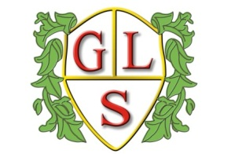
Class P1 Topics Summer Term 2022

Maths
Fractions, area, perimeter and revisit of number

English
Scary Stories and Poetry

Science
Matter, atoms, elements and compounds (Summer 1) and Structure and Function of Living Organisms (Summer 2)

History
Local History

Geography
Investigating Seas

ICT
E safety and Multimedia

Design Technology
Structures (Summer 1) and Pasta Meals (Summer 2)

Spanish
Months of the year and birthdays

Art
‘Day of the Dead’ and ‘View through a Door’

PSHE
‘British Values’ and ‘Natural Disasters’

PE
Tennis and Athletics
RE
Buddhism and Christianity

