The Water Tower- Learning Resources

Resources for session 1
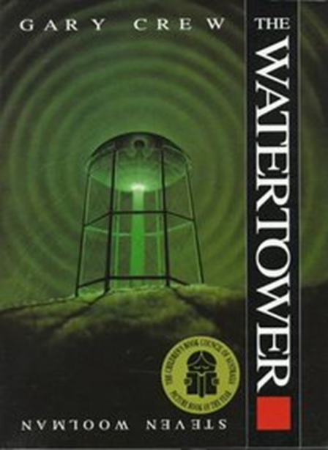
You also need to watch the video of me reading the story (on the school website)

Resources for session 2
The Watertower (Rumour 1)

I heard this story about the watertower. It happened to a friend of a friend. One night, two children sneaked up to the tower, despite being warned to keep well away by their parents. There used to be a security fence around the tower but somehow it had been torn away in one part and the children crawled through the space into the tower. No-one knows what happened that night, but just as the sky was at its darkest, the local people heard an agonising scream. Who made that scream? We will never know because one of the children never returned. And the other one? That child never uttered a single word again…

The Watertower (Rumour 2)

I’ve heard that if you walk around the watertower three times at midnight on the longest night then you can travel back in time for one night only.

The Watertower (Rumour 3)

You must never, ever go near the watertower! Not unless you want to disappear. Someone my dad knew went up there for a dare. A couple of other children were watching and they saw a strange light flashing above the tower for a full minute. When the light started to fade, they saw the shape of a child floating upwards towards the sky. After the light had gone completely, the children went to look for their friend. But the poor child could not be found anywhere…

Resources for session 3

Proper and common nouns
Nobody in Preston could remember when the watertower was built, or who had built it, but there it stood on Shooters Hill- its iron legs rusted, its egg-shaped tank warped and leaking- casting a long, dark shadow across the valley, across Preston itself.

It was the time of year Farmer Bailey liked best, when summer turned to fall. He whistled as he drove along. A cool breeze blew across his face through the truck’s open window. Then it happened. There was a loud “thump.” Mr. Bailey jammed on his brakes.
“Oh no!” he thought. “I’ve hit a deer.”

Mr. Bailey drove home. He helped the stranger inside, where Mrs. Bailey made him comfortable on the parlor sofa. Katy, their daughter, peeked into the room. The man on the sofa was dressed in odd, rough leather clothing. She heard her father whisper “...must be some kind of hermit...sort of fellow who lives alone in ten woods.” The stranger didn’t seem to understand the questions Mr.Bailey asked him. “I don’t think,” whispered Mrs. Bailey, “he knows how to talk.”

Read the text
It was late summer when the stranger came to live with the Baileys, and while fall has come to the surrounding areas, the weather remains unchanged on the Baileys' land. The stranger becomes increasingly concerned when he compares the orange and red leaves of autumn across the hill with the green leaves of the Baileys' trees. Soon he can think of nothing else but the drab green leaves, until one day he pulls a leaf from a tree and blows on it. It immediately turns orange. The stranger remembers who he is! He dresses in his old clothes and bids the Baileys goodbye. As he leaves they notice that the leaves have all turned and the air is cold and crisp. Every autumn thereafter, the trees at the Bailey farm stay green for a week longer than the trees to the north, and then change overnight. In the frost on the farmhouse windows the Baileys read the words "See you next fall."

Underline all proper nouns in red.
Find all adjectives used to describe the leaves. Underline in blue.
Find the verb that tells you what the stranger did with the leaf he pulled from the tree.
_________________
Find the verb that tells you what the Baileys did with the words on the farmhouse window.

Resources for session 4- this will be a ‘live lesson’
