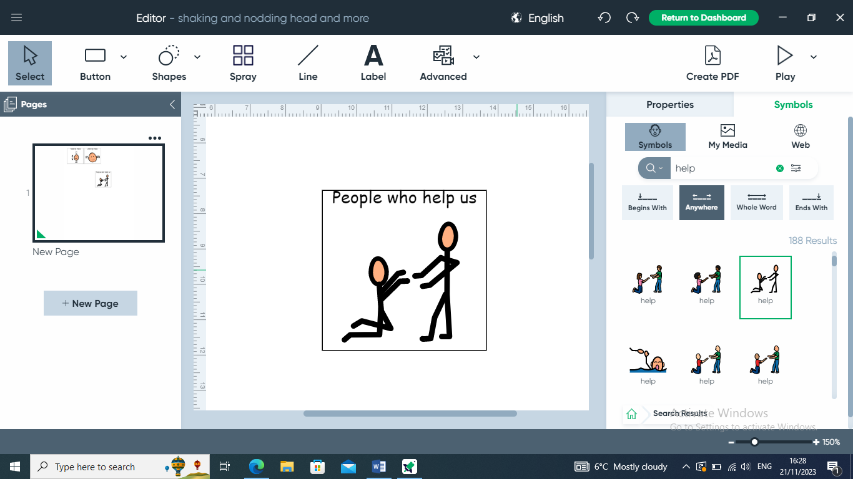 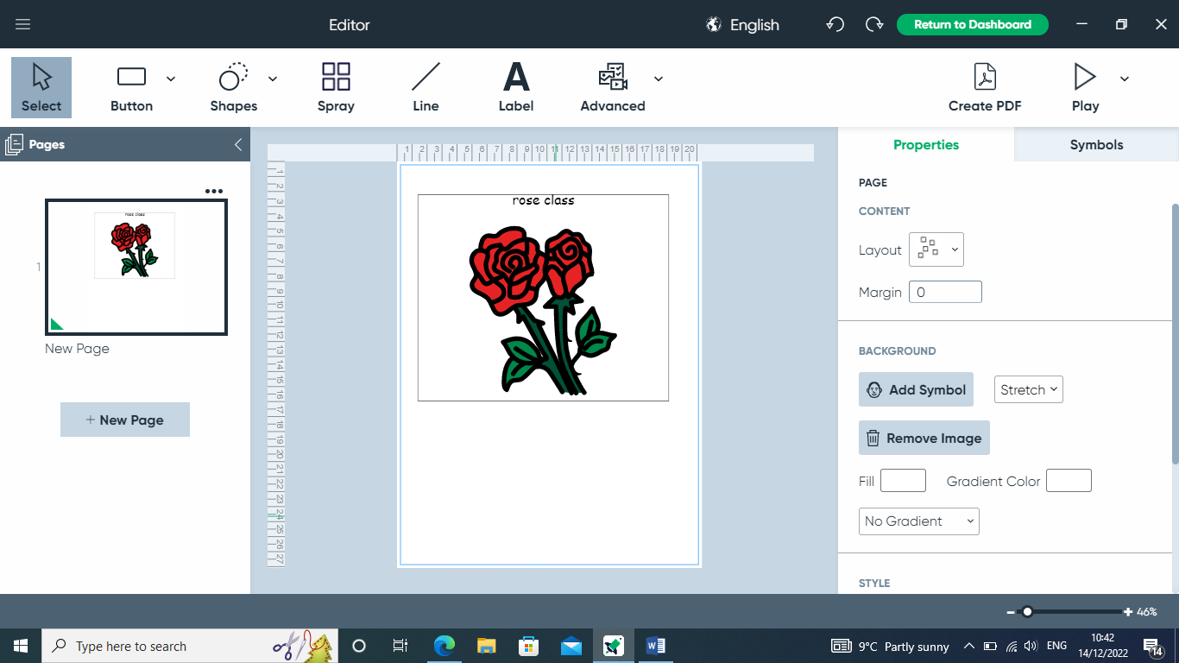

**Topics**

Addition and subtraction

Measuring mass

Time Repeating patterns

2D Shapes

Properties of shapes

Making pictures using shapes

Positions

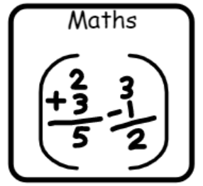

**Topics**

Stories through role play

Posters

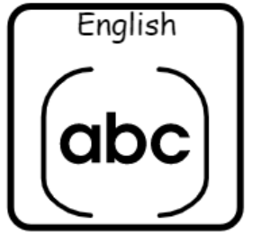

**Topics**

Programming and Algorithms

Multimedia – Sound and Music

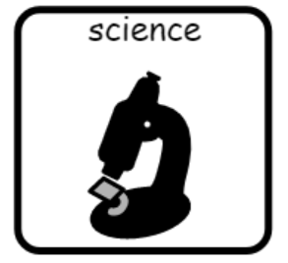

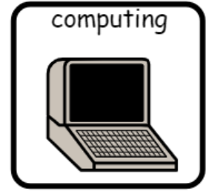

**Topics**

Changing materials

Exploring electricity

Spring Term Science Day – Our World

**Topic**

Weather in the UK

**Topic**

Junk Modelling

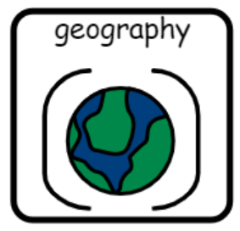

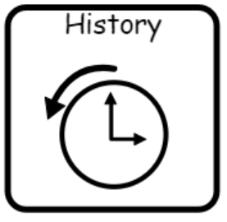

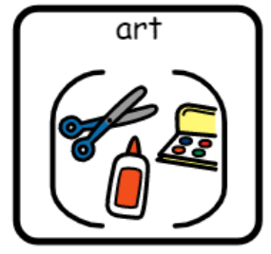

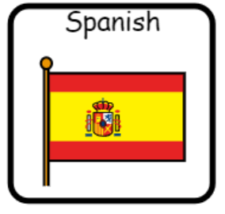

**Topic**

The Great Fire of London

**Topics** –

Numbers to 5

All about Spain

**Topics**

Stories from different religions (The Good Samaritan)

Easter (The Easter Story)

**Topics**

Games

Core Skills

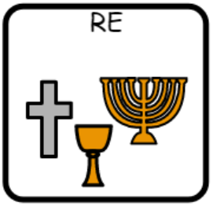

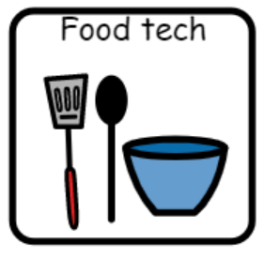

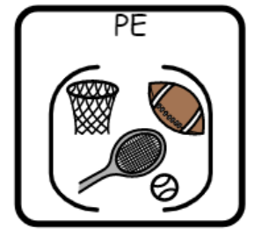

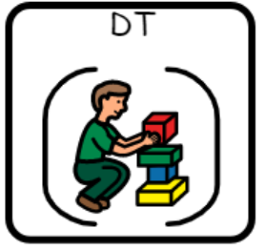

**Topic** –

Mechanisms (wheels and axles) - vehicles

**Topic**

Foods that make us warm (Soups)