Home Learning Activities
Class: Q3 Week: 6 Week Beg: 08.02.2021

Monday | Tuesday | Wednesday | Thursday | Friday
Maths  ZS/IS/HC/MG/GW/KL/DHG – Sort the 2D and 3D shapes – Use the shape mat to help name any shapes that you are unsure of.  Play the game -  https://www.education.com/game/2d-3d-shapes/  Match the 3D shape to its name (see attached.)  KM/LR – Use the nets of 3D shapes to make a cube, cylinder, cuboid (also known as a rectangular prism,) cone and a square based pyramid (see attached.) Use the shapes to help you complete the properties of 3D shape table (see attached.) | Maths  ZS/IS/HC/MG/GW/KL/DHG – Sort the everyday 3D shapes (booklet attached.)  KM/LR – 3D shapes and their faces – Answer the questions using your nets from yesterday to help you. | Maths  ZS/IS/HC/MG/GW/KL/DHG – Use the nets of 3D shapes to make a cube, cylinder, cuboid (also known as a rectangular prism,) cone and a square based pyramid (see attached.) You will need these for tomorrow’s activity.  KM/LR – A right angle is an angle measuring 90 degrees. Enclosed you will find your right angle finder!  Use this to help you decide if each shape has a right angle in on the attached sheet ‘is it a right angle’? | Maths  ZS/IS/HC/MG/GW/KL/DHG – Complete the 3D shapes properties table showing how many straight edges, curved edges and vertices each shape has. Test each shape to see if it can roll and stack (see attached.)  KM/LR – Right angle shape sorting – Sort the shapes under the headings no right angles, 1 right angle, 2 or more right angles. Use your right angle finder to help you! (See attached.) | Maths  ZS/IS/HC/MG/GW/KL/DHG – 3D shapes colouring. Name each 3D shape and colour each shape in the correct colour (see attached.)  KM/LR –  Read through the types of angles power point (see attached.)  Use the example to help you decide which angle is shown in each of the shapes on the ‘types of angles worksheet’ (see attached.)
English  Look at the images (see attached,) ‘how do they feel’?  Based on the photographs is each person feeling happy, sad or angry? Why do you think that is?  Look at the list of emoji’s. What feeling does each emoji represent? Think of something that makes you feel in each way, e.g. Happy – Spending time with friends (see attached.) | English  Read the completed survey on visiting Walton Gardens.  Complete the table to show what the review thinks about Walton Gardens (positive and negative.) See attached. | English  The completed survey had lots of positive comments but also showed that improvements could be made. Imagine that you are the Manager of Walton Gardens and read the reviews on trip advisor –  https://www.tripadvisor.co.uk/Attraction_Review-g190764-d213886-Reviews-Walton_Hall_and_Gardens-Warrington_Cheshire_England.html#REVIEWS  (Read a selection of these reviews - attached.)  Write a formal letter to any of the people that left a review highlighting the need for improvements and explaining what you are going to do to improve Walton Gardens further. You may wish to include several of the areas for improvement from both the reviews and the completed survey.  Can you persuade them to return? | English  Re-read the persuasive letter that you wrote yesterday. Highlight any positive adjectives that you used to describe Walton Gardens.  Remember an adjective describes a noun, e.g. pretty dress.  Complete ‘finding adjectives’ – Page 2 (see attached.)  Never forget that using fabulous adjectives will help to keep the reader’s attention!

PSD/ASDAN  Read the information ‘CV writing information’ (see attached.) A CV is an important document that you could send to potential employers. It tells them important information about you. As you are currently at school your CV looks slightly different to a person who has had employed jobs. Many young people use their school CV when applying for weekend jobs or voluntary work so make sure that when you complete it you think carefully and take your time.  Complete ‘My School CV’ (see attached.) Use previous work on your skills and qualities to help you complete this. |  |  | PSD/ASDAN  When applying for jobs it is important that you ‘proof read’ your CV.  Spend some time re-reading your CV. Could you make it more interesting by changing some of the words? E.g. ‘I am good a reading’ could instead say ‘I have a passion for reading’.  Remember you want an employer to remember your application! Make it stand out! | PSD/ASDAN  Lots of jobs are advertised online and you can often apply quickly by completing the online application form and uploading your CV.  Type up your CV using the template ‘My CV’. You will find this on the school website under home learning, Q3, week 6 resources, ‘My CV’. You will need to download and save this to your computer before adding information. When you save your CV save it as ‘Curriculum Vitae of __ name__’.  Please email these to me at our school email address  greenlane_school@warrington.gov.uk
PE  Jump on the spot for 5 minutes then, bend down and touch toes then stretch for 5 minutes. | PE  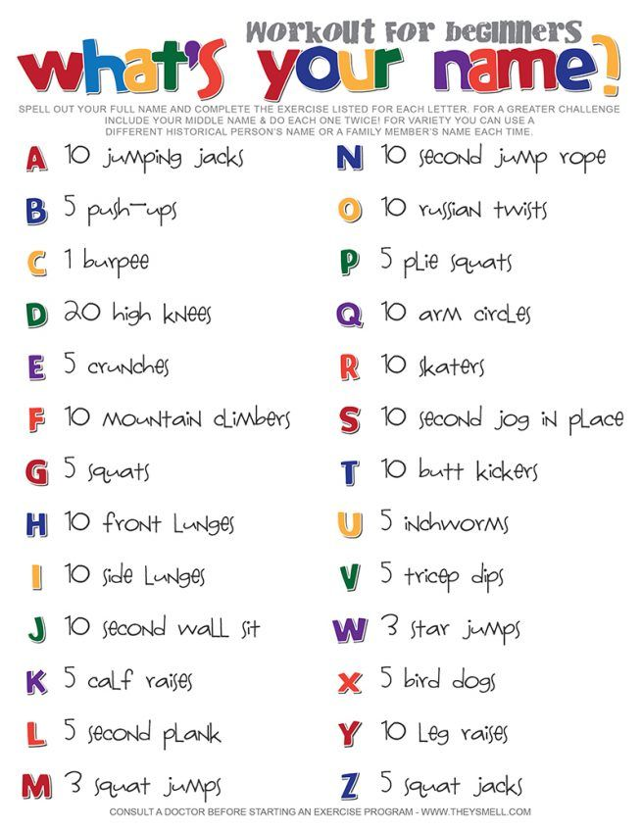 |  | PE  Using a pack of playing cards pick out 6 at random and do each action for 15 seconds –  Spade – Star jumps  Diamond – Jog on the spot  Heart – Squats  Clubs - Jumping | PE |  | PE  https://www.youtube.com/watch?v=fAUckPMJKSY  5 minute move – Workout 4
Phonics
Practice your spellings. Remember to test yourself at the end of the week.
Phase 3 – st – step, stop, stuck, list, mist, best, nest, test, vest, west
Phase 4 – ea/ck – peach, reach, teach, lead, read, flick, kick, lick, pick, sick
Phase 5 – ke/ur – flake, coke, choke, broke, smoke, spoke, like, pike, disturb, church
Phase 6 – silent/qu – yolk, quality, quantity, quarter, queen, queer, quench, query, question, quick
Science  Watch -https://www.youtube.com/watch?v=qg2nGY1aqlg&feature=emb_logo The Grisly murders of Jack the Ripper.  Consider the information on the suspects described in the video along with everything that you have learnt so far this half term (particularly last week’s profile of Jack the Ripper.)  Which suspect do you think was actually Jack the Ripper and why? Write a short paragraph explaining your thoughts. |  | Food wise  Before your family go shopping agree on a meal that you can buy as a ready meal and then make yourself from scratch (pizzas are a delicious choice however what you choose is totally up to you.)  Write a comparison of both meals – Time taken to prepare, cost, number of stars for taste, number of stars for appearance (see attached.) |  |  | Art  Make your own origami penguin (see instruction sheet attached.)
Don’t forget where possible please upload evidence of your completed work to EFL.
Well done for your hard work and dedication throughout this half term – I am extremely proud of you all!
Next week is half term so please take some time to relax and enjoy time with your families. Work packs for the first week back will be posted this week. We will come together via zoom on the first Monday after half term (22/02/21.) Details to follow.

