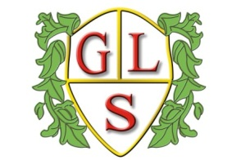
Class 2MC Topics Spring 2022

Science
How do rocks change over time?
Why do things happen?

History
School through Time

Geography
Equator

ICT
Programming and Algorithms
Multimedia- sound and music

Spanish
My Spanish Passport
Spanish Food

RE
Islam
Easter

Art
A Storm in a Teacup

Design Technology
Textiles – items of clothing

PSHE
Balanced lifestyle and Consequences
Physical and Emotional Changes of Growing Up

PE
Warrington Wolves Foundation

