
Home Learning Activities
English/Communication  Puppets  Find old socks, add cardboard eyes, nose, mouth and ear. You can decorate them as much as you like.  Give your puppet a name, what noises can he make? | Maths  Maths song: Big and Small (Little Baby Bum songs on Youtube)  Hide a range of big & small objects around the garden / house. Have a treasure hunt. When you have found everything, sort them into big & small piles. | Maths  Maths song: Colours song  (Super simple songs on Youtube)  Colour/paint a rainbow, ask me to name or find colours. | SCERTS  Song: This is my happy song (Super simple songs on Youtube)  Use a mirror, make different faces – happy, sad, cross, scared.  Talk about what you are feeling today. | English/Communication  Use the puppets we made earlier in the week and have a puppet show. Maybe you could act out action songs or stories.
SCERTS / PSED  Play Simon says: we all stand still until mum/dad says: hop like a frog / slither like a snake/ jump like a kangaroo etc. | Phonics  Put each letter of my full name on a separate piece of paper/card and hide them around the house or garden. Let me find all the letters and put them in the correct order. If I struggle write the name down for me to copy. | Phonics  Using our voices:  Role play using telephones, talk to each other about what you have been doing, what you have seen on your daily walk etc. | SCERTS: Cooperate and communicate with a partner  Give everyone a circle that is of different colours. Have a colour hunt – this can be inside or on your daily walk, how many things can you find in your colour? | SCERTS / PSED  Give me lots of little jobs to do around the house – all the children in our class are used to doing jobs and do them very well!  This week draw a little timetable of 3 jobs for me to do.
SCERTS / PD  Have a dance party – decorate the room a little if you can, turn up the music and get moving!  *I expect dad to join in too!!! | SCERTS  Cooperate with a partner  Continue to water the seeds we planted last week.  This week you can decorate the pot too. | SCERTS / PD  Use a long piece of sticky tape outside on the patio / path – lay a straight line and see if you can balance along it  (it is like walking on a beam but on the floor - so no one gets hurt) | SCERTS / PD  Get a box, cut a small circle in 1 corner. Then put a small ball in the box and move to get the ball out.  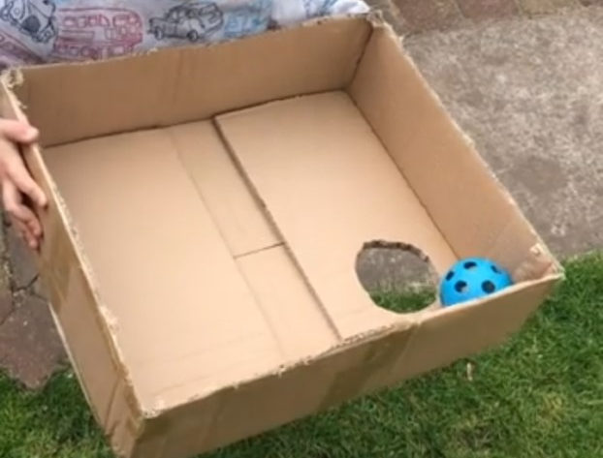 | SCERTS / PD  Put a bucket of water at one end of the garden and an empty bucket at the other end. Give me a plastic cup and get me to run from 1 end of the garden to the other, moving the water to the empty bucket using the cup.
Expressive arts / Sensory  Make pegosaurus 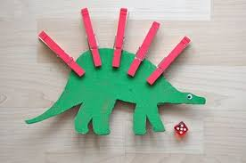 | Knowledge and Understanding of the World.  Use thick card (an old box is perfect), cut out 2 huge dinosaur feet. Attach a sponge or handle to the back. Dip the feet in paint and make footprints on paper a long piece is best. | SCERTS: Cooperate with a partner  Make sandwich of your choice – please try & draw simple instructions for me to follow. Cut the sandwiches into simple dinosaur footprint shapes. | Expressive arts  Paint a big dinosaur to go with your footprints. | SCERTS  Bake or cook together, try and draw some simple pictorial instructions. We have made bread in class a few times and so pupils will recognise the process involved so this would be good to try.
Class: 3N Week: 9 Week of: 18/05/20 Topic: Dinosaurs

