Autumn/Winter 2020 MENU – WEEK 2
OPTION | MONDAY |  | TUESDAY |  |  | WEDNESDAY |  |  | THURSDAY |  |  | FRIDAY
1 | Pizza (Ham & Cheese) & potato wedges |  | Roast chicken, roast potatoes,stuffing,carrots, broccoli and gravy | 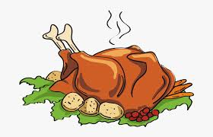 |  | Pork meatballs and tomato sauce pasta bake | 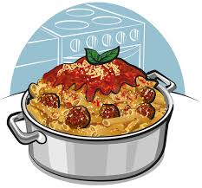 |  | Seasoned chicken, potato waffle and baked beans | 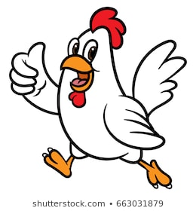 |  | Fish  (cod or Salmon) with Chips
2 | Sandwich (PL)  Choice of Ham, Cheese or Tuna |  | Sandwich (PL)  Choice of Ham, Cheese or Tuna |  |  | Sandwich (PL)  Choice of Ham, Cheese or Tuna |  |  | Sandwich (PL)  Choice of Ham, Cheese or Tuna |  |  | Sandwich (PL)  Choice of Ham, Cheese or Tuna
V
JP | Filled  Jacket Potato |  | Filled  Jacket Potato |  |  | Filled  Jacket Potato |  |  | Filled  Jacket Potato |  |  | Filled  Jacket Potato
DESSERTS
 | Vanilla ice cream |  | Piece of Fruit |  | Blueberry Muffin |  |  | Homemade cake |  |  | Homemade Biscuit
Vegetarian alternative:- Fruit yoghurt, a selection seasonal fresh fruit, soreen and cheese & biscuits available everyday
Unlimited fresh salad and unlimited wholemeal bread
LUNCH WILL BE SERVED WITH FRESH MILK OR WATER
Menu Cycle Week 2:9th Nov, 30th Nov, 21st Nov, 11th Dec

