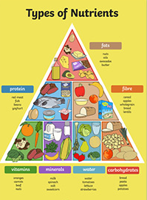
Food groups

Head to the kitchen… Can you find one food from each food group? Make a list of these foods.

fats
protein
fibre
vitamins
minerals
water
carbohydrates

How do we know if each of these foods is good for us?
__________________________________________________________
Pick one of the foods and complete the nutritional information.
Food | Calories | Sugar | Fat | Salt

