Moving pictures

Topics

Number

Positions

Time

Money

Probability

Languages

Topics

Colours

Spanish flag

Numbers to 10

Computing

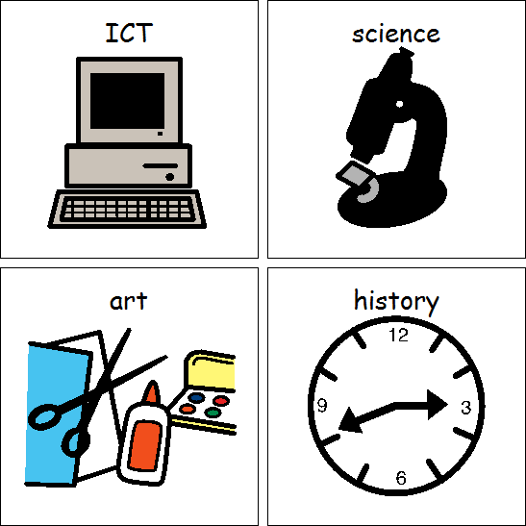

Topics

Making music

Presenting ideas

Maths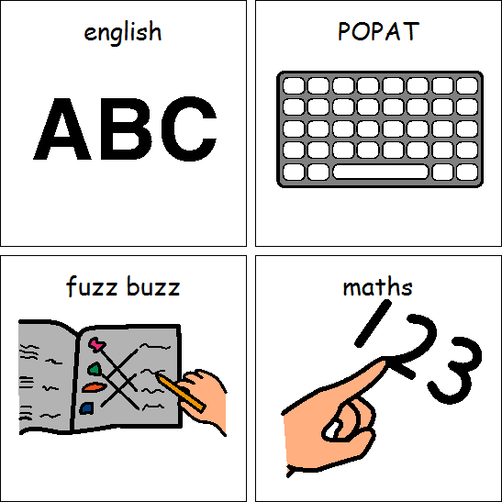

A happy helper

Looking after the environment

Sikh Dharam

Islam

English



Topics

Playscripts

Classic Poetry for Performance

POPAT

Letters and sounds

Colour and Pattern

DT

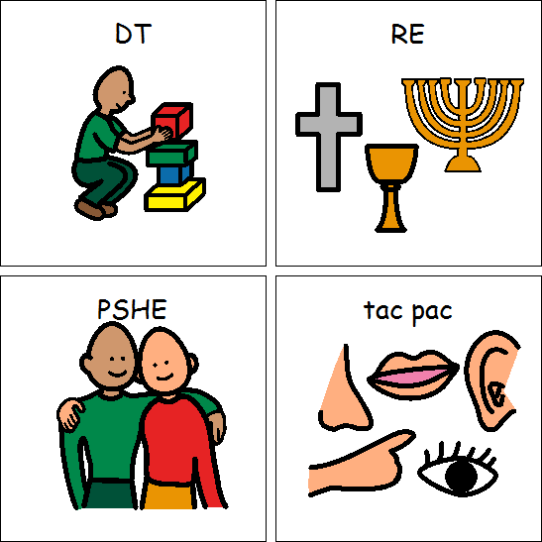

ART



PSHE

RE

Health and Fitness

Athletics

PE

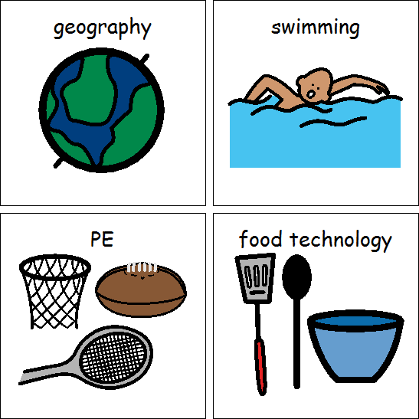

Testing Materials

Applying forces

Science



Our School and its grounds

Geography

What did people really think of Florence Nightingale?

History

Class 4 Summer 2019