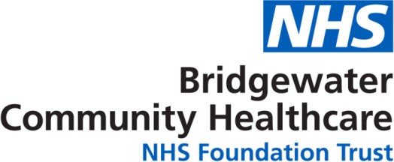

MAY 2021

Text support service for parents, carers and teens 11-19 years

Bridgewater Community Healthcare NHS Foundation Trust has rolled out a new secure text messaging service for parents and carers of children and young people aged 0-19 years old and a Young People's Service for 11-19 years, enabling them to get timely and trusted health advice from a health professional (a Health Visitor or School Nurse).

There are 3 text numbers for:
- 11 – 19 Young People's Service
- 0 - 5 Parents Service
- 5 - 19 Parents Service

As our lives have changed over the last few months due to coronavirus, it’s more important than ever for young people families to have easy access to support, particularly in the absence of face to face interaction.

The service does not aim to replace face to face contacts, rather increase choice for service users about how they access advice from a health professional and provides a new line of communication as face to face contact is reduced.

The ChatHealth text number will operate Monday-Friday from 9am until 5pm.

Messages will be responded to within 24 hours during this period. Outside these hours, service users will receive a ‘bounce back’ text message indicating that they will receive a response when the line re-opens.

ChatHealth is not an emergency service, and accordingly parents will be instructed to follow usual advice in seeking urgent medical attention.

The text numbers for Warrington are:
- 11 - 19 Young People's Service – 07507 330101
- 0 - 5 Parents Service – 07507 327981
- 5 - 19 Parents Service – 07480 635994

Or visit chathealth.nhs.uk to start a chat

