Autumn/Winter 2 2020 MENU – WEEK 1
OPTION | MONDAY |  | TUESDAY |  |  | WEDNESDAY |  | THURSDAY |  |  | FRIDAY
1 | Sausage, mash and gravy.  With seasonal vegetables | 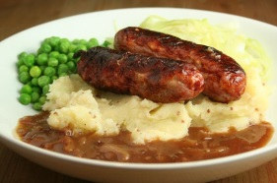 | Roast turkey with sage and onion stuffing with roast & creamed potatoes. Fresh broccoli or carrots Gravy | 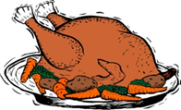 |  | Pasta Bolognaise/  Lasagne, garlic bread and Broccoli | 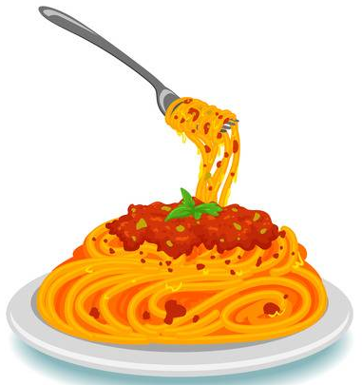 | Chicken Curry, rice and peas |  |  | Fish, Chips and peas or beans
2 | Sandwich (PL)  Choice of Ham, Cheese or Tuna |  | Sandwich (PL)  Choice of Ham, Cheese or Tuna |  |  | Sandwich (PL)  Choice of Ham, Cheese or Tuna |  | Sandwich (PL)  Choice of Ham, Cheese or Tuna |  |  | Sandwich (PL)  Choice of Ham, Cheese or Tuna
V
JP | Filled  Jacket Potato |  | Filled  Jacket Potato |  |  | Filled  Jacket Potato |  | Filled  Jacket Potato |  |  | Filled  Jacket Potato
DESSERTS
 | Vanilla ice cream |  | Piece of Fruit |  | Blueberry Muffin |  |  |  | Homemade cake |  |  | Homemade Biscuit
Vegetarian alternatives available:- Fruit yoghurt, a selection seasonal fresh fruit, soreen and cheese & biscuits available everyday
Unlimited fresh salad and unlimited wholemeal bread
LUNCH WILL BE SERVED WITH FRESH MILK OR WATER
Menu Cycle Week 1: 2ndNov,23rd Nov,7th Dec

