Word problems using a number line
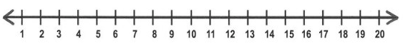

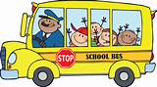
6 people are on the bus. 4 more people get on the bus. How many people are on the bus now?

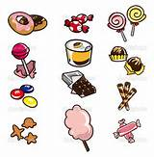
Jon has 3 sweets and Leon has 7 sweets. How many sweets do they have altogether?

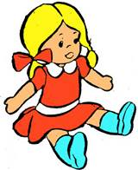
Chastity has 5 dolls. She gets 5 more dolls for her birthday. How many dolls does she have in total?

Thomas has 2 cats. The mummy cat has 8 kittens. How many cats does Thomas have now?

On Saturday Jon scored 7 goals. On Sunday he scored 3 goals. How many goals did he score at the weekend?
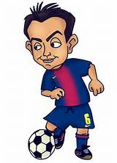

Shannon has 9 stickers. Her mam gave her 1 more. How many stickers does she have now?

Hollie has 3 hats. She gets 2 more for her birthday. How many hats does she have altogether?

Habiba has 6p. Her mam gives her 8p more. How much money does she have now?

