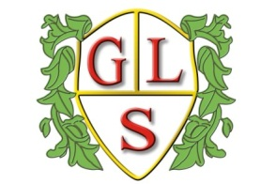
Class 6 Topics Autumn 2020

Science
Changing Materials
Under the Magnifying Glass –Living Things

History
World War I and World War II

Geography
Surrounding Seas around the UK

ICT
E Safety
What is a Computer?
Multimedia: Photographs/Text

Spanish
All About Spain
Numbers/Spanish Christmas

RE
Jesus as Leader
Celebrating Christmas

Art
Moods and Feelings

Design Technology
Cooking Healthy Snacks

PSHE
Feeling Safe in a Family – What Makes me Happy?
Road Safety

PE
Games (Wolves Foundation)

