Healthy Eating- Sandwiches and Salads

Topics

Number

Patterns

Sorting, ordering & classifying

Fractions

Making graphs

Languages

Topics

Spanish greetings

Spanish food

Computing

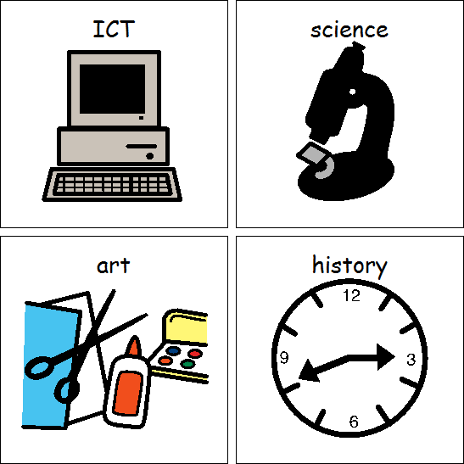

Topics

Effective searching

Creating a picture

Maths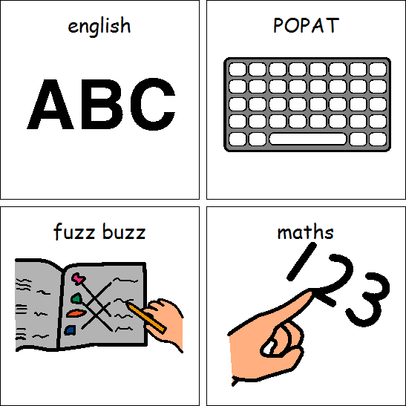

My friends

Staying safe- saying no

The Jewish Passover

The Easter Story

English



Topics

Fables

Discuss for & against

Natural Art

DT

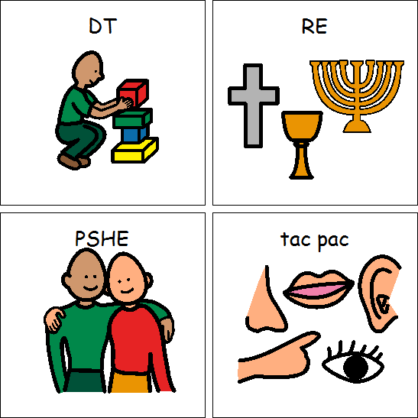

ART



PSHE

RE

Games

Core Skills

PE

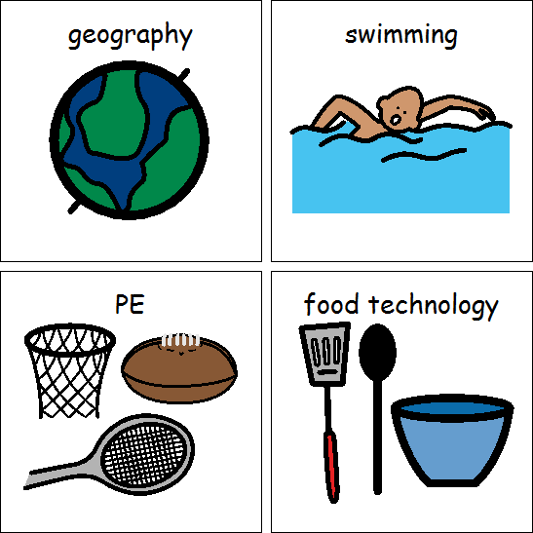

Rocks and Soil

Comparing Plants

Science



The Seaside

Geography

What toys did my grandad play with?

History

Class 4 Spring 2019