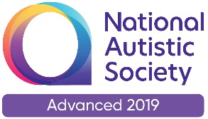 | 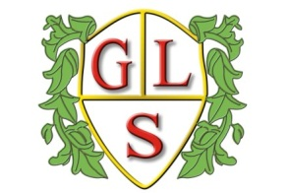 | Paul King  Headteacher  Joanne Mullineux  Deputy Headteacher

17th May 2021

Dear Parents / Carers

I hope this letter finds you well and enjoying the rain! As we enter further easing of lockdown restrictions and the potential impact on schools, I felt it was important to inform you of our intentions over the next few weeks / months.

Staff and Upper School pupils have become used to the routine of wearing face coverings coming into and leaving school and moving around the corridors. We would like to maintain this routine by encouraging all Upper School pupils and all staff to continue wearing face coverings at these times until the end of the school year. Along with the continuation of frequent hand washing and hand sanitising we feel this will further reduce potential risks relating to Covid-19 and the numerous variants.

I would also like all parents and visitors coming onto the site to continue to wear face coverings. Obviously this is not compulsory but I do feel if we continue with our current processes we will maintain our levels of safety for everyone.

If you would like further information or would like to have a conversation about this matter, please contact me in school.

Yours sincerely
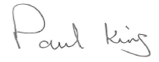
Paul King
Headteacher

