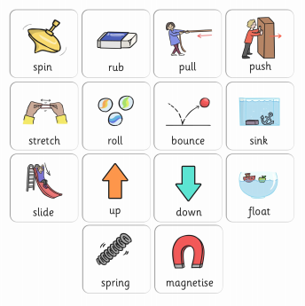
Can you think of any objects that match these forces? i.e. you can push and pull a door,

