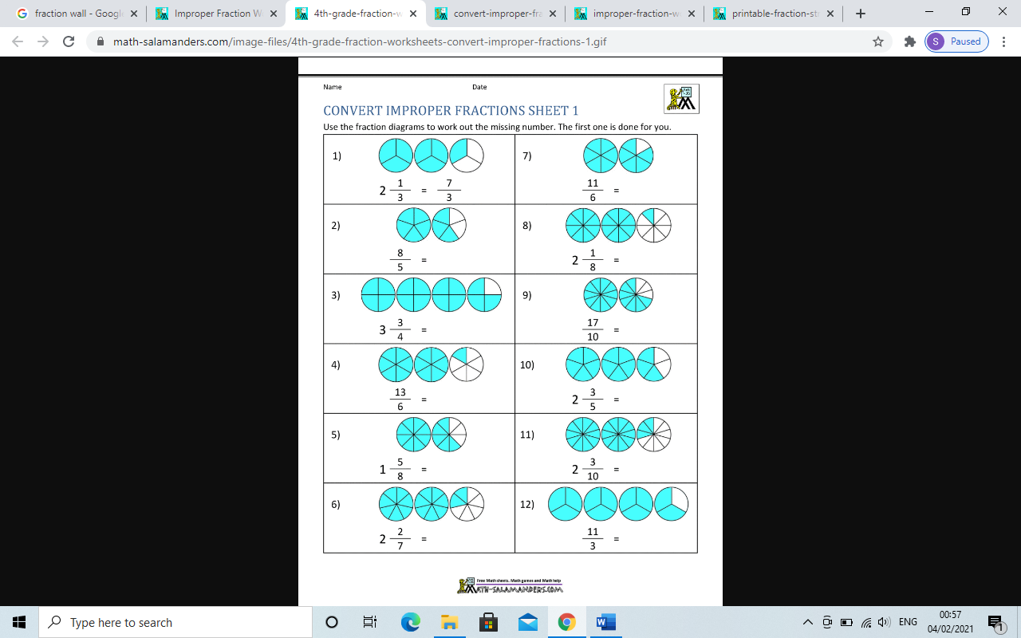LO: To recognise improper fractions

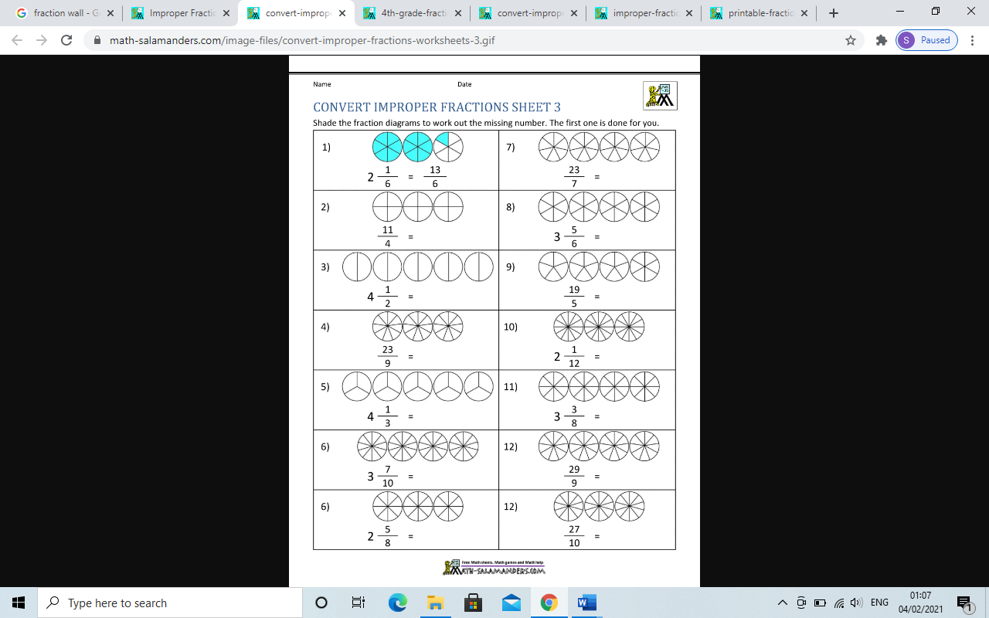LO: To recognise improper fractions

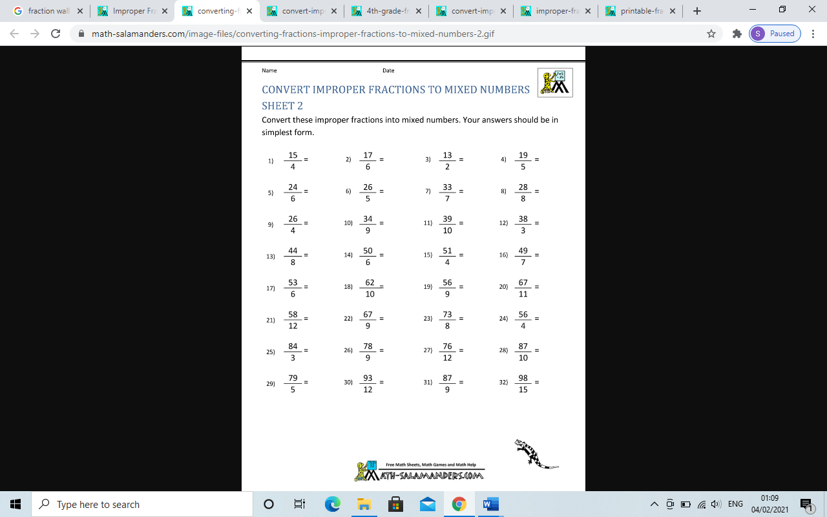

e.g 15/4= 3 ¾

Challenge