Class 3G Autumn topic overview (year 3)

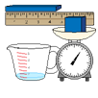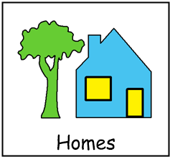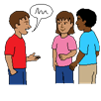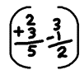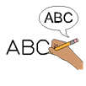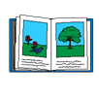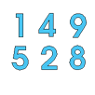2022 - Summer topic theme – ‘HOMES’

**Topic / SCERTS / ASDAN (KS4)**

**History** – Homes – Homes, then and now.

**Geography** – Homes – Compass points & locations

**Art** – Homes – Sculptures

**RE** – Homes – Islam / Daily jobs – rituals

**Design Technology** – Homes – Structures, designs & templates

**Food Technology** – Homes – Vegetables / Traditional cooking

**Computing** – Homes – Data counting / Multi-media photographs

**MFL** – Colours / Spanish music & instruments

**PE** – Key skills & Invasion games / Athletics

Speech and Language therapy – Use of PECS & communication books

Occupational Therapy – Self and emotional regulation & Sensory awareness skills

**English**

Homes – Explanation texts

Homes – Traditional tales

Phonics / POPAT

Letters & Sounds

Reading books

Handwriting

**Science**

Homes – Materials

Homes – Our world

**Maths**

Number

Data Handling

Measures