Autumn/Winter 2020 MENU – WEEK 3
OPTION | MONDAY |  | TUESDAY |  |  | WEDNESDAY |  |  | THURSDAY |  |  | FRIDAY
1 | Cooks Choice  Pasta Bake with broccoli | 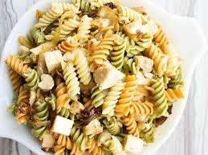 | Roast gammon,  stuffing  roast and creamed potatoes, carrots, broccoli and gravy | 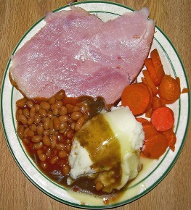 |  | Chicken Goujons, herby diced potatoes and vegetables or beans | 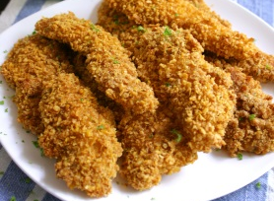 |  | Cooks Choice  Chilli and rice/chicken Curry | 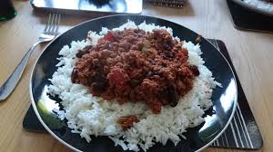 |  | Fishfingers, Chips and beans
2 | Sandwich (PL)  Choice of Ham, Cheese or Tuna |  | Sandwich (PL)  Choice of Ham, Cheese or Tuna |  |  | Sandwich (PL)  Choice of Ham, Cheese or Tuna |  |  | Sandwich (PL)  Choice of Ham, Cheese or Tuna |  |  | Sandwich (PL)  Choice of Ham, Cheese or Tuna
V
JP | Filled  Jacket  Potato |  | Filled  Jacket Potato |  |  | Filled  Jacket Potato |  |  | Filled  Jacket Potato |  |  | Filled  Jacket Potato
DESSERTS
 | Vanilla ice cream |  | Piece of Fruit |  | Blueberry Muffin |  |  | Homemade cake |  |  | Homemade Biscuit
Vegetarian alternative:- Fruit yoghurt, a selection seasonal fresh fruit, soreen and cheese & biscuits available everyday
Unlimited fresh salad and unlimited wholemeal bread
LUNCH WILL BE SERVED WITH FRESH MILK OR WATER
Menu Cycle Week 3: 26th Oct, 16th Nov,7th Dec,28th Dec, 18th Jan

