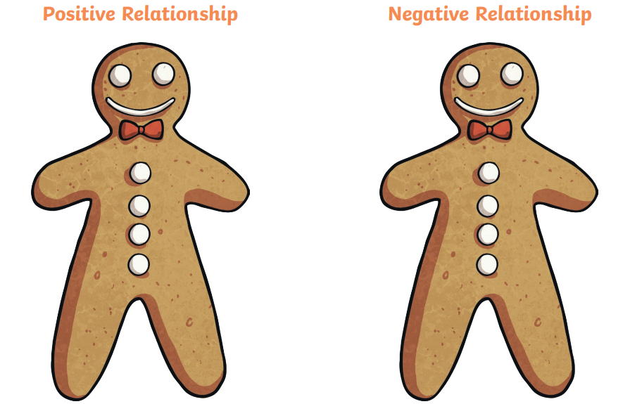

I feel worried that they might tell people things about me that I don’t want them to tell.

I think that I am not important to them.

I know that I can tell them things about myself.

I don’t feel happy most of the time.

I feel happy when I am with them.

I know that I am loved.