Green Lane School

Supporting Pupils at School with Medical Conditions

Headteacher: Mrs Joanne Mullineux
Green Lane School
Woolston Learning Village
Holes Lane Woolston
Warrington WA1 4LS
Tel: 01925 811617

Reviewed in: Sept 2023

Contents

- Overview
- Aims
- Legislation and statutory responsibilities
- Roles and responsibilities
- Equal opportunities
- Being notified that a child has a medical condition
- Individual healthcare plans
- Managing medicines
- Medication
- Emergency procedures
- Training
- Record keeping
- Liability and indemnity
- Complaints
- Monitoring arrangements
- Links to other policies
- Appendix 1
- Appendix 2
- Appendix 3
- Appendix 4

1. Overview

Green Lane School is an inclusive community that supports and welcomes pupils with medical conditions.

- We understand that we have a responsibility to make the school a welcoming and supportive environment to all pupils with medical conditions who currently attend and to those who may join us in the future
- We aim to provide all children with medical conditions the same opportunities as others at school. We will help to ensure that they can be healthy, stay safe, enjoy and achieve and make a positive contribution
- Pupils with medical conditions are encouraged to take control of their condition if and when possible
- We aim to include all pupils with medical conditions in all school activities
- Parents/Carers of pupils with medical conditions feel secure in the care their children receive in school
- The school ensures all staff understand their duty of care to children and young people in the event of an emergency
- All staff feel confident in knowing what to do in an emergency
- This school understands that certain medical conditions can be serious and can be potentially life-threatening (particularly if ill managed and/or misunderstood)
- All staff understand the common medical conditions that affect children at this school
- The medical conditions policy is understood and supported by the whole school

2. Aims

This policy aims to ensure that:
- Pupils, staff and parents understand how our school will support pupils with medical conditions
- Pupils with medical conditions are properly supported to allow them to access the same education as other pupils (including school trips and/or sporting activities

The governing board and Head Teacher will implement this policy by:
- Making sure that sufficient staff are trained
- Making staff aware of pupils’ conditions (where appropriate)
- Making sure there are cover arrangements in place to ensure that someone is always available to support pupils with medical conditions
- Providing supply staff with appropriate information about the policy and relevant pupils
- Developing and monitoring individual healthcare plans (IHP’s)

The named person with responsibility for implementing this policy is Mrs Joanne Mullineux (Acting Head Teacher)

3. Legislation and statutory responsibilities

This policy meets the requirements under Section 100 of the Children and Families Act 2014, which places a duty on governing boards to make arrangements for supporting pupils at their school with medical conditions.

It is also based on the Department for Education’s statutory guidance on supporting pupils with medical conditions at school.

4. Roles and responsibilities

4.1 The governing board

The governing board has ultimate responsibility to make arrangements to support pupils with medical conditions. The governing board will ensure that sufficient staff have received suitable training and are competent before they are responsible for supporting children with medical conditions.

4.2 The Head Teacher

The Head Teacher will:
- Make sure all staff are aware of this policy and understand their role in its implementation
- Ensure that there is a sufficient number of trained staff available to implement this policy and deliver against all individual healthcare plans (IHP’s), including in contingency and emergency situations
- Ensure that all staff who need to know are aware of a child’s condition
- Take overall responsibility for the development of IHP’s
- Make sure that school staff are appropriately insured and aware that they are insured to support pupils in this way
- Contact the school nursing service in the case of any pupil who has a medical condition that may require support at school, but who has not yet been brought to the attention of the school nurse (if applicable)
- Ensure that systems are in place for obtaining information about a child’s medical needs and that this information is kept up to date

4.3 Staff

Supporting pupils with medical conditions during school hours is not the sole responsibility of one person. Any member of staff may be asked to provide support to pupils with medical conditions, although they will not be required to do so. This includes the administration of medicines.

Those staff who take on the responsibility to support pupils with medical conditions will receive sufficient and suitable training, and will achieve the necessary level of competency before doing so.

Teachers will take into account the needs of pupils with medical conditions that they teach. All staff will know what to do and respond accordingly when they become aware that a pupil with a medical condition needs help.

4.4 Parents

Parents will:
- Provide the school with sufficient and up-to-date information about their child’s medical needs
- Be involved in the development and review of the child’s IHP (and may be involved in its drafting)
- Carry out any action that they have agreed to as part of the implementation of the IHP, e.g. provide medicines and equipment, and ensure that they or another nominated adult are contactable at all times

4.5 Pupils

Pupils with medical conditions will sometimes be best placed to provide information about how their condition affects them. Where appropriate, pupils should be included in discussions about their medical support needs and contribute as much as possible to the development of their IHP’s (they are also expected to comply with their IHPs).

4.6 School nurses and other healthcare professionals

Our school nursing service will notify the school when a pupil has been identified as having a medical condition that will require support in school (this will be before the pupil starts school wherever possible). They may also support staff to implement a child’s IHP.

Healthcare professionals, such as GPs and Paediatricians, will liaise with the school’s nurses and notify them of any pupils identified as having a medical condition. They may also provide advice on developing IHP’s.

5. Equal opportunities

Our school is clear about the need to actively support pupils with medical conditions to participate in school trips and visits, or in sporting activities, and not prevent them from doing so.

The school will consider what reasonable adjustments need to be made to enable these pupils to participate fully and safely on school trips, visits and sporting activities.

Risk assessments will be carried out so that planning arrangements take account of any steps needed to ensure that pupils with medical conditions are included. In doing so, pupils, their parents and any relevant healthcare professionals will be consulted.

6. Being notified that a child has a medical condition

When the school is notified that a pupil has a medical condition, the process outlined below will be followed to decide whether the pupil requires an IHP.
The school will make every effort to ensure that arrangements are put into place within 2 weeks, or by the beginning of the relevant term for pupils who are new to our school.

See Appendix 1

7. Individual healthcare plans

The Head Teacher has overall responsibility for the development of IHP’s for pupils with medical conditions. This is in conjunction with Hayley Chadwick and NHS health professionals.

Plans will be reviewed at least annually, or earlier if there is evidence that the pupil’s needs have changed.

Plans will be developed with the pupil’s best interests in mind and will set out:
- What needs to be done
- When
- By whom

Not all pupils with a medical condition will require an IHP. It will be agreed with a healthcare professional and the parents when an IHP would be inappropriate or disproportionate. This will be based on evidence. If there is no consensus, the Head Teacher will make the final decision.

Plans will be drawn up in partnership with the school, parents and a relevant healthcare professional, such as the school nurse, specialist or paediatrician, who can best advise on the pupil’s specific needs. The pupil will be involved wherever appropriate.

IHP’s will be linked to, or become part of, any education, health and care (EHC) plan.

The level of detail in the plan will depend on the complexity of the child’s condition and how much support is needed. The governing board, the Head Teacher and Medical Intervention (Hayley Chadwick) will consider the following when deciding what information to record on IHP’s:
- The medical condition, its triggers, signs, symptoms and any treatments
- The pupil’s resulting needs, including medication (dose, side effects and storage) and other treatments, time, facilities, equipment, testing, access to food and drink where this is used to manage their condition, dietary requirements and environmental issues, e.g. crowded corridors, travel time between lessons
- Specific support for the pupil’s educational, social and emotional needs. For example, how absences will be managed, requirements for extra time to complete work, use of rest breaks or additional support needed in order to catch up with learning etc
- The level of support needed (included in emergencies). If a pupil is self-managing their medication, this will be clearly stated with appropriate arrangements for monitoring
- Who will provide this support, their training needs, expectations of their role and confirmation of proficiency to provide support for the pupil’s medical condition from a healthcare professional, and cover arrangements for when they are unavailable
- Who in the school needs to be aware of the pupil’s condition and the support they may require
- Arrangements for written permission from parents/carers for medication to be administered by a member of staff, or self-administered by the pupil during school hours (refer to Appendix 2)
- Separate arrangements or procedures required for school trips or other school activities falling outside of the usual school timetable that will ensure the pupil can participate, e.g. risk assessments
- Where confidentiality issues are raised by the parent/carer/pupil, the designated individuals to be entrusted with relevant information about the pupil’s condition
- What to do in an emergency, including who to contact, and contingency arrangements

8. Managing medicines

The medical conditions policy is supported by a clear communication plan for staff, parents/carers and other key stakeholders to ensure its full implementation.

8.1 Parents will be informed and regularly reminded about the medical conditions policy:
- By including the policy statement on the school website and signposting access to the policy
- At the start of the year when communication is sent out about Healthcare Plans
- When their child is enrolled as a new pupil

8.2 School staff are informed and will be regularly reminded about the medical conditions policy:
- Through discussion at staff meetings
- At scheduled medical conditions training
- Through the key principles of the policy being displayed in the staff room

8.3 First Aiders working in school will be informed and reminded about the school’s medical conditions policy:
- Via Medical Intervention (Hayley Chadwick)

8.4 All staff understand and are trained in what to do in the event of an emergency for the most common serious medical conditions at this school

8.5 Staff at this school understand their duty of care to pupils in the event of an emergency. In an emergency situation, staff are required under common law (duty of care) to act like any reasonably prudent parent (this may include administering medication)

8.6 All staff who work with groups of pupils at this school receive training and know what to do in an emergency for the pupils with medical conditions in their care (this training is refreshed on an annual basis)

8.7 This school has procedures in place so that a copy of the pupil’s Healthcare Plan can be taken to an emergency care setting with the pupil

9. Medication

Prescription and non-prescription medicines will only be administered at school:
- When it would be detrimental to the pupil’s health or school attendance not to do so
- Where there is written consent from a parent/carer

The only exception to this is where the medication has been prescribed to the pupil without the prior knowledge of the parent/carer

Pupils under 16 years of age will NOT be given medication containing aspirin (unless prescribed by a Doctor)

Anyone giving a pupil ANY medication (for example, for pain relief) will first check maximum dosages and when the previous dosage was taken/administered (Parents/carers will always be informed).

The school will only accept prescribed medications that are:
- In date
- Labelled
- Provided in the original box/container, as dispensed by the pharmacist, and include instructions for administration, dosage and storage

All medicines will be stored safely (in either a locked medical cabinet in the pupils’ classroom or a locked fridge or cabinet in the medical room). Medicines and devices such as asthma inhalers, blood glucose testing meters and adrenaline pens will be readily available.

Medication will be returned to parents/carers to arrange for safe disposal when no longer required.

9.1 Controlled drugs are prescription medicines that are controlled under the Misuse of Drugs Regulations 2001 and subsequent amendments, such as morphine or methadone

A pupil who has been prescribed a controlled drug may have it in their possession if they are competent to do so, but they MUST NOT pass it to another pupil to use. All other controlled drugs are kept in a secure medical cabinet or medical fridge. .

Controlled drugs will be easily accessible in an emergency and a record of any doses used and the amount stored will be kept.

9.2 Pupils managing their own needs
Pupils who are competent will be encouraged to take responsibility for managing their own medicines and procedures. This will be discussed with parents/carers and will be reflected in their IHP’s.

Pupils will be allowed to carry their own medicines and relevant devices wherever possible. Staff will not force a pupil to take a medicine or carry out a necessary procedure if they refuse, but will follow the procedure agreed in the IHP and inform parents/carers so that an alternative option can be considered (where necessary).

9.3 Unacceptable practice
School staff should use their discretion and judge each case individually (with reference to the pupil’s IHP), but it is generally not acceptable to:
- Prevent pupils from easily accessing their inhalers and medication, and administering their medication when and where necessary
- Assume that every pupil with the same condition requires the same treatment
- Ignore the views of the pupil and their parent/carer
- Ignore medical evidence/opinion (although this may be challenged)
- Send children with medical conditions home frequently for reasons associated with their medical condition or prevent them from staying for normal school activities (unless this is specified in their IHP)
- If the pupil becomes ill, send them to the school office or medical room unaccompanied or with someone unsuitable]
- Penalise pupils for their attendance record if their absences are related to their medical condition, e.g. hospital appointments
- Prevent pupils from eating, drinking or taking a toilet break whenever they need to in order to manage their medical condition effectively
- Require parents/carers, or otherwise make them feel obliged, to attend school to administer medication or provide medical support to their pupil (including toileting issues). No parent/care should have to give up working because the school is failing to support the child’s medical needs
- Prevent pupils from participating, or create unnecessary barriers to pupils participating in any aspect of school life
- Administer, or ask a pupil to self-administer medication in the school toilets (unless in the event of a seizure taking place in there and being unable to move the pupil)

9.3 Safe disposal
Staff should ensure that they are adhering to the following:
- Out-of-date medication is handed to parent/carer to dispose of (in the event of the pupil being on transport this will be handed to the bus escort so no contact is had by the pupil)
- A named member of staff (Hayley Chadwick) is responsible for checking the dates of medication. This check is done on medication coming into school and every half term accordingly
- Sharps boxes are used for the disposal of needles. Parents/carers obtain sharps boxes from the child’s GP or paediatrician on prescription. All sharps boxes will be stored in a locked cupboard unless alternative safe and secure arrangements are put into place on a case-by-case basis
- Collection and disposal of sharps boxes is arranged with parents/carers

9.4 Medication administration form and countersignature
Members of staff responsible for the administration of medication to a pupil in school will need to ensure that they are filling in the correct paperwork and storing it in the red medical file. These forms should be filled in as the medication is brought into school and will include the name of the pupil, the name of the mediation, the dose and what time to administer it. The person administering the medication will fill in details of the name of the medication that they gave, the time they gave it and how much remains in school. They will then sign the paperwork and have it countersigned by a witnessing member of staff (counter signatory does not need medication training).

9.5 Staff Administering Medication
- Any staff member administering medication should have been given training by a healthcare professional (e.g. school nurse). In an emergency, any member of staff can administer medication as part of their duty of care.
- If a child refuses medication, the member of staff should try again so that a maximum of two attempts have been made. If the child refuses the medication on the second attempt, the parent/carer should be informed. It should be logged on the Medication administration form that the child has refused to take their medication. It should also be logged on CPOMS with a reference to the fact that the parent/carer has been informed.

See appendix 3

10. Emergency procedures

Staff will follow the school’s normal emergency procedures (for example, calling 999). All pupil’s IHP’s will clearly set out what will constitute an emergency and will explain what to do.

If a pupil needs to be taken to hospital, staff will stay with the pupil until the parent/carer arrives, or accompany the pupil to hospital in the ambulance.

11. Training

Staff who are responsible for supporting pupils with medical needs will receive suitable and sufficient training in order to do so.

The training will be identified during the development of the IHP’s. Staff who provide support to pupils with medical conditions will be included in meetings where this is discussed.

The relevant healthcare professionals will lead on identifying the type and level of training required and will agree this with the Head Teacher. All training MUST be kept up-to-date

Training will:
- Be sufficient enough to ensure that staff are competent and have confidence in their ability to support the pupils
- Fulfill the requirements in the IHP’s
- Help staff to have an understanding of the specific medical conditions that they are being asked to deal with, their implications and preventative measures

Healthcare professionals will provide confirmation of the proficiency of staff in a medical procedure, or in providing mediation.

All staff will receive training so that they are aware of this policy and understand their role in implementing it, for example, with preventative and emergency measures so they can recognize and act quickly when a problem occurs (this should be provided for new staff during their induction).

12. Record keeping

The governing body will ensure that written records are kept of all medicines administered to pupils for as long as these pupils are at the school. Parents will be informed if their child has been unwell at school.

IHP’s are kept on the school system in class folders and are readily available for all staff to see.

We will maintain records of all medications for 5 years after it is expired or no longer needed.

13. Liability and indemnity

The governing board will ensure that the appropriate level of insurance is in place and also that it reflects the school’s level of risk

See Appendix 4

14. Complaints

Any parent/carer with a complaint about their child’s medical condition should arrange to discuss this with the Head Teacher and Medical Intervention in the first instance. If the matter cannot be resolved then the parent/carer will be directed to the school’s complaints procedure.

15. Monitoring arrangements

This policy will be reviewed and approved on an annual basis

16. Links to other policies

This policy links to the following policies:
- Complaints
- First Aid
- Health and Safety
- Safeguarding

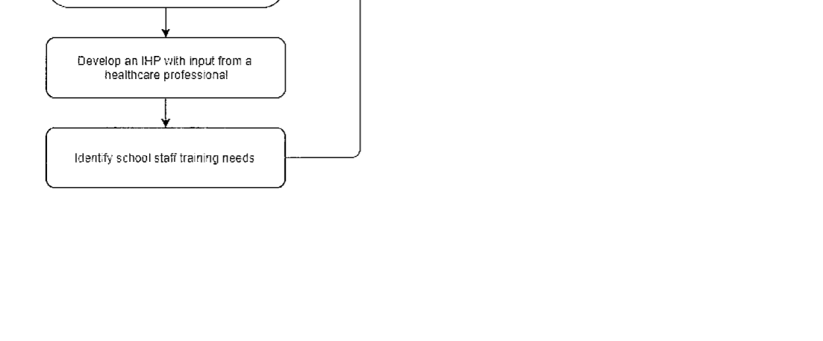
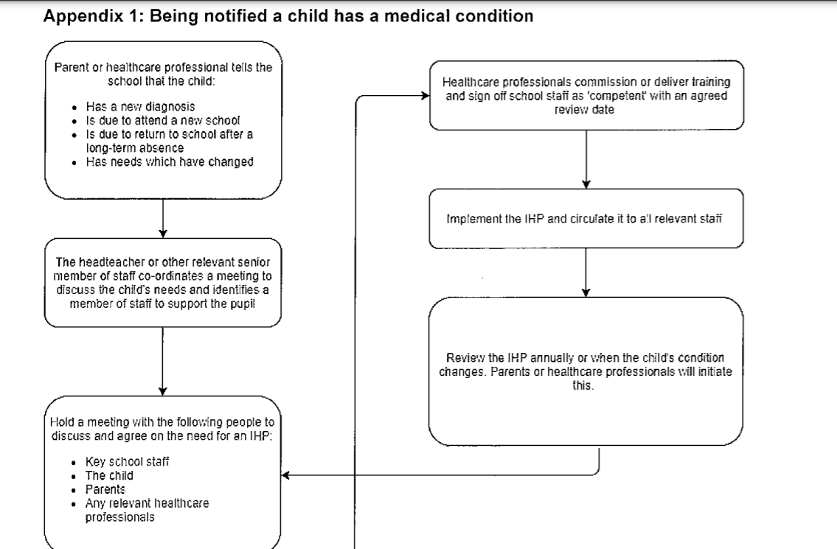
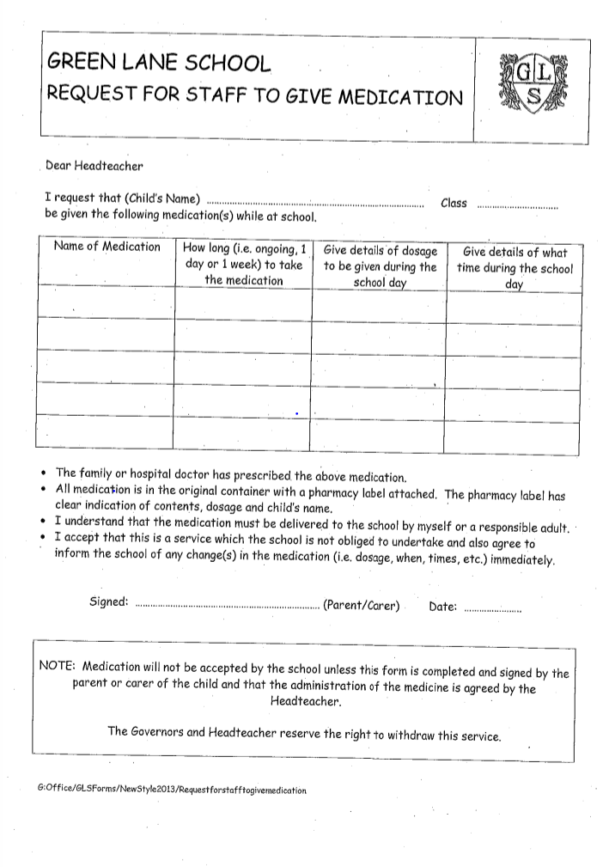
Appendix 2 – Permission Form for Medication Administration

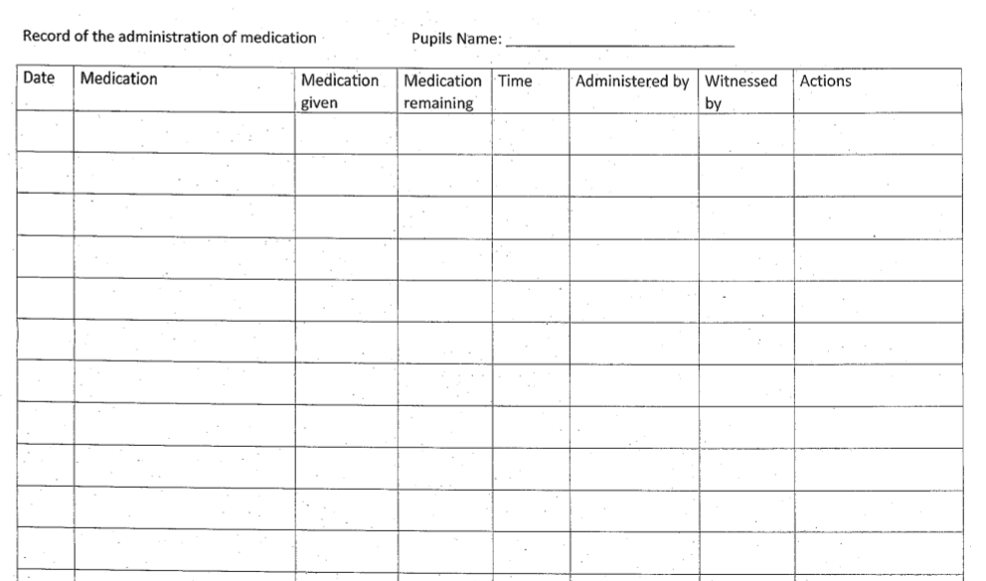
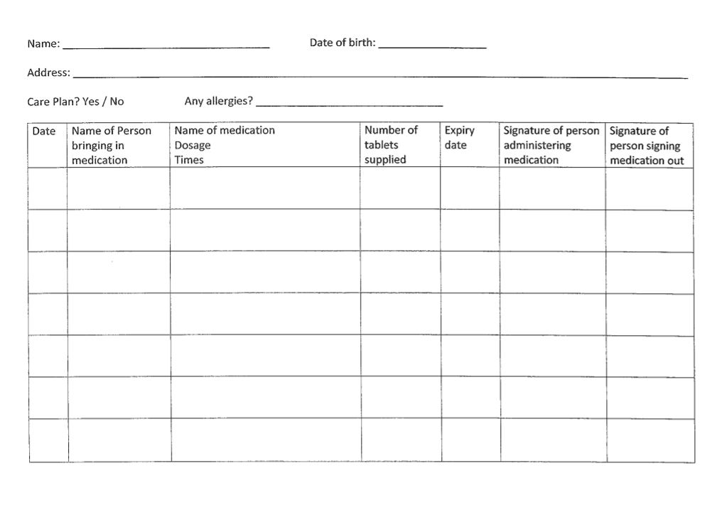
Appendix 3 – Administering Medication Log
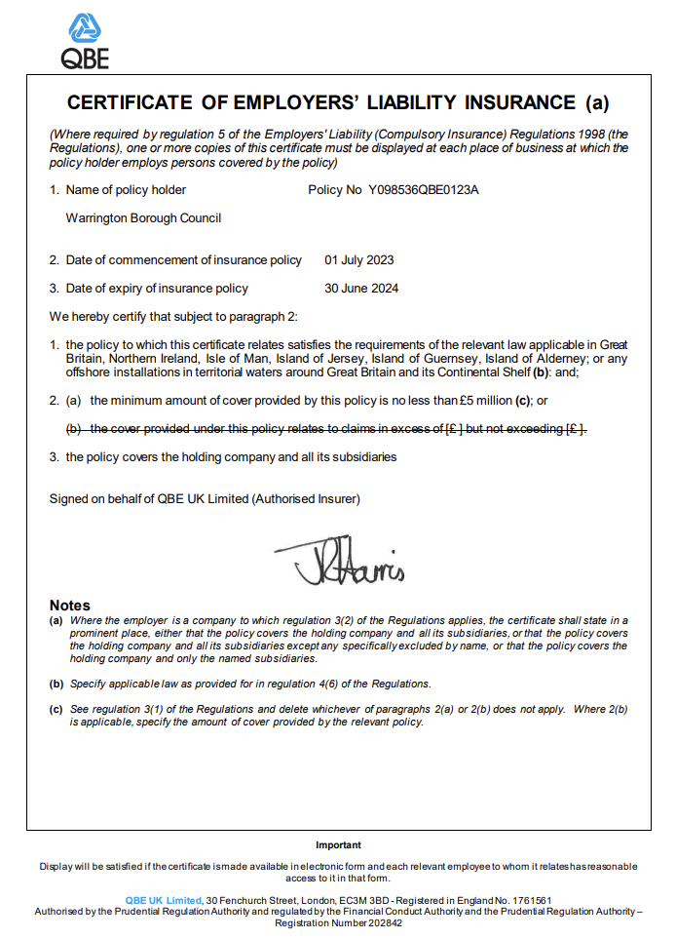
Appendix 4 – Liability and Indemnity Cover

