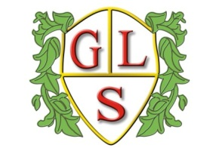
Class P3 Topics Autumn 2020

Science
Earth and Space
Properties and changes of materials - Magnets

History
The Viking invasion of Britain

Geography
Capital cities and counties in the UK

ICT
E-Safety
Multimedia: Sound and Music; Presentation & Algorithms and Programming

Spanish
Numbers and greetings
Spanish Christmas and fiestas; comparing with Argentinian celebrations

RE
Christianity
Celebrations – Christmas

Art
Exploring Drawing
Spanish Tiles

Design Technology
Structures
Basic Food Hygiene and Winter Warmers

PSHE
Families and Health

PE
Fitness Training
Inclusive Sports

