

Green Lane School

Asbestos Management Plan

April 2020

Template Reviewed:

VERSION:

3
DOCUMENT CONTROL

Record of Amendments
DATE | AMENDMENT  REFERENCE | VERSION | PAGES | AMENDMENT  ACTIONED BY
Nov 2013 | Written | 1 | 15 | D Watson
Sept 2015 | Template Reviewed - updated emergency procedures flowchart | 2 | 15 | D Watson
August 2017 | Template Reviewed – updated WBC logo | 3 | 18 | J Howard

Contact Department | Email | Telephone ext.
Community Safety and Resilience Team  Health & Safety | Health&safety@warrington.gov.uk | 01925 442174 or 442169

Target audience
All WBC staff | Y | OTHERS

Contents Page Page Number

1. | Responsible Person and Premise Details | 4
2. | Introduction | 4
3. | Responsibilities | 5
4. | Drawings / Plan (Location of Asbestos) | 6
5. | Asbestos Risk Register | 7
6. | Asbestos Containing Material Condition Inspection | 8
7. | Asbestos Action Plan | 9
8. | Communication | 10
9. | Risk Assessment | 14
10. | Emergency Procedures | 15
11. | Training Records | 18
12. | Annual Review | 18

Note
This Asbestos Management Plan must be adapted by Directorates and Schools to include relevant information relating to their premise and their activities.

1. Responsible Person and Premise Details

Responsible Person Paul King - Headteacher
Deputy and (Job Title) Stephen Dodd – Maintenance Officer.
Premise Green Lane School
Address Woolston Learning Village
Holes Lane
Woolston
Warrington
WA1 4LS
Date April 2020
List Relevant Surveys

2. Introduction

Asbestos is a microscopic mineral fibre that is so small that it can’t be seen with the naked eye. Once disturbed, fibres can remain in the air for hours. If fibres are inhaled, they can cause serious health hazards which might not become apparent for years.
Click here to see what asbestos may looks like.

Asbestos should only be disturbed or maintained by specialist personnel working under strictly controlled conditions. Further information regarding maintenance or removal can be obtained from Building Services on Tel: 443506.

The Responsible Person has a ‘duty to manage’ the premise in respect of any asbestos it may contain. This requires knowing what asbestos containing materials (ACMs) may be present, their location and condition. The simplest way to do this is to have a survey undertaken by a qualified asbestos surveyor. This can be sourced by Building Services, for further details contact Tel: 442568.

The contents of your survey can then be used to produce the management plan. This should include regular checking of the condition of the ACMs and controlling any building or repair works to ensure this is not disturbed, except by specialists under controlled circumstances.

By completing the attached management plan will ensure that a consistent approach to Asbestos Management is being followed in all Council Buildings and the Warrington Family of Schools.

It is important that this document is read and completed in line with the Standard Operating Procedure SOP03 - The Management of the Risk from Asbestos in Civic Buildings and Schools.

3. Responsibilities
This duty requires the Responsible Person (designated through the duty holder) to take the following key actions:

To ensure anyone who enters the premise (to include employees, pupils, contractors, service users and visitors, etc.) do not disturb ACMs and are safe from potential asbestos exposure.

Key point: Take note of any previous asbestos surveys undertaken, but don't rely that all asbestos materials within the building as being identified within them. (There is the possibility that asbestos containing materials located on site may not have been detected during the survey.)

Duty Holders for the Premise
Paul King - Headteacher
Responsible for the buildings and Health, Safety and Welfare matters.

Head Teacher
Responsible for monitoring and ensuring work is undertaken in accordance with the Control of Asbestos Regulations 2012.

Insert Name: Paul King.
Job Title:Headteacher

For the provision of selecting a competent contractor to undertake work in accordance with statutory provision, to include:- Control of Asbestos Regulation 2012, CDM 2015, Management of Health and Safety at Work Regulations 1999, HASAWA 1974, COSHH 2002, etc. Also for ensuring that appropriate information is shared with their selected contractor prior to any intrusive works being undertaken.

Responsible Person
Day to day management of ACM’s in their premise / building(s) to ensure Asbestos Management Plan and register is undertaken, maintained and communicated and that ACM’s identified are managed and controlled and any work undertaken on the premise is undertaken in accordance with the Control of Asbestos Regulations 2012.

Insert Name : Stephen Dodd
Job Title: Maintenance Officer

.
WBC Building Services

Via Mears

Specialist Approved Licensed Asbestos Contractor:

Mears

Notification of Licenced Work and Notifiable Non Licensed Work to:
The Health and Safety Executive

Appointed Person
Insert responsibilities
Insert Name: …………………………………
Job Title: ……………………………………………

4. Drawings / Plan (location of asbestos)
Insert Drawing Plan (marking location of identified or presumed asbestos) click here to see the HSE example of site plan

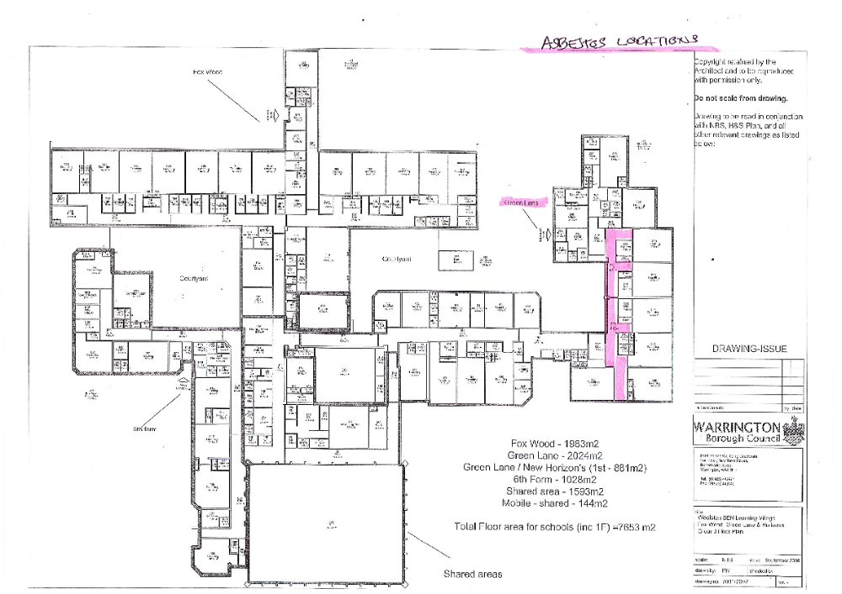
5. Asbestos Risk Register
Location  Plan ID | Where on site | Product | How Much? | Surface Coating | Condition | How easy is access? | Asbestos Type | Comment | Material Score | Priority Score | Risk Rating  H/M/L
GLS – D Block | D block D47 ground floor corridor under staircase | Dust and debris | N/A | Debris | N/A | N/A | NAD |  | 0 | 0 | None
GLS – D Block | D block D47 ground floor corridor – | Blue floor tiles beneath modern fitted vinyl sheet flooring Floor tiles and bitumen | N/A | Floor tiles and bitumen | N/A | N/A | NAD |  | 0 | 0 | None
GLS – D Block | D block D04 Reception ground floor corridor – | Mastic sealant to ventilation ducting above ceiling tiles throughout level. | N/a | Mastic | N/A | N/A | NAD |  | 0 | 0 | None
GLS – D Block | D block ground floor corridor D46 | General dust and debris to underside of staircase | N/A | Debris | N/A | N/A | NAD |  | 0 | 0 | None
GLS – D Block | D block ground floor corridor D46 | Grey floor tiles beneath modern fitted vinyl sheet flooring | 1square m | Floor tiles and bitumen | Low damage | Moderate | Chrysotile |  | 1 | 1 | Very low risk
GLS – D Block | D block first floor corridor Redundant area | Bitumen felt visible to edge on 2 No. skylights | N/A | Felt | N/A | N/A | NAD |  | 0 | 0 | None
GLS – D | D block first floor corridor Redundant area | Exposed boarding clad to structural steel beam | N/A | Boarding | N/A | N/A | NAD | Material is modern and has been sampled for confirmation | 0 | 0 | None
GLS – D Block | D block ground floor corridor D44 – Cleaners Store | Bitumen wrap to redundant pipe to ceiling void above ceiling tiles | N/A | Bitumen | N/A | N/A | NAD |  | 0 | 0 | None
GLS – C Block | C block ground floor Headteacher C02 | Boarding remnants to wood batons above ceiling tiles | N/A | Boarding | N/A | N/A | NAD |  | 0 | 0 | None
GLS – C Block | C block ground floor Headteacher C01 | Boarding remnants to wood batons above ceiling tiles | N/A | Boarding | N/A | N/A | NAD |  | 0 | 0 | None
GLS – C Block | C block ground floor Classroom C26 | Boarding remnants to wood batons above ceiling tiles | N/A | Boarding | N/A | N/A | NAD |  | 0 | 0 | None
GLS – C Block | C block ground floor  Classroom C26 | Boarding remnants to wood batons above ceiling tiles | N/A | Boarding | N/A | N/A | NAD |  | 0 | 0 | None

Location  Plan ID | Where on site | Product | How Much? | Surface Coating | Condition | How easy is access? | Asbestos Type | Comment | Material Score | Priority Score | Risk Rating  H/M/L
GLS – C Block | C block ground floor  Sensory Room C24 | Boarding remnants to wood batons above ceiling tiles | N/A | Boarding | N/A | N/A | NAD |  | 0 | 0 | None
GLS – C Block | C block ground floor  Sensory Room C24 | Cement mixed with straw forming roof above ceiling tiles extending above C18 to C26 | N/A | Cement | N/A | N/A | NAD |  | 0 | 0 | None
GLS – F Block | F block ground floor  Hall F07 | Boarding to ceiling | N/A | Boarding | N/A | N/A | NAD |  | 0 | 0 | None
GLS – F Block | F block ground floor  Hall F07 | Boarding to ceiling | N/A | Boarding | N/A | N/A | NAD |  | 0 | 0 | None
GLS – D Block | D block first floor Food Tech area D1.09 | Mastic sealant to ventilation ducting above ceiling tiles throughout level. | N/A | Mastic | N/A | N/A | NAD |  | 0 | 0 | None
GLS Sports Hall | Sports Hall | Boarding with panels to expansion joints | N/A | Boarding | N/A | N/A | NAD |  | 0 | 0 | None

Location  Plan ID | Where on site | Product | How Much? | Surface Coating | Condition | How easy is access? | Asbestos Type | Comment | Material Score | Priority Score | Risk Rating  H/M/L
GLS External Roof  019 | External roof | Roofing felt | N/A | Roofing felt | N/A | N/A | NAD |  | 0 | 0 | None
GLS External Roof  020 | External roof | Roofing felt | N/A | Roofing felt | N/A | N/A | NAD |  | 0 | 0 | None
GLS External Roof  021 | External roof | Bitumen coating to sports hall roof | N/A | Bitumen | N/A | N/A | NAD |  | 0 | 0 | None
GLS External Roof  022 | External roof | Old mastic sealant to original skylights of first floor roof | 35 square m | Mastic | Low damage | Difficult | Chrysotile |  | 1 | 1 | Very low risk
GLS External Roof  023 | External roof | Roofing felt to first floor roof | N/A | Roofing felt | N/A | N/A | NAD |  | 0 | 0 | None
GLS – F Block | F block ground floor  Reprographics room F06 | Boarding to ceiling above ceiling tiles | N/A | Boarding | N/A | N/A | NAD |  | 0 | 0 | None

Location  Plan ID | Where on site | Product | How Much? | Surface Coating | Condition | How easy is access? | Asbestos Type | Comment | Material Score | Priority Score | Risk Rating  H/M/L
GLS  E Block | E Block ground floor  Room E15 | Mastic sealant to ventilation ducting above ceiling tiles throughout level. | N/A | Mastic | N/A | N/A | NAD |  | 0 | 0 | None
Sixth Form College | A Block – Ground Floor Staff Room A05 | Boarding to ceiling above ceiling tiles extending above rooms | N/A | Boarding | N/A | N/A | NAD |  | 0 | 0 | None
Sixth Form College | A Block – Ground Floor Hygiene Room A23 | Boarding to ceiling above ceiling tiles extending above rooms | N/A | Boarding | N/A | N/A | NAD |  | 0 | 0 | None
Sixth Form College | A Block – Ground Floor Classroom A09 | Boarding to ceiling above ceiling tiles extending above rooms A06 to A08 | N/A | Boarding | N/A | N/A | NAD |  | 0 | 0 | None
Sixth Form College | A Block – Ground Floor Classroom A12 | Boarding to ceiling above ceiling tiles extending above rooms A11 to A12 | N/A | Boarding | N/A | N/A | NAD |  | 0 | 0 | None

Location  Plan ID | Where on site | Product | How Much? | Surface Coating | Condition | How easy is access? | Asbestos Type | Comment | Material Score | Priority Score | Risk Rating  H/M/L
Sixth Form College | A Block – Ground Floor Quiet Room A16 | Boarding to ceiling above ceiling tiles extending above rooms A13 to A19 | N/A | Boarding | N/A | N/A | NAD |  | 0 | 0 | None
Sixth Form College | A Block – Ground Floor Classroom A21 | Boarding to ceiling above ceiling tiles | N/A | Boarding | N/A | N/A | NAD |  | 0 | 0 | None
Sixth Form College | A Block – Ground Floor Male W.C. A27 | Boarding to ceiling above ceiling tiles extending above rooms A26 to A29 | N/A | Boarding | N/A | N/A | NAD |  | 0 | 0 | None
Sixth Form College | A Block – Ground Floor Classroom A30 | Boarding to ceiling above ceiling tiles | N/A | Boarding | N/A | N/A | NAD |  | 0 | 0 | None

Completed or reviewed by: Paul King / Stephen Dodd Date: 31st March 2020

6. Asbestos Containing Material Condition Inspection

Good Practice Guidance:
- Take photographs of ACMs for each inspection and store for future reference
- Compare previous photographs with current condition to determine whether there has been any deterioration since the last inspection
- Where the condition is determined as either Medium or High, the emergency procedure needs to be instigated
Condition Key:

Good: No visible damage; review at next inspection date | Low: A few scratches or surface marks but no signs of asbestos debris; review at next inspection date for further signs of deterioration
Medium: Significant breakage of materials or several small areas where material has been damaged; encapsulation works likely - follow the emergency procedure | High: Visible asbestos debris; environmental clean and encapsulation works likely – follow the emergency procedure

Location Plan ID | Where on Site | Asbestos Type | (delete as applicable)  CONDITION | INSPECTION COMMENTS
GLS – D Block | D block ground floor corridor D46 | Chrysotile | Low damage | Very low risk. Satisfactory condition – inspect periodically.
GLS – External roof | First floor skylight has old mastic sealant. | Chrysotile | Low damage | Very low risk. Satisfactory condition – inspect periodically.

Completed by: Paul King / Stephen Dodd Date: 31st March 2020

7. Asbestos Action Plan

Where | Product | Condition | Action taken | How often | By whom | Annual Inspection date | Inspected + signed by
GLS - D block ground floor corridor D46 | Floor tiles and bitumen -Chysotile | Low damage | Maintenance Officer to carry out annual checks. | Annually | Peter Turner | February each year | 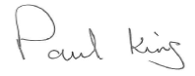  31st March 2020
GLS – External roof | First floor skylight has old mastic sealant.-  Chrysotile | Low damage | Maintenance Officer to carry out annual checks. | Annually | Peter Turner | February each year | 31st March 2020

Completed or reviewed by: Paul King / Stephen Dodd Date: 31st March 2020

8. Communication

Asbestos location

Staff
All relevant staff will be provided with relevant information on:
- Types and location of ACMs (via this Asbestos Register and Plan)
- The visual means of identifying ACM’s (labels/colour coding)
- How to avoid risks from asbestos (e.g. not disturbing) any prohibited areas.
- How to report concerns about ACMs (e.g. to the Responsible Person)
- All new staff, trough the Induction process, will be introduced to the Asbestos Management Plan.
- A safe system of working will be produced.
- Any concerns from staff will be reported to the Maintenance Officer or Headteacher
- A monthly check and an annual evaluation will be made around ACMs and these reports will be available for staff.
- The Headteacher and Maintenance Officer will receive regular training around asbestos.
- The safe system of working will identify and clarify what staff should or should not do around asbestos.

Maintenance & Contractors
All Maintenance workers and contractors will be provided with relevant information on:
- The whereabouts and stability af ACMs via the school plan and the Asbestos Register and Management Plan.
- That monthly asbestos checks are carried out monthly and are dated and signed.
- Before any internal work is carried out in the school contractors are made aware of the Asbestos Management Plan and the location of ACMs.
- Where suspicion of ACMs is given we will request an appropriate survey before work is undertaken.

Other
Any relevant visitors, groups or clubs will be provided with relevant information on:

Communications

Contractor Review of Asbestos Register/Survey

This sheet should be signed by all those carrying out repair/maintenance work on the premises that will involve disturbing the fabric of the premises.

Persons signing this sheet are signing to say that they have seen the Asbestos Register and Management Plan and any relevant Surveys and checked that there is no known or presumed asbestos in the area in which they are working.

Date | Company | Details of Work | Print Name | Signature

Where an asbestos containing material is suspected, no work must be carried out until the relevant procedures have been put in place to manage the risks of exposure. This may require sampling to detect the presence of ACM’s or a Refurbishment Survey if multiple materials are to be disturbed, If ACM’s are detected removal may be required prior to any work being undertaken.

Communication

Staff review of Asbestos Register Management Plan and Safe System of Work.

The following members of staff have received information relating to asbestos risks within the premise

Enter Premise Green Lane School

Date | Name | Job Title | Signature
31/03/2020 | Joanne Mullineux | Deputy Headteacher
 | Mike King | Teacher
 | Lynne Ledgard | Teacher
 | Sam Bani | Teacher
 | Mel Andrews | Teacher
 | Julie Naylor | Teacher
 | Kerryjane White | Teacher
 | Sarah Delaney | Teacher
 | Chrissy Skermer | Teacher
 | Sarah van Rooy | Teacher
 | Leonie McLoughlin | Teacher
 | Joanna Barnes | Teacher
 | Hannah Williams | Teacher
 | Angela Davey | Teacher
 | Danielle Taylor | Teacher
 | Luke Bennett | Teacher
 | Bridgeen Whittle | Teacher
 | Emma Blinco | Teacher
 | Teri King | Teacher
 | Clare Friend | Teacher
 | Alison Wright | Teacher (supply)
 | Vicky Hunt | Teacher (supply)
 | Vicky Rogers | Teacher (supply)
 | Jackie Price | HLTA
 | Chris Daniels | TA
 | Joy de Schimdt | TA
 | Manon Wright | TA
 | Karen Dickson | TA
 | Carly Dumican | TA
 | Julie Barker | TA
 | Andrew Norton | TA
 | Hayley Chadwick | TA
 | Liz Cronie | TA
 | Kerry Lothrop | TA
 | Jenny Davies | TA (supply)
 | Lian White | TA
 | Joanne Milnes | TA
 | Karen Bate | TA
 | Gemma Philips | TA (supply)
 | Gemma Clark | TA (supply)
 | Belinda Williams | TA
 | Lesley Fernyhough | TA
 | Emma Borque | TA
 | Emma Burton | HLTA
 | Julie Hooper | TA
 | Mike Gaskell | TA
 | Sonia Bhalia | TA
 | Lynda Buxton | TA (supply)
 | Tracey Dey | TA
 | Sue Tahroui | TA
 | Sara Egan | TA
 | Sue Clarke | TA
 | Clare Ball | TA
 | Bern Forshaw | TA
 | Beth Laws | TA
 | Jo Farrington | TA
 | Jaymee Oddie | TA
 | Paul McLoughlin | TA
 | Becky Hockenhull | TA
 | Carla Moorcroft | TA
 | Sue Jones | Office Manager
 | Chris Beeton | Finance Assistant
 | Kate | Office Assistant
 | Amanda Harrison | Receptionist
 | Gill Woosey | Cleaner
 | Carol Eagland | MDA
 | Heidi | MDA
 | Karen Smith | MDA
 | Vicky Edwards | Cook
 | Chris Gingell | Assistant cook
 | Debi Ost | Occupational Therapist

Visitors, Groups or Clubs, Organisers review of Asbestos Register Management Plan and Safe System of Work.
The following Visitors or organisers of clubs or groups have received information relating to the management of asbestos of this premise.
Date | Club or Group | Organiser name | Signature
1st April 2020 | School Youth Club | Claire Perrins
1st April 2020 | Wolves Foundation Football | Craig Thomason

9. Risk Assessment

Directorate: Children’s Services | Location: Green Lane School |  | Date of Assessment: |  | Review Date: 01/04/2020
Name of Assessor:  Paul King  Stephen Dodd |  | Position of Assessor:  Headteacher  Maintenance Officer |  | Signatures:

Title and Ref. Number of Task – Asbestos Containing Materials (ACMs)

Hazard | Persons at Risk | Potential Harm | Existing Control Measures | Risk Rating  (H/M/L) | Further Action Required | Residual Risk (H/M/L)
GLS - D block ground floor corridor D46 - Floor tiles and bitumen -Chysotile | Pupil, Staff, visitors and workmen | Exposure to Asbestos. | Potential risk is very low. ACMs have been identified and will be monitored annually. Moderately difficult to access. | L | Ensure monitoring sheets are signed and dated. | L
GLS external roof. First floor skylight has old mastic sealant.-  Chrysotile | Workmen – caretaker going on roof | Exposure to Asbestos. | Potential risk is very low. ACMs have been identified and will be monitored annually. They are on the roof and are difficult to access | L | Ensure monitoring sheets are signed and dated. | L

10. Emergency Procedures (Asbestos Containing Materials)
If suspected ACM’s are discovered during work or become damaged by any other physical method, the risk assessment for work undertaken and the asbestos register for ACM’s should be readily available and all relevant personnel should be provided with information, instruction and training in the emergency procedures

- If you suspect ACM’s - STOP WORK IMMEDIATELY inform the Responsible Person who will commission Building Services or the designated licensed asbestos contractor to deal with the incident immediately and to make safe. The Risk and Resilience Team must be informed if ACM’s may have been disturbed along with details of the incident.
- Isolate the area i.e. shut doors and windows, turnoff ventilation systems and fans if possible
- Post warning notices informing all staff to keep away
- DO NOT ALLOW any access into the area until it is made safe by an approved contractor
- Check register to establish whether ACM’s are present
- In circumstances where the register is not specific engage with Building Services / alternative competent licensed contractor immediately to sample the area
- If the analysis confirms that the material is none asbestos then work can continue
- If asbestos is discovered and confirmed then the contracted licensed asbestos removal company should be called to remove / repair the asbestos / if non licensed worked is required then this should be determined before any work is undertaken and all work should be in accordance with current legislation before the room can be re-occupied (possibly with air clearance certification the asbestos contractor will provide guidance on what would be required).
- The Responsible Person must ensure that ACM’s are identified and managed before any planned maintenance is undertaken.

Emergency Procedures (Asbestos Containing Materials)
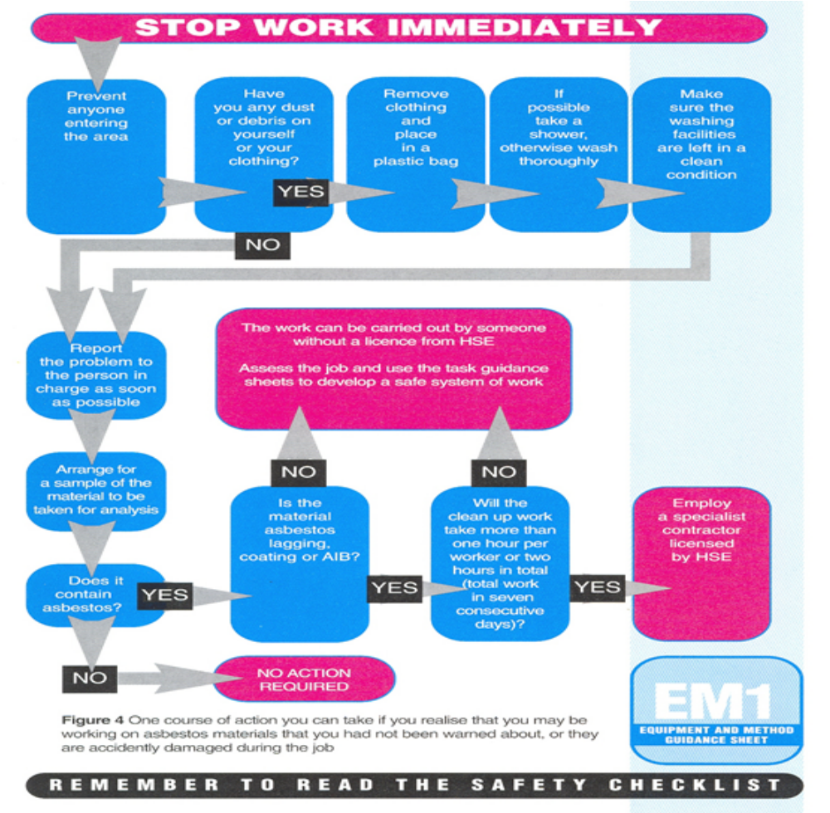

Emergency Procedures (Asbestos Containing Materials)

Follow the chart on page 14 and carry out a risk assessment to decide who must do the work, you may need a licensed contractor, minimise the spread of contamination to other areas to keep exposures as low as possible, clean up the contamination using an approved contractor in line with legislation.

No Council employee will be engaged to remove any ACM’s from any council building. If licensed work is required then only licensed asbestos removal contractors may undertake this work and for non-licensed work this may be undertaken by approved contractors in accordance with the regulations, ensure appropriate notifications are made to the HSE.

DO NOT
Allow any work to continue on any materials which are suspected of containing asbestos, if suspected ACM’s have been damaged or disturbed during work (s) in progress, the materials should be:

- left in-situ,
- the work (s) suspended
- the area isolated pending further investigation

DO NOT
Attempt to take a sample, the actual act of sampling asbestos can expose the sampler to dangerous levels of asbestos fibres and the surrounding areas could also become contaminated. Samples can only be taken by a UKAS accredited laboratory.

Should the material be found to contain asbestos, a scope of work must be agreed with the environmental analyst, asbestos removal contractor and contract administrator to repair or remove the material as soon as possible.

If licensed work is required the removal contractor will submit notification to the HSE where appropriate and the area should remain closed until the asbestos works are complete and the environmental analyst has issued the relevant certificate of reoccupation. It may be necessary to programme further asbestos removal works.

COPIES OF ALL REPORTS FROM SAMPLING TO REMOVAL MUST BE RETAINED IN THE ASBESTOS MANAGEMENT FILE.
11. Training Records – Asbestos Management / Asbestos Awareness
Name | Course Name | Course Provider | Date of Training | Signature
Paul King | Asbestos Management Training | WBC | 19/06/2018
Stephen Dodd | Asbestos Management Training | WBC | 15 November 2016

12 Annual Review
This asbestos management plan must be reviewed on an annual basis to ensure risk registers, risk assessments, training and the action plan are kept up to date.
Any changes to the management of asbestos in Civic Buildings and Community Schools should be communicated to all relevant parties identified within the Communication Section.

Emergency Procedures (Asbestos Containing Materials) flowchart taken from HSE EM1
Discovered or damaged materials that could contain asbestos? Stop work immediately, and

Keep everyone else out of the area

Is there dust or debris on clothing?

A lot e.g. contaminated clothes, hair, footwear.

Stay Put.

Wipe down with damp rags.

A little, e.g. dust on sleeve, on shoes.

Get help all put on RPE.

Put contaminated clothes, towels etc. in a plastic bag for a specialist laundry.
Leave any washing facilities clean.

Wipe down with damp rags.

Undress, shower and wash hair.

Dispose of rags as asbestos waste

Keep a record of the event
Report the event using the WBC accident / incident online reporting system

Report the problem to the responsible person as soon as possible

Put up warning signs ‘possible asbestos contamination / access prohibited do not enter’

Get the material samples and analysed.

Does it contain asbestos?

No

Yes

No action required

Refer to Asbestos Management Plan, decide if the task needs an HSE –Licensed Contractor.

Contact Building Services to arrange clean up or contact own Specialist Approved Licensed Contractor

