Home Learning Activities

Maths
Go to this site:
https://www.bbc.co.uk/bitesize/dailylessons
This is brilliant! It gives you a week’s worth of maths lessons. Each one has a short video explaining what to do and then links to worksheets/games to consolidate the skill.
The idea is that you choose a year group. For P1 maths I would recommend starting with Year 3 or Year 4- however there is no reason why you can’t challenge yourself by trying Year 5 or even Year 6.
At the time of writing this, The current Year three lessons are about place value and the current Year 4 lessons are about rounding.
When I ring on Tuesday 28th, please let me know if you have tried them (although no pressure to do so) and if so, did you find it any good- I’ve been doing some of the Year 1 lessons with my 5-year-old at home!

English  Similar to maths. Visit:  https://www.bbc.co.uk/bitesize/dailylessons  Choose a Year group- For P1 I would recommend starting at Year 2- again, no reason why you can’t go on higher year groups if you feel it is too easy of course!  Currently there are some lessons about writing questions. It could be that one lesson may take up to 3 days. Once again, I’d love to hear how you have found this.  If it is no good, then I’ll try something else next week. |  |  | English  Keep a daily diary of your time at home. What did you do today?  (continue from last week- this is an ongoing task) | English  Read some of your book  (continue from last week- ongoing task)
PSHE  Go online and see if you can find out about ways of helping the environment | PSHE  Make a list of all the ways of helping the environment that you have found out about. | PSHE  Use your list to create a poster about various different ways you can protect the environment. | PSHE  Telephone/facetime a friend and have a chat.  (keep as a weekly task) | PSHE  Play a game with someone in your house.  (ongoing task)
PE  Try the Joe Wicks PE lesson- I did this the other day and am ashamed to say that I had to change my T-shirt as I was sweating so much! | PE  Go for a walk/run/walk the dog. Can you find a different route to one you have tried before? | PE  Another walking activity- can you find at least 5 interesting things on your walk/run?  You could collect them in a bag or take a picture of them if you would rather not touch them. | PE  Do a circuit – 20 star jumps, 10 press ups, 20 tuck jumps, 30 second wall sit. Repeat 3 times.  Keep this routine from last time BUT- can you add an extra 10 reps to each exercise?  Or, if you follow a physio programme, do some of the moves from it. | PE  Lift some weights. Use real ones if you have them or if not, use tins! Do exercises you have learned!  Continue from last week- can you do more repetitions than last week?
ART  Can you do a self-portrait- it doesn’t have to be realistic it could be abstract with wonderful different colours  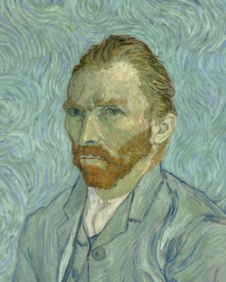 | FOOD TECH  I’ve seen some pics of some of the baking you guys have been doing- My challenge this week is who can make an amazing, delicious sandwich! | Geography  https://www.bbc.co.uk/bitesize/articles/zhtyvk7  Try this fun lesson on maps! | SCIENCE  Choose a subject to research on the BBC bitesize website  Same activity as last week- but choose a different subject | COMPUTING  Using e-safety rules, stay in touch and chat to your friends for an hour or two each day.  Continue from last week- it is important to maintain good relationships with friends.
Class: P1 Week: 6 Week Beg: 27th April

****Grown-ups- please remember, do not put yourselves under lots of pressure to try and complete everything on this sheet. Do what you feel you can. If there is one particular area of interest, then do more on that and less on the other bits. I know how busy you all are in these strange times! Stay safe!****

