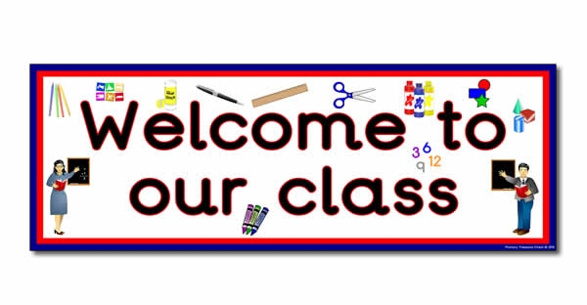

**Topics**

**Number: -** Number and place value. Addition & Subtraction, (+), subtraction (-) and equals (=) signs. Multiplication, identifying doubles. Division and fractions (halves, quarters)

**Shape:** - patterns

**Measures –** time – dates, days, months

Capacity – volume (full/empty)

**Data** – tally charts, graphs, tables

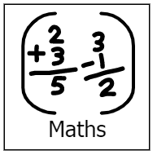

**Topics**

Persuasion

Stories from other cultures

Letters and sounds, phonics work, Guided Reading,

Handwriting.

Speech and language work.

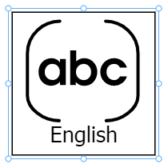

**Topics**

Programming

Multimedia art





**Topics**

Light and shadows

Life cycles

Science day – the solar system

**Topic**

Talking textiles (landscapes)

**Topic**

Compass, directions and locations



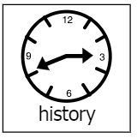

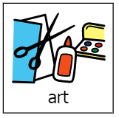

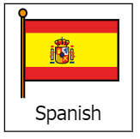

**Topics** –

Spanish food

Days of the week

**Topic**

Neil Armstrong and Tim Peak

**Topics**

Islam

The church

**Topics**

Health and fitness

Athletics

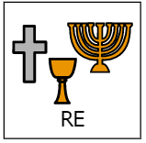

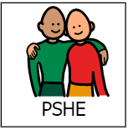

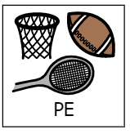

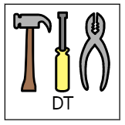

**Topic**

Different types of families

Talking about emotions

**Topic** –

Mechanisms – vehicles