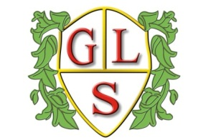
Class 6 Topics Autumn 2019

Science
How are Everyday Objects Made?

History
Would you take a Golden Ticket to the Moon?

Geography
UK and Sicily

ICT
E Safety
What is a Computer?
Multimedia: Photogrpahs/Text

Spanish
Numbers to 20
Number Games

RE
The Church

Art
Matisse

Design Technology
Where food comes from- Grains (Bread/Cakes)

PSHE
Relationships
Health and Wellbeing

PE
Games (Wolves Foundation

