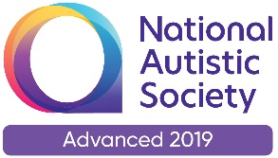 | 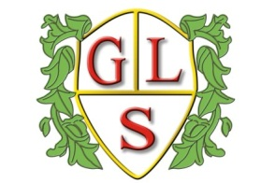 | Paul King  Headteacher  Joanne Mullineux  Deputy Headteacher

Dear Parents / Carers / Staff

The Spring Bank Holiday has been moved to Thursday 2nd June, 2022 and an additional Bank Holiday on Friday 3rd June, 2022 will see a four-day weekend to celebrate Her Majesty The Queen’s Platinum Jubilee.

The DfE have amended the number of days pupils will be required to attend school for the academic year from 195 days to 194 days, this is to accommodate the extra Bank Holiday (which falls in the school holiday). Therefore the holiday dates for 2021/22 have now been amended and there will be an additional day off on Monday 6th June, the pupils will now return on *Tuesday 7th June, 2022.

Yours sincerely
Paul King

TERM DATES – 2021/2022

Terms | Date of Opening | Date of Closing
2021
Autumn 1 | Thursday 2nd September | Friday 22nd October
Autumn 2 | Monday 1st November | Friday 17th December
2022
Spring 1 | Wednesday 5th January | Friday 18th February
Spring 2 | Monday 28th February | Friday 1st April
Summer 1 | Tuesday 19th April | Thursday 26th May
Summer 2 | *Tuesday 7th June | Wednesday 20th July

Good Friday – Friday 15th April, 2022
Easter Monday – Monday 18th April, 2022
May Day Holiday – Monday 2nd May 2022
Additional day (Queen’s Platinum Jubilee) – Monday 6th June, 2022

Teacher Training Days

Wednesday 1st September 2021
Tuesday 4th January 2022 (Taken as Twilights in Autumn Term 21),
Friday 27th May, 2022
Thursday 21st July 2022
Friday 22nd July 2022

