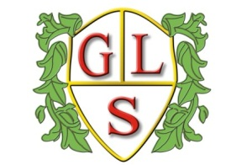
Class 6 Topics Summer 2019

Science
Natural and man-made lights
Staying alive

History
How did the unsinkable Titanic sink?

Geography
The Four Seasons

ICT
Animation
Effective Searching/Hardware

Spanish
Days of the week
Greetings - Emotions

RE
Judaism

Art
Create a Scene!

Design Technology
Mechanisms – Moving Toys

PSHE
Living in the wider world

PE
Games (Wolves)

