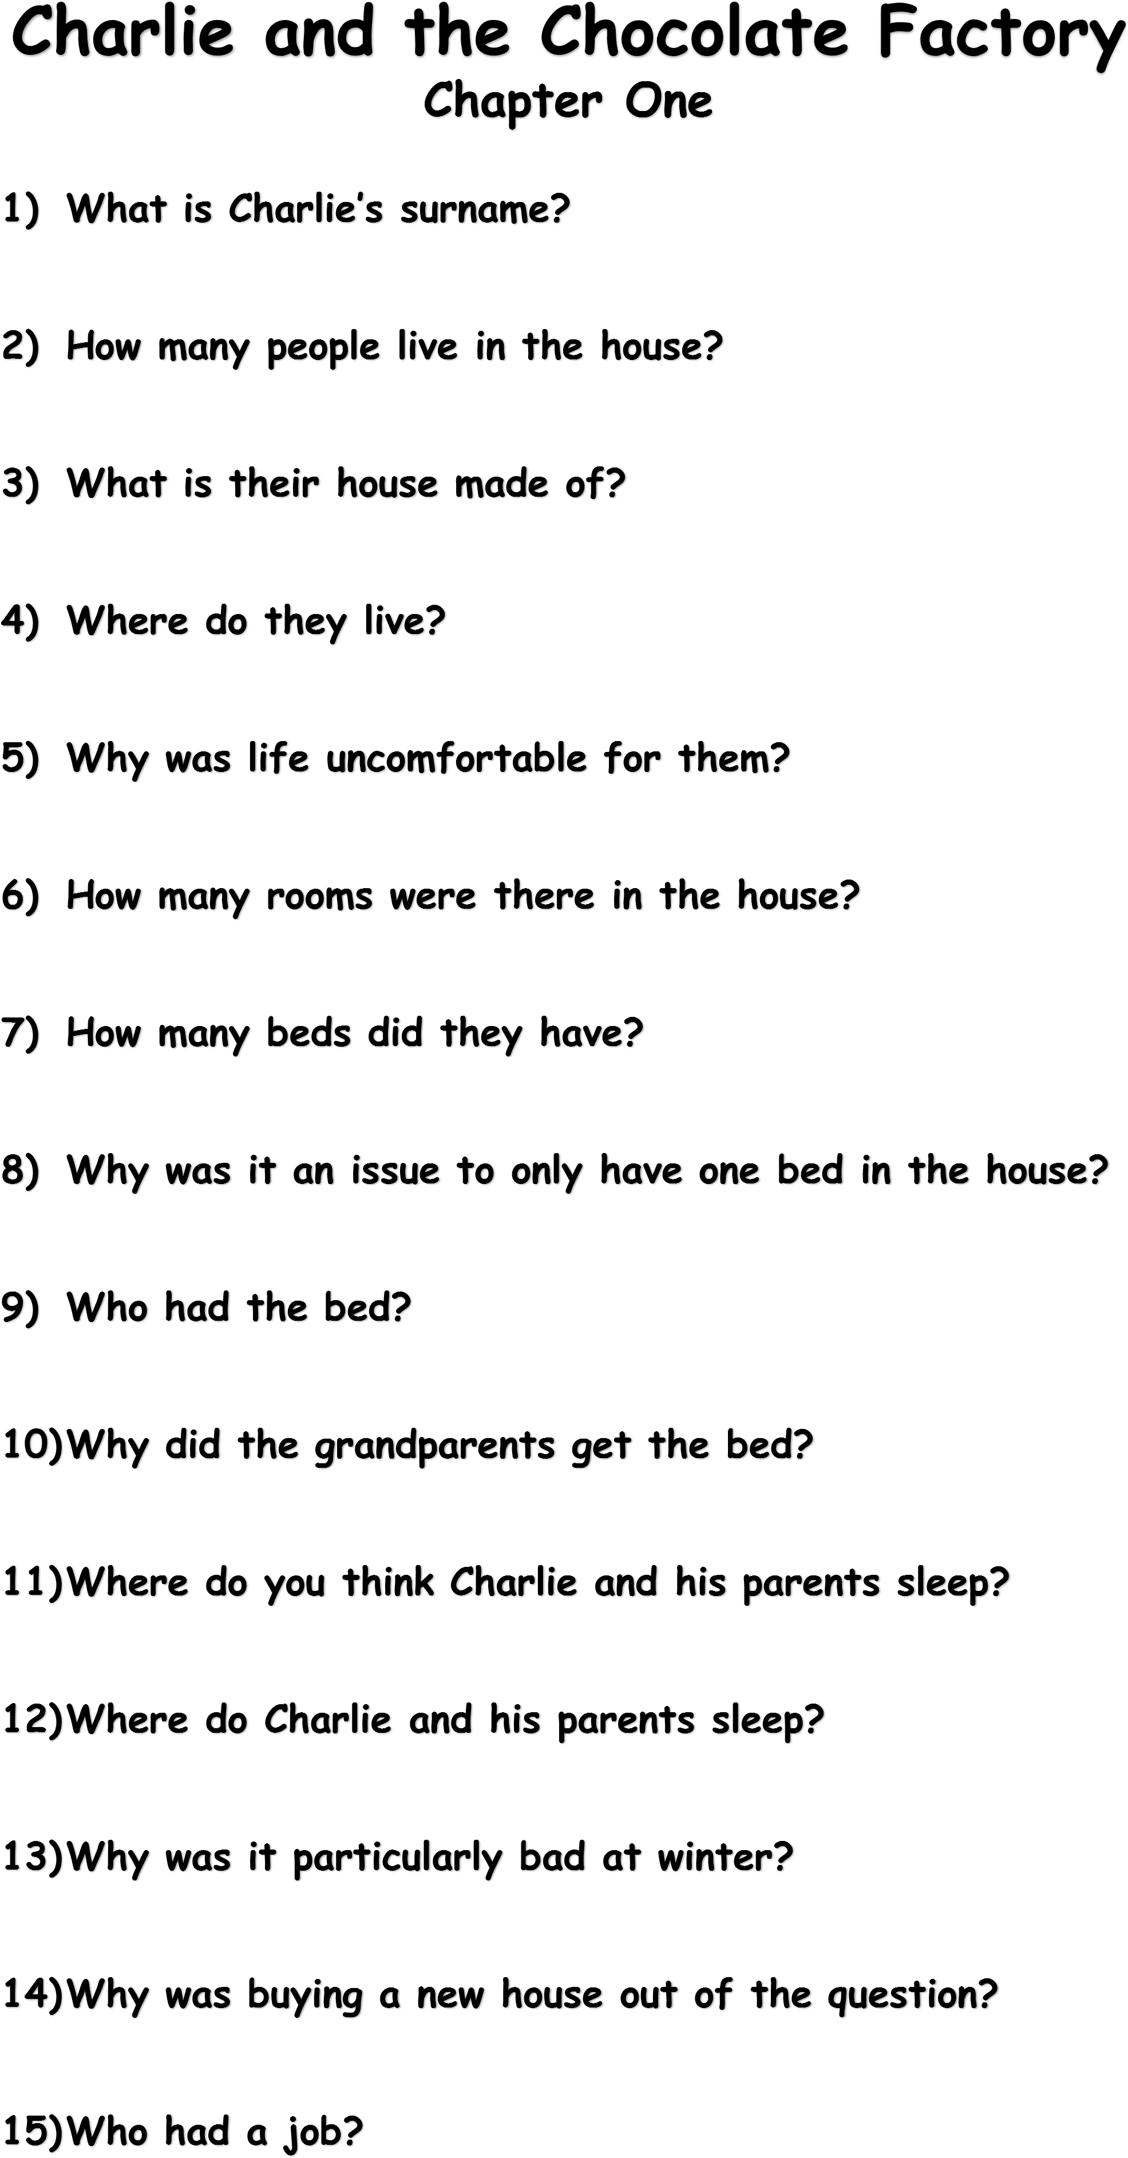
- Where did Mr Bucket work?
- How many people in the house worked?
- Why was Mr Bucket the only person in the house who worked?
- What did Mr Bucket do at the factory?
- Does he get paid more for working harder?
- Why would he work so hard if he doesn’t get extra money?
- What meals could they afford?
- Why couldn’t they buy proper food?
- Why did they look forward to Sunday?
- What happened on a Sunday?
- What was the horrible empty feeling in their tummies?
- Who gave up their food for Charlie?
- Why did they give up their food for Charlie?
- What did Charlie want more than anything?
- When would Charlie see chocolate?
- Why would Charlie’s mouth water?
- What would Charlie do when he saw chocolate?
- What was pure torture?
- What happened on Charlie’s birthday?
- When did Charlie get chocolate?
- How often was Charlie allowed chocolate?
- How long did Charlie make a bar of chocolate last?
- Where would Charlie store his chocolate?
- How did Charlie treat his chocolate?
- Why did Charlie only take tiny nibbles?
- How much was a bar of chocolate?
- What tortured Charlie more than anything?
- What was within sight of the house?
- Why wasn’t it an ordinary factory?
- Who owned the factory?
- Why was Willy Wonka special?
- Why does the factory have huge iron gates and high walls surrounding it?
- How far does the smell of chocolate carry?
- How often did Charlie walk past the factory?
- Why did Charlie walk past the factory twice a day?
- What would Charlie do when he walked past the factory?
- Why did Charlie slow down when he passed the factory?
- Summarise the events of the first chapter.

