Green Lane Music Department
Welcome to Green Lane Music Department.
Music Lessons
The children in lower school have hourly lessons every week. We sing, play instruments and have fun performing musical stories. We also listen to different styles of music and compose.
6P Exploring drums and percussion instruments
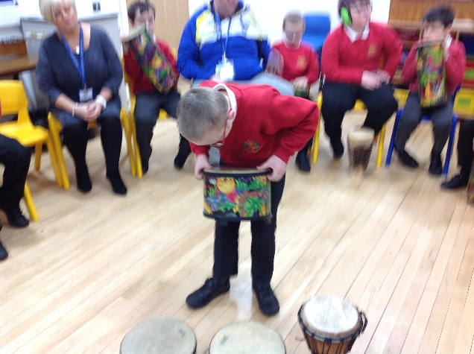
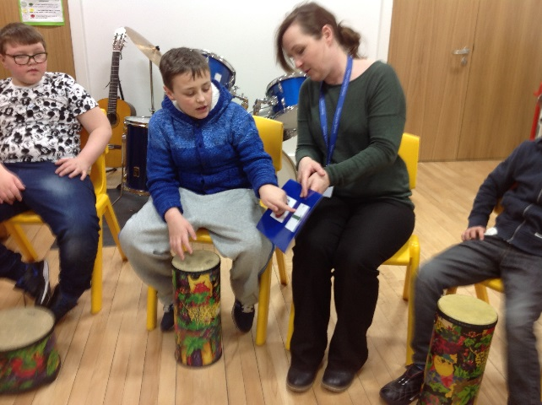
Class 6 take part in ensemble work jamming with the 12 Bar Blues
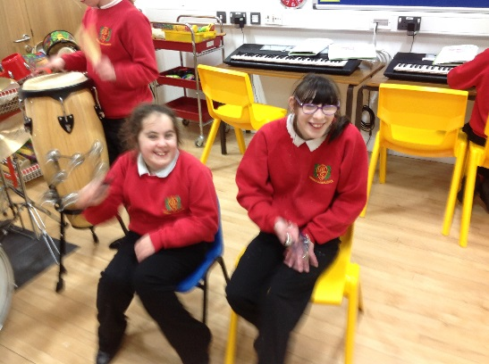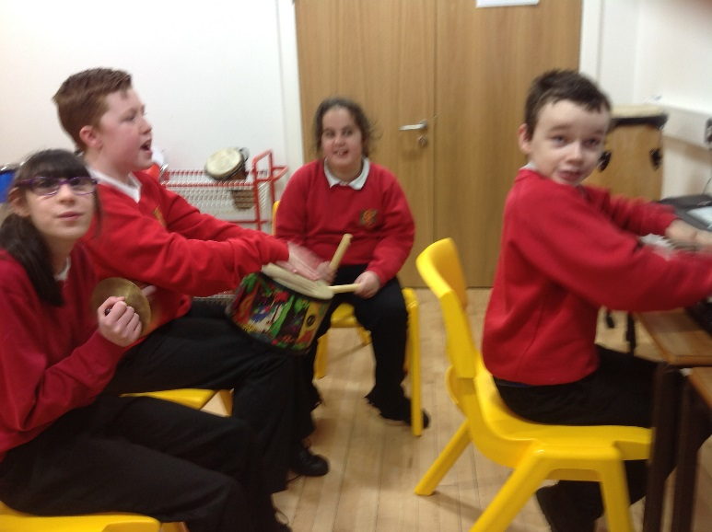

Class 5 celebrate the pantomime season with some musical theatre and role-play
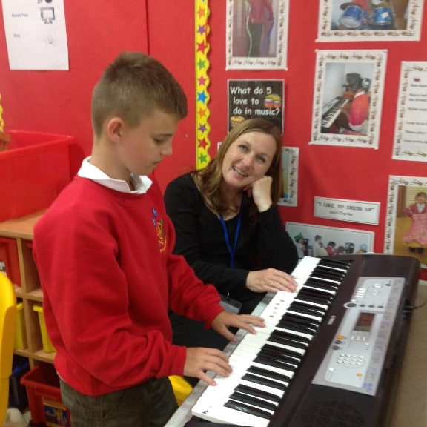
Playing the keyboard using a good technique.
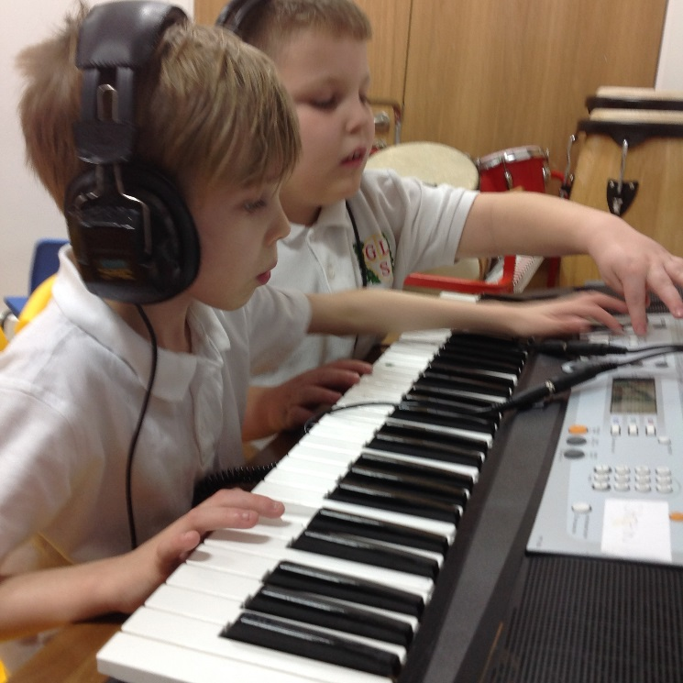
Composing together – great team work boys!

Class 6 have a jamming sessions using the 12 bar blues.

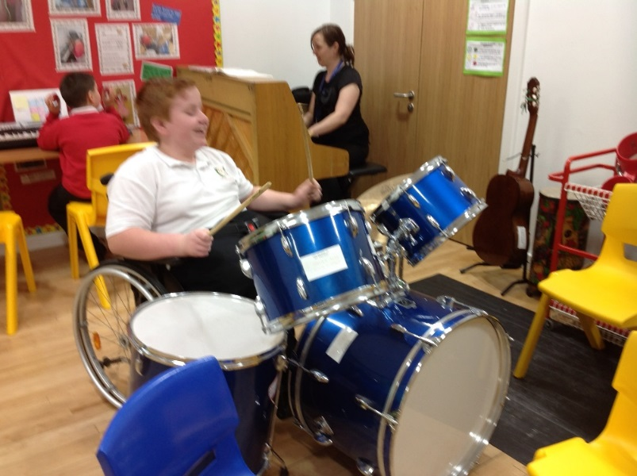
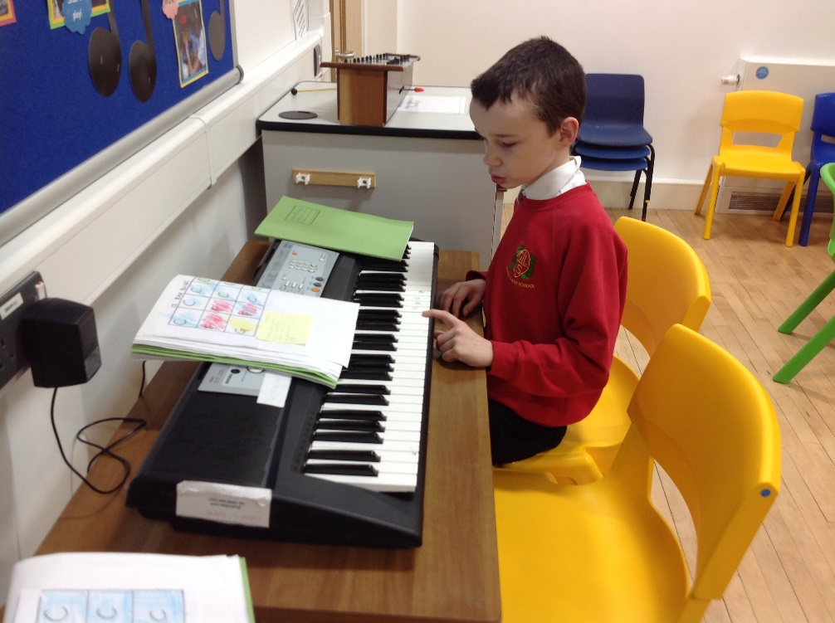

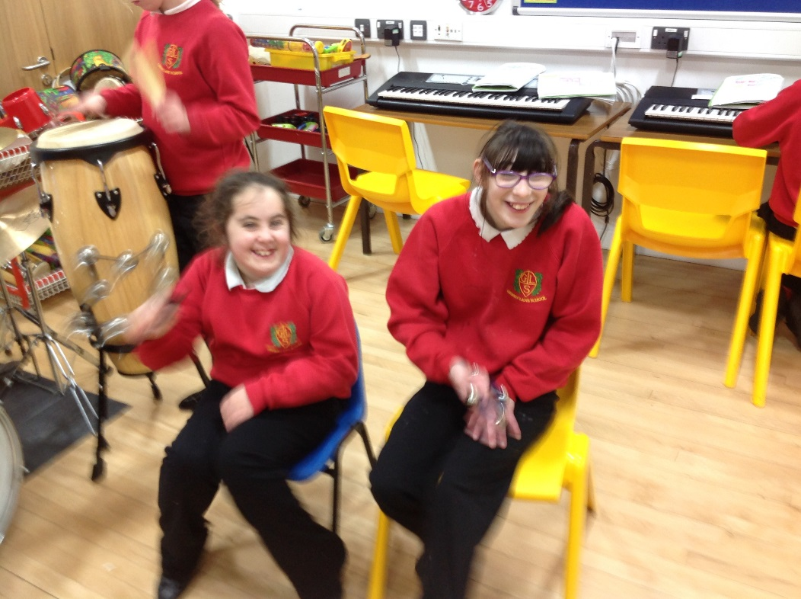

Class 2 celebrate the Chinese New Year with music and a dragon dance.
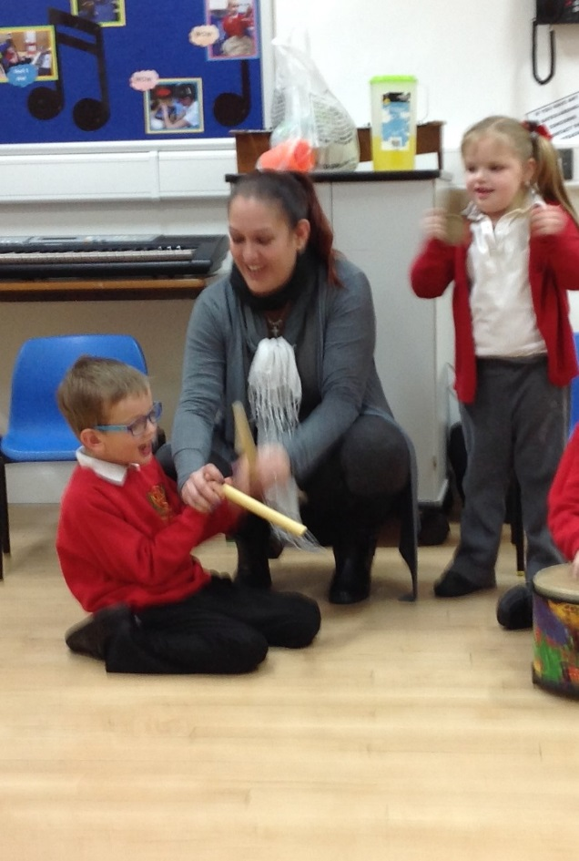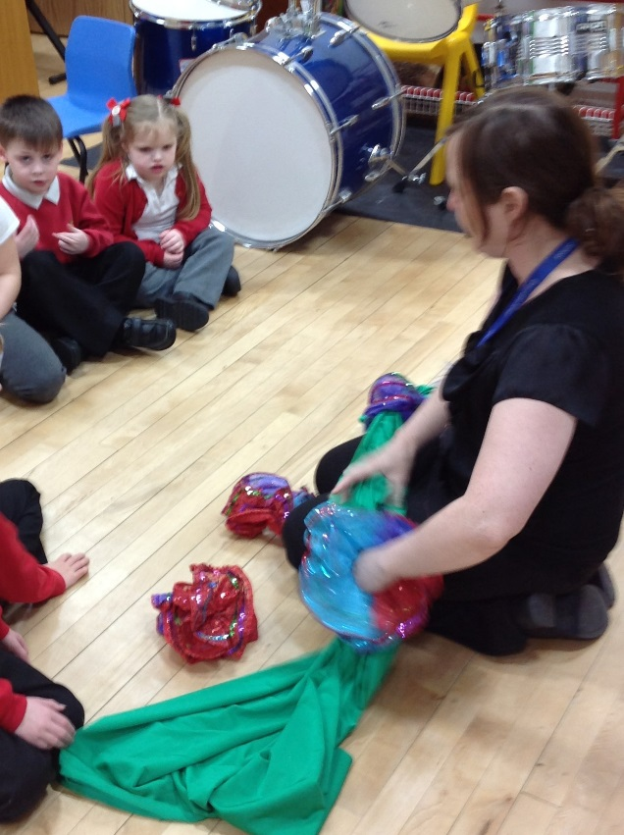

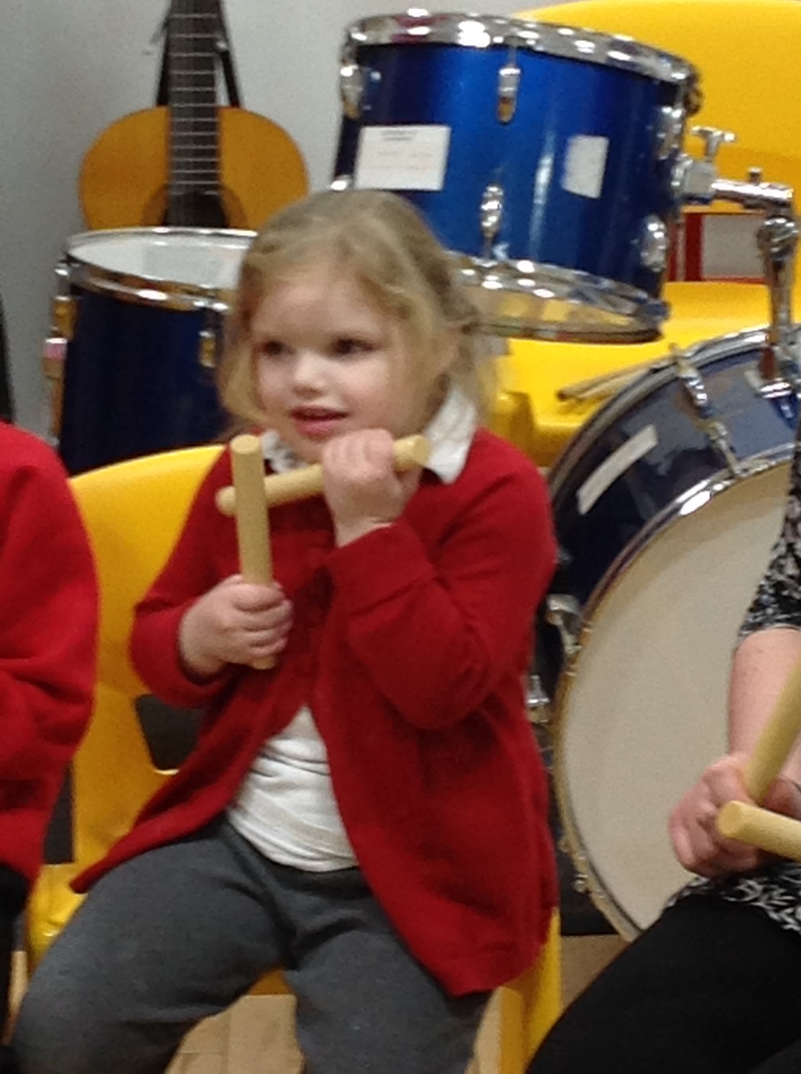

Pantomime time for Class 5!
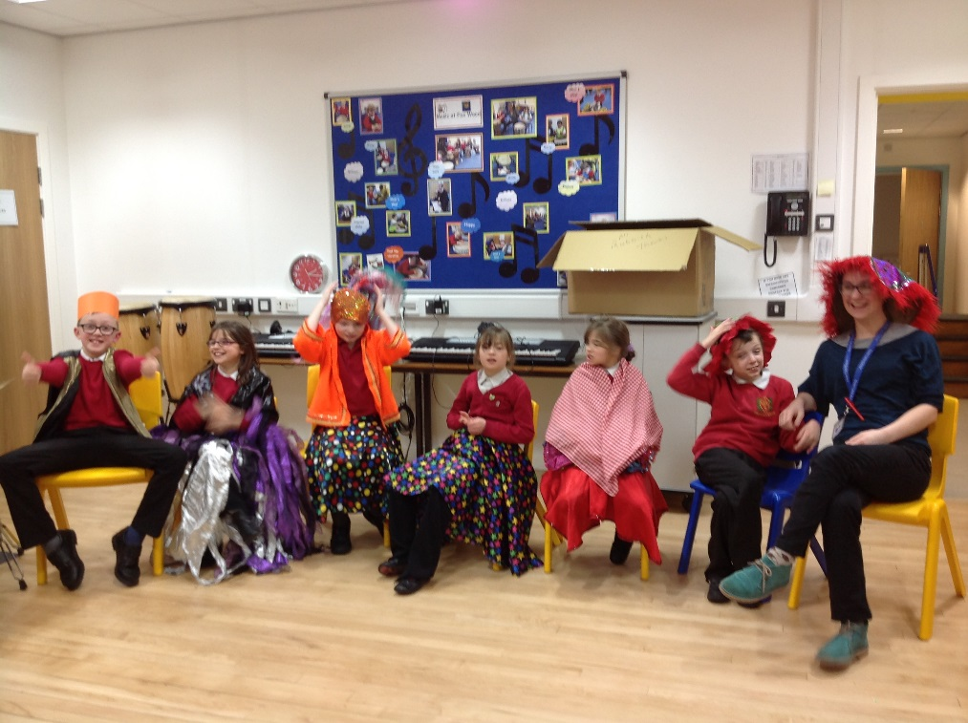

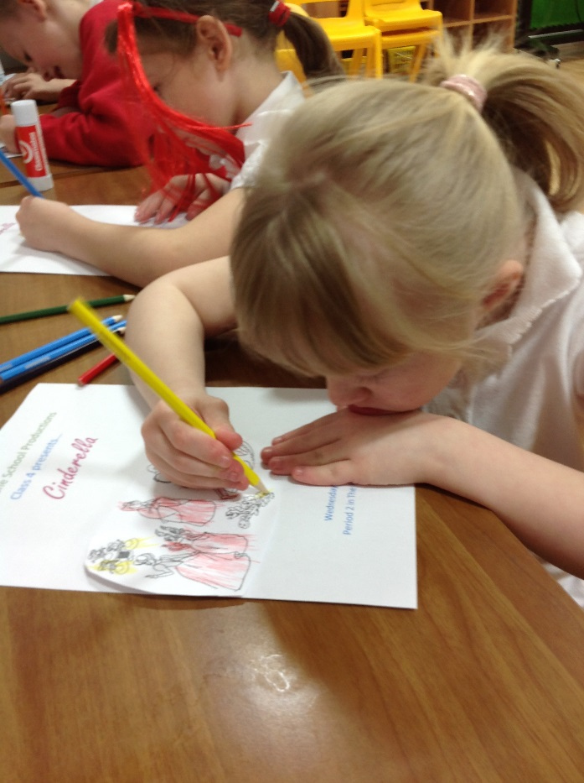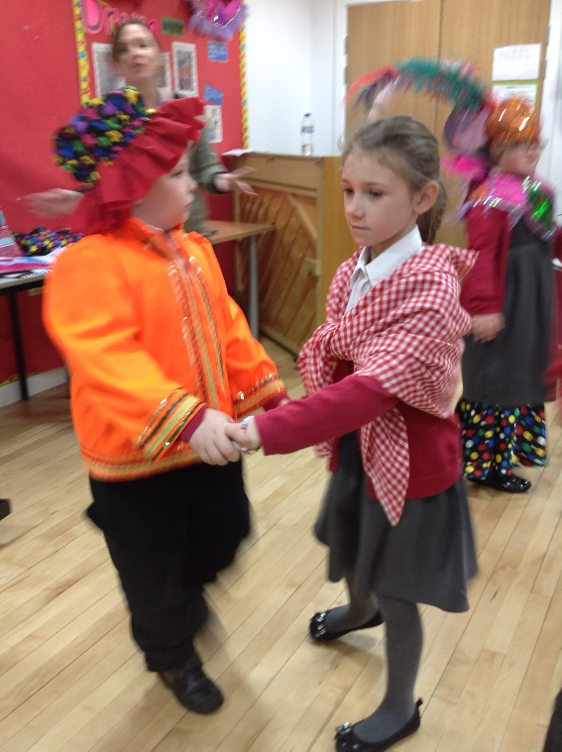
Class 4 make posters to advertise their production of Cinderella and rehearse their waltz for the New Year Ball.

3N pretend their claves are The 5 Little Speckled Frogs…

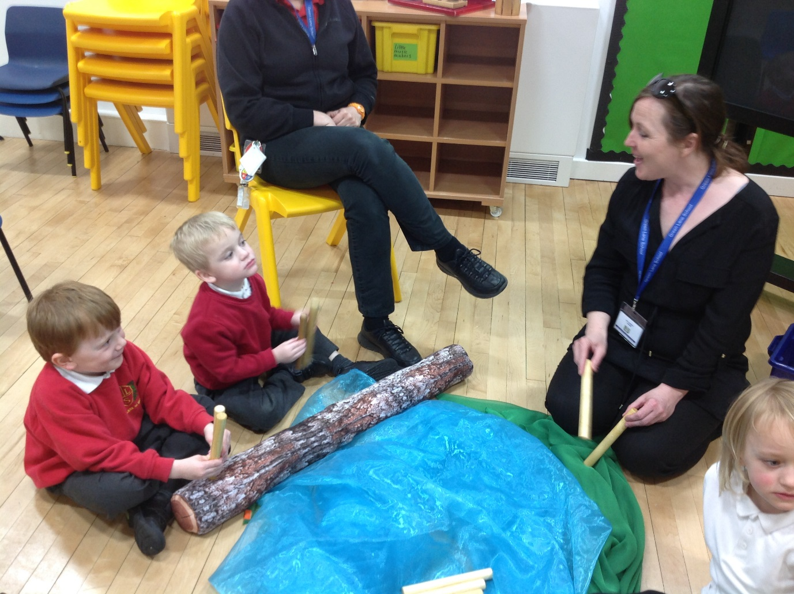

…then a raft for the rabbit to float on!
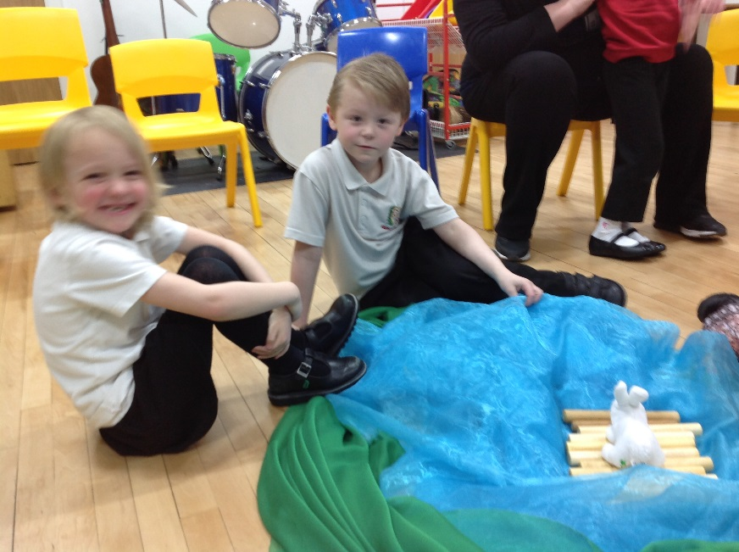

Class 3 are back off on their adventures singing sea-shanties as they sail off as pirates! Arrgh!
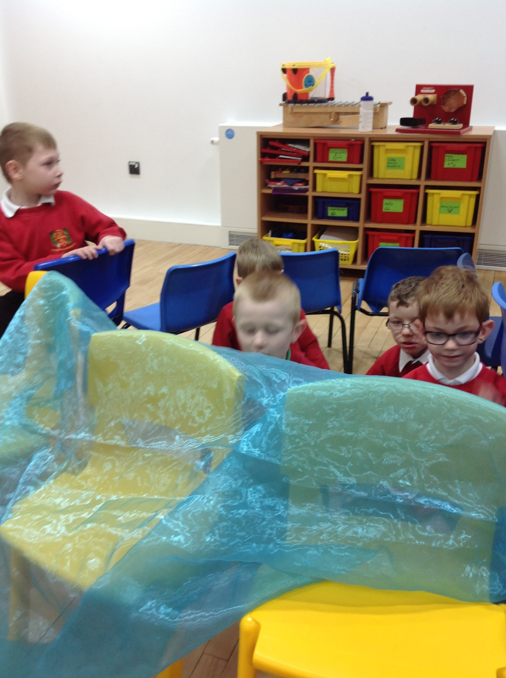

A King who loves music so much, he must hear his musicians all the time.
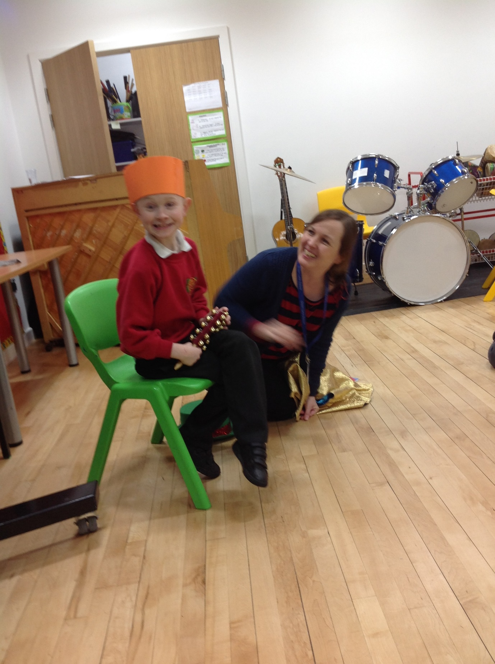

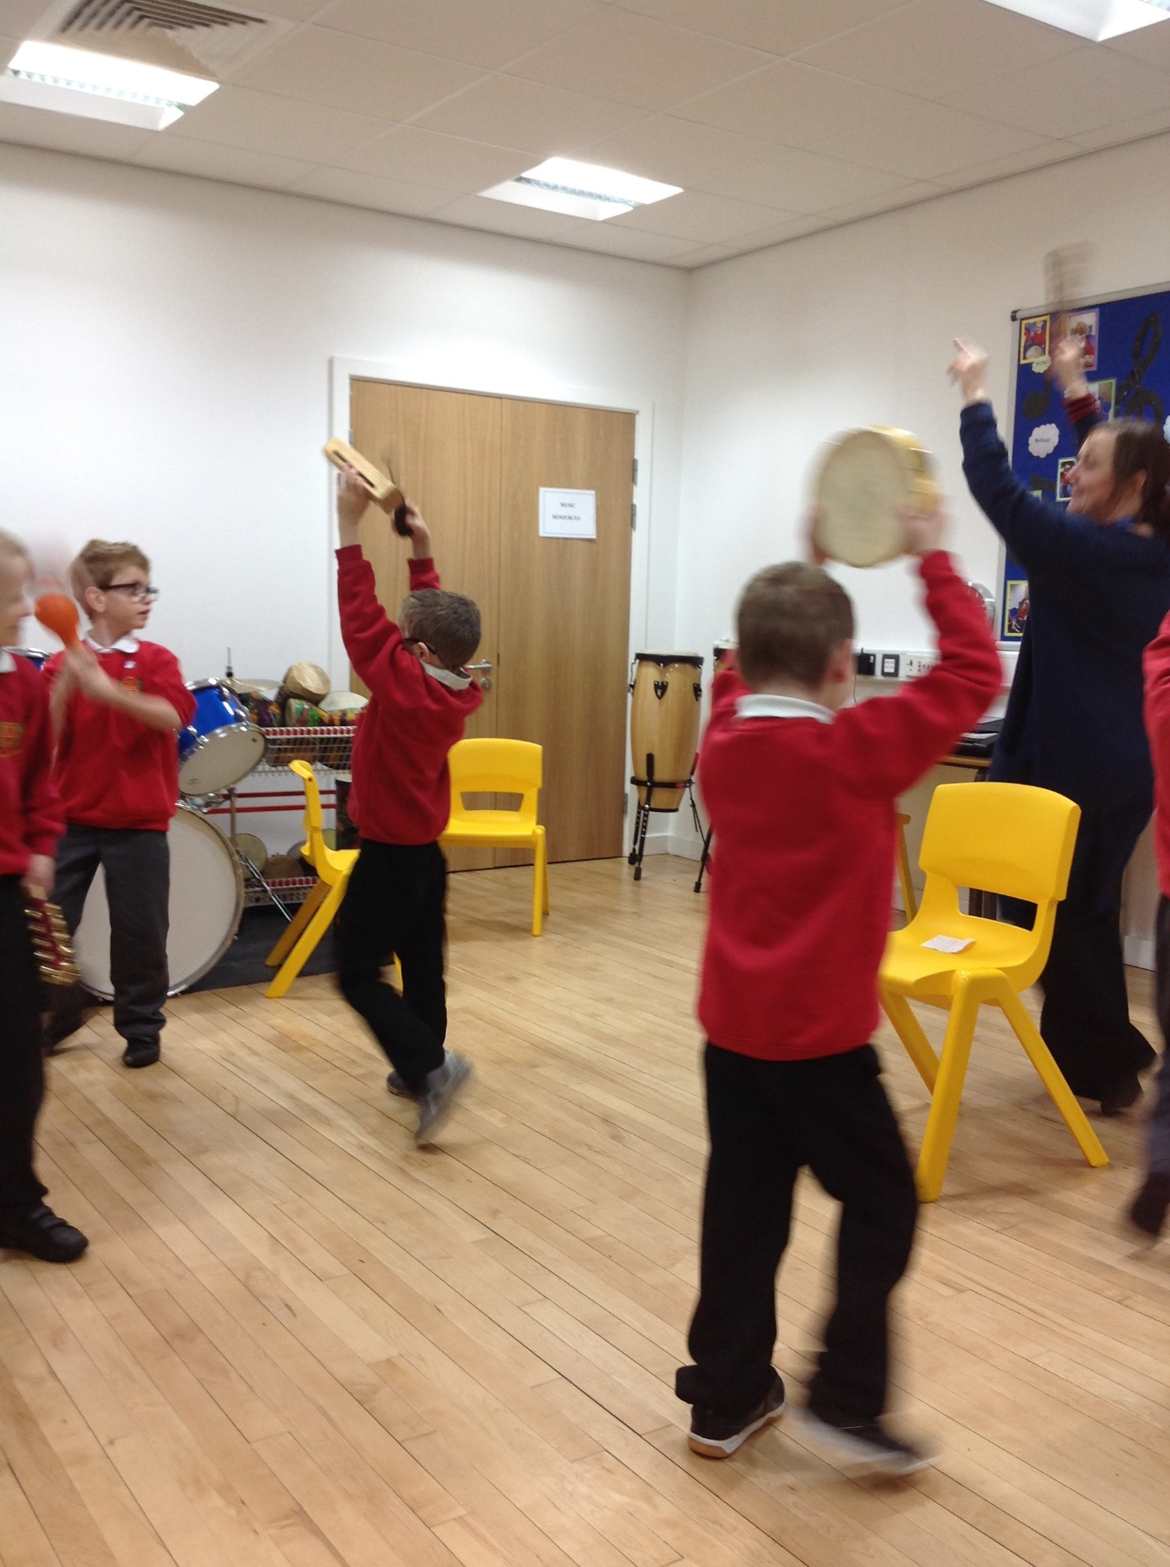
Circle time helping us to stay in time and play music following instructions.
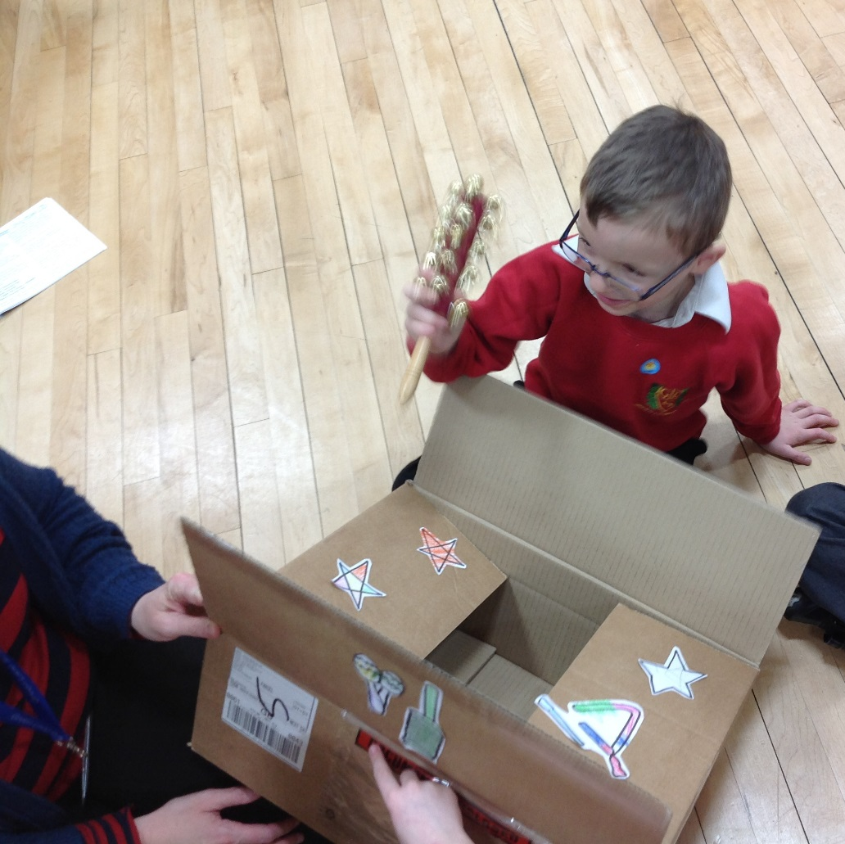

Children look and see what instrument is in the Magical Musical Box and usually get it right. Brilliant work!

The Big Sing
The Big Sing takes place every Wednesday morning. We sing and sign to a range of songs from pop to hymns. We also play instruments and have disco time!
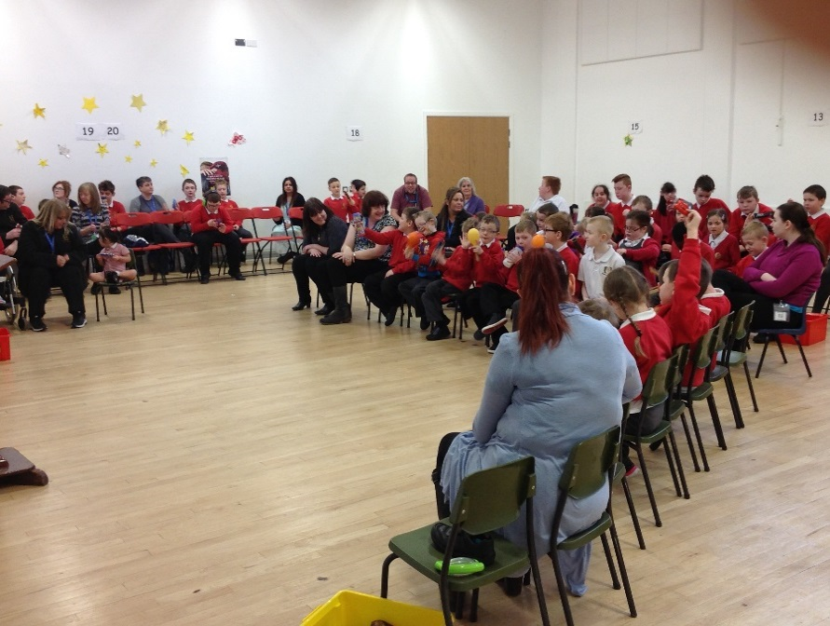
Class 3 have their turn to play an interesting rhythm
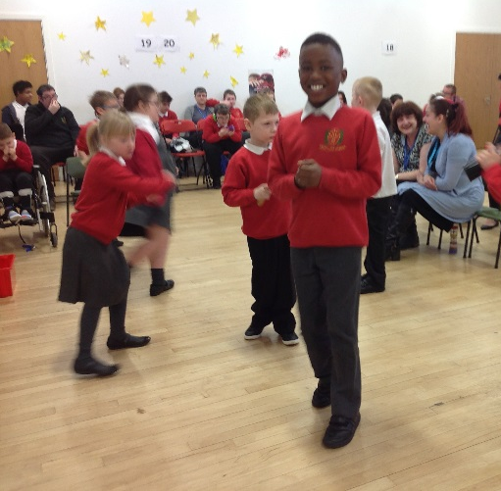
Time to dance to those rhythms!
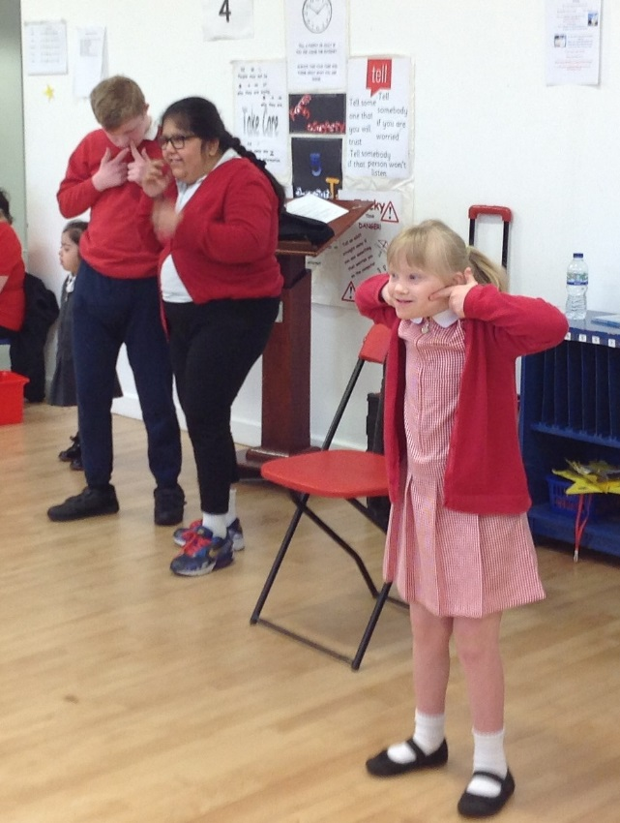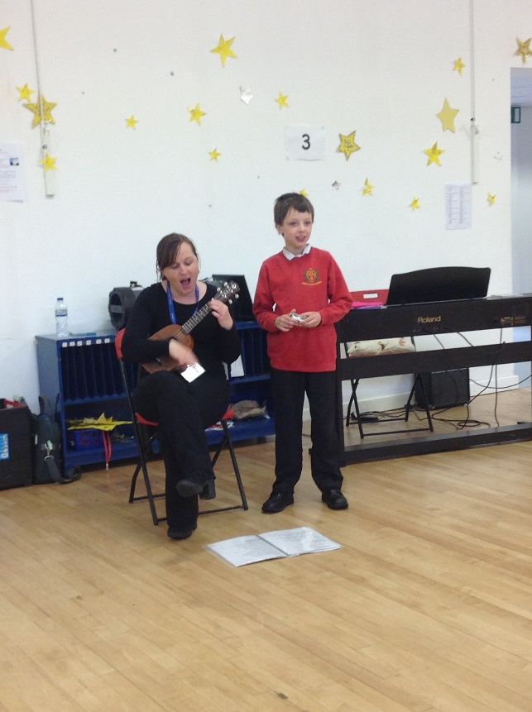

And there are action songs and ukulele songs too!

Dancing and expressing ourselves to music!
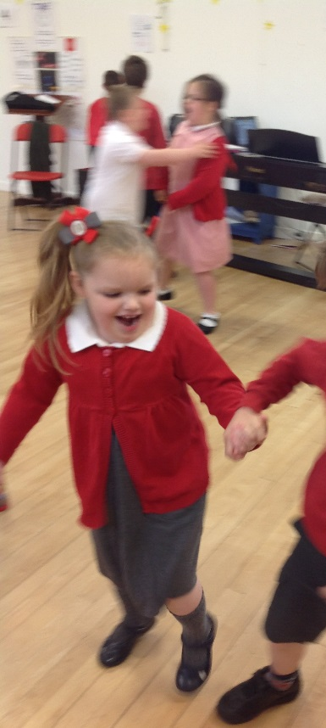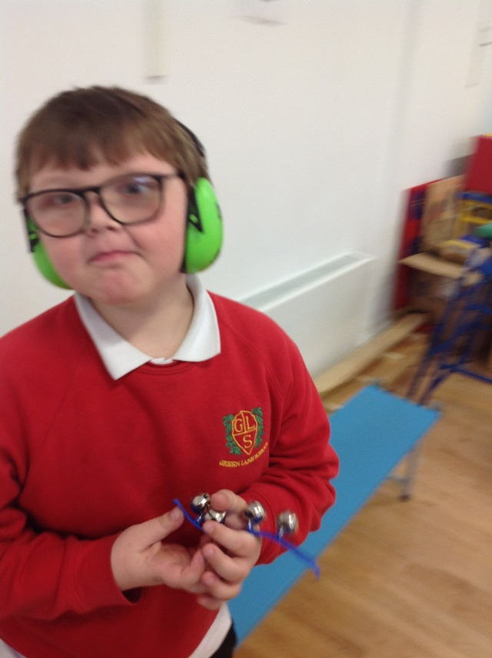
And having fun with our friends and helping to lead the songs.
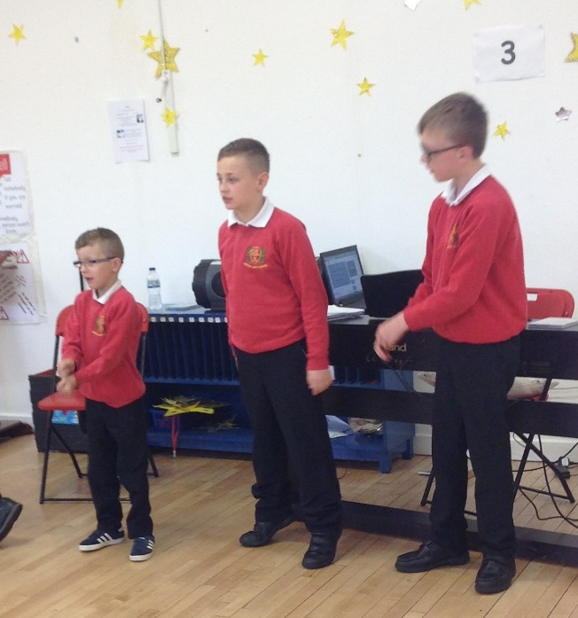

Green Lane Choir
Our choir takes place every Friday lunch time for Upper School pupils. We have great fun singing, signing, playing and dancing to lots of different songs. We are currently singing Rule the World (Take That), You Can Count On Me (Bruno Mars) and I’m Gonna Sing (African-American Spiritual). We always have good fun starting with our warm-up song, To Stop the Train.
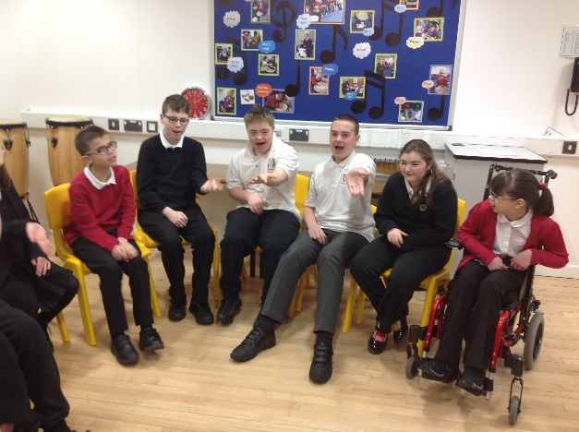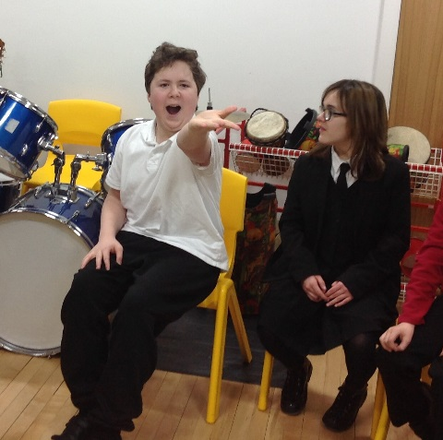
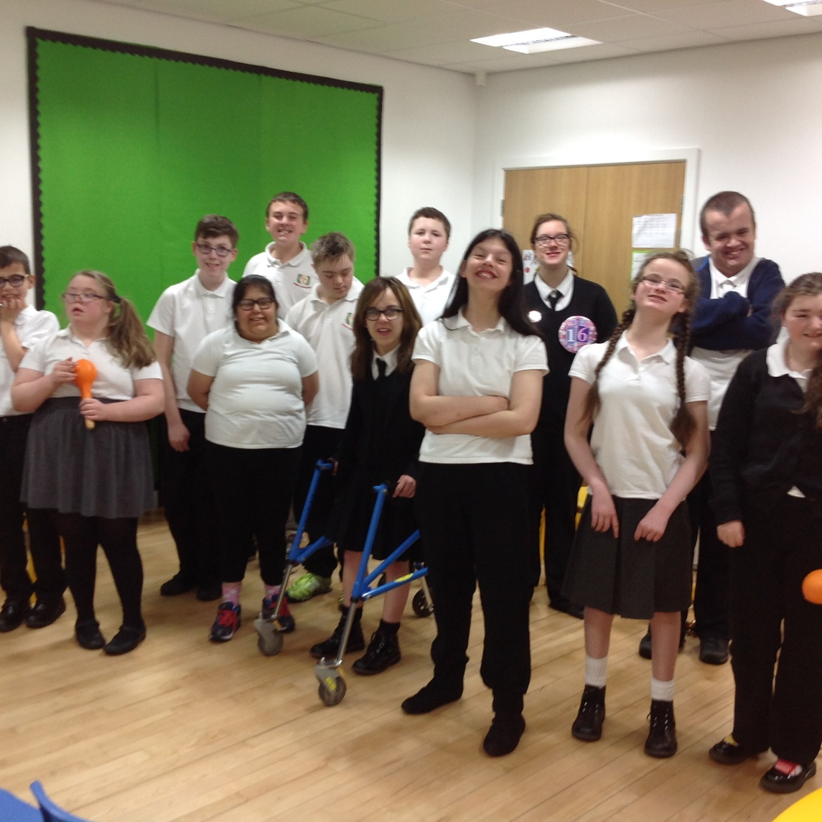
Concerts
Our big performance takes place at Christmas when parents are invited to watch each class present their part in the Christmas play. We also work towards a whole school performance for the end of year Aiming High awards celebration (the Mayor comes to this!)
In addition to our main performance we put on smaller class productions and invite other classes and staff to come and watch.
CHRISTMAS PERFORMANCE PHOTOS & FILM TO GO HERE

