Topics

Coding

Online Safety

Spreadsheets

Questioning

ComputingC:\Program Files (x86)\Microsoft Office\MEDIA\CAGCAT10\j0205582.wmf

People and places in school

Making choices

How and why do symbols help us understand god?

Celebrations

English

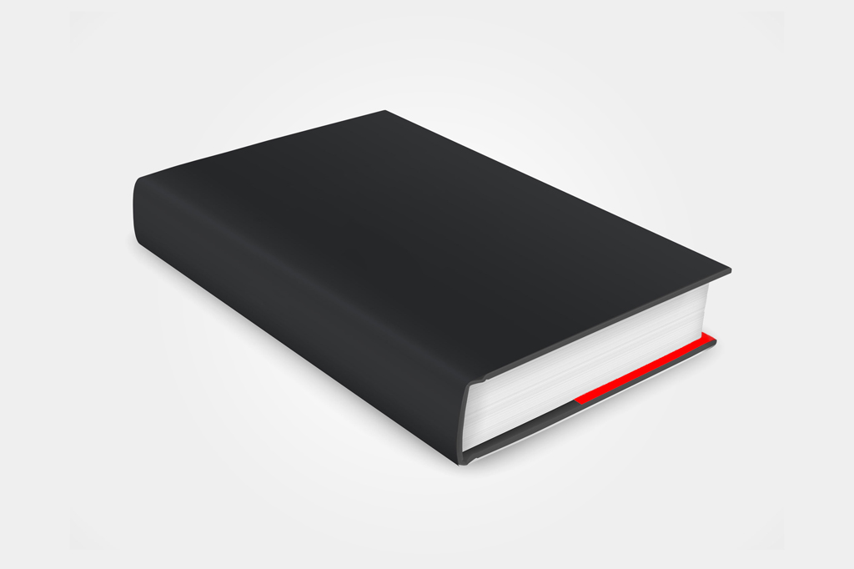

Topics

Stories with a familiar setting

Explanation texts

POPAT

Handwriting

Letters and sounds

Puppets

Junk Modelling

DT



ART



PSHE

RE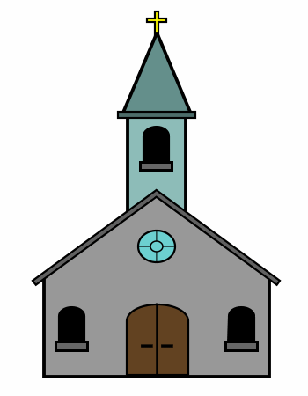

Dance

Gymnastics

PEC:\Program Files (x86)\Microsoft Office\MEDIA\CAGCAT10\j0299763.wmf

Everyday materials

ScienceC:\Program Files (x86)\Microsoft Office\MEDIA\CAGCAT10\j0251301.wmf

England & Australia

GeographyC:\Program Files (x86)\Microsoft Office\MEDIA\CAGCAT10\j0335112.wmf

Why did the Great Fire burn down so many houses?

History

Topics

All about Spain

Spanish instruments

Spanish Christmas

Languages

Topics

Number

Measurement

Shape & Space

Maths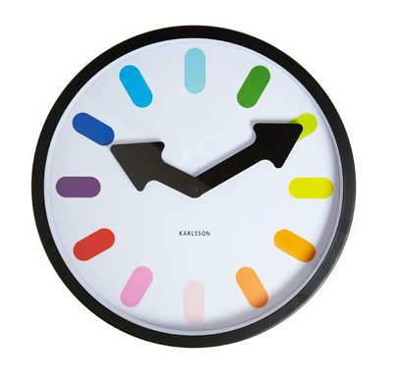

Class 4 Autumn 2017