P2 Autumn Term 2021

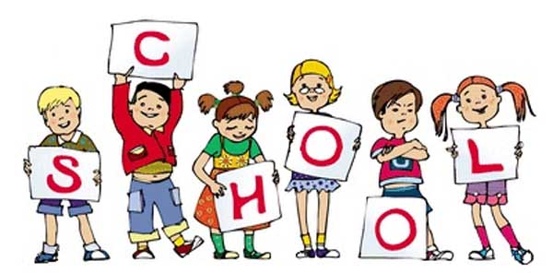

P2 staff

Ms K.White

Mrs K.Dickson

Ms J.Forrest

**Topics**

**Autumn 1**

Place Value and methods of addition, subtraction, multiplication and division.

**Autumn 2**

Geometry and measures. 2D and 3D shapes, symmetry and angle.

Statistics.

**Topics**

**Autumn 1**

Instructions

**Autumn 2**

Magazine/Newspaper Articles.

**Ongoing** - Spelling and Phonics, Guided Reading, Guided Writing, Handwriting.

Speech and language work.

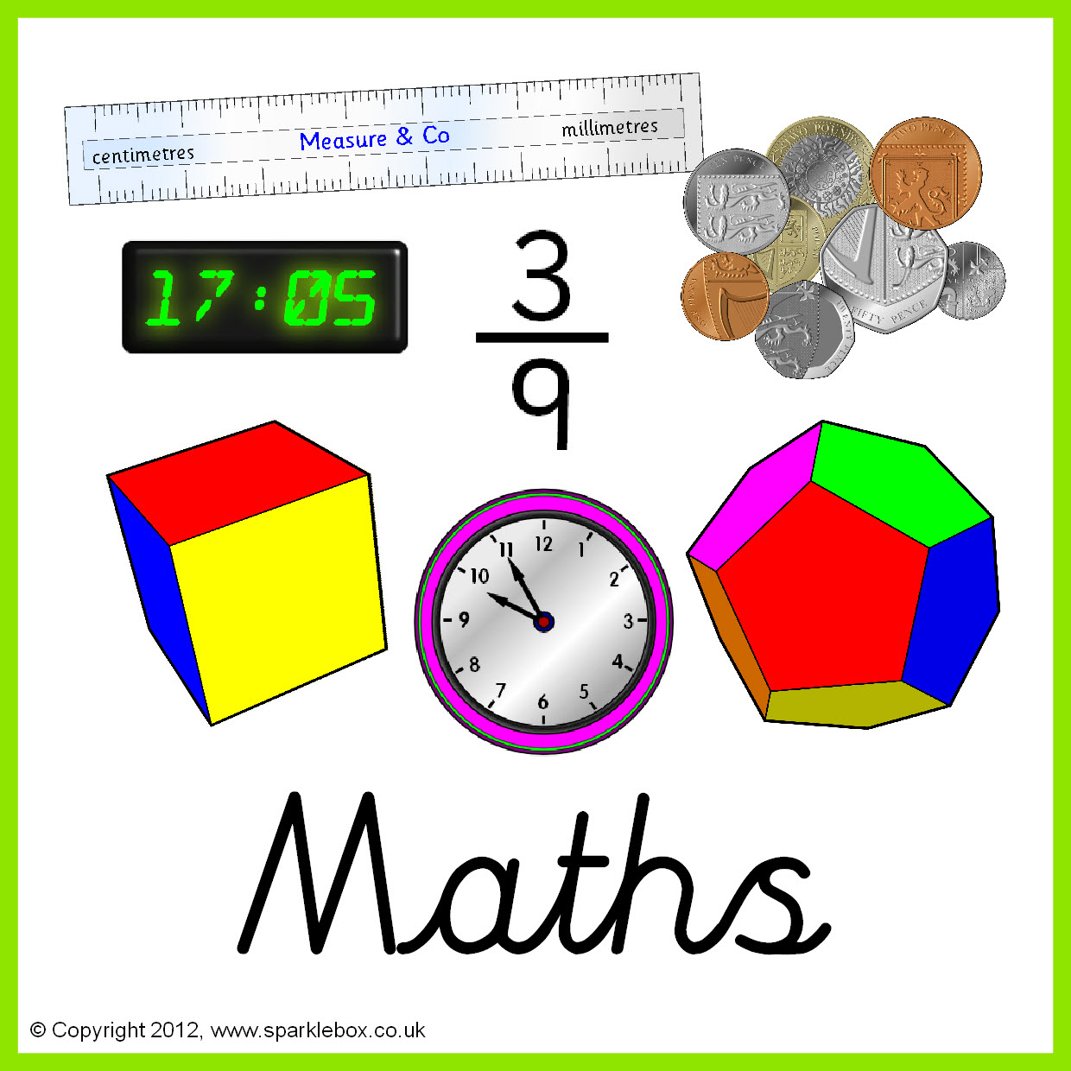

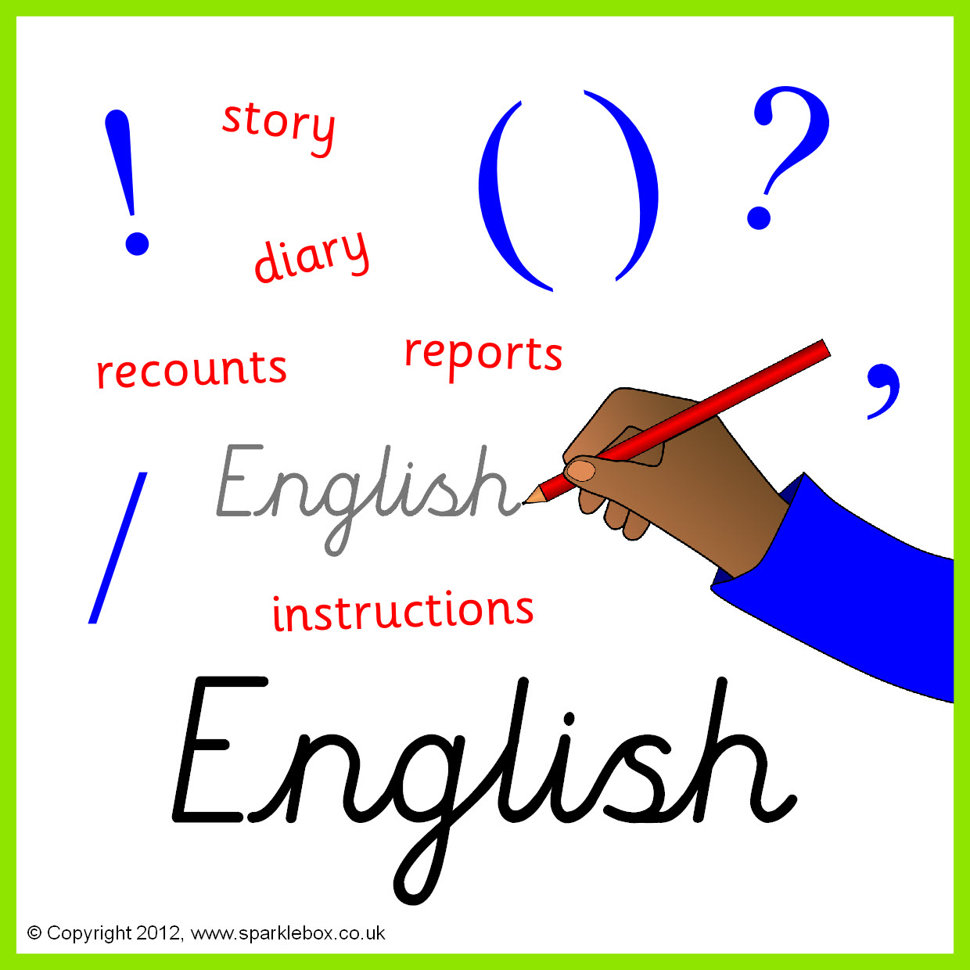

**Topics**

**Autumn 1** - Earth and Space.

**Autumn 2** - Properties and changes of materials.

**Topics**

**Autumn 1** - E-safety.

**Autumn 2** - Algorithms & programming.

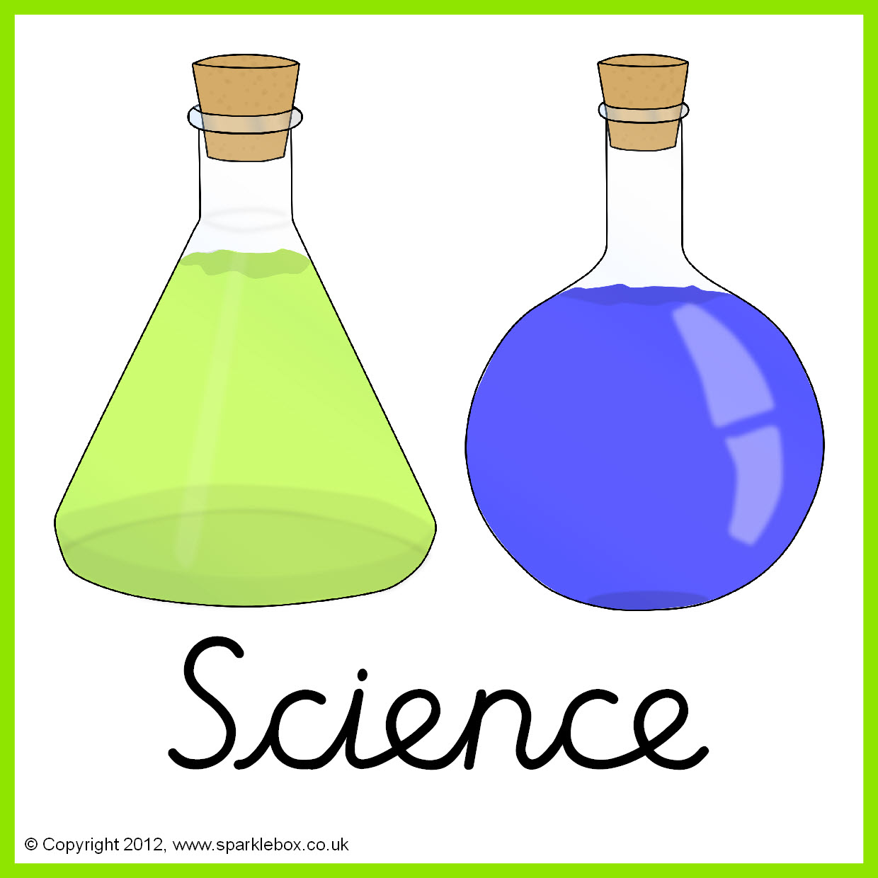



**Topics** – Taught by L.Fernyhough

Exploring drawing.

Spanish tiles.

**Topics** - Taught by L. Fernyhough

Capital cities in the U.K.

Counties in the U.K.

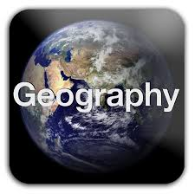





**Topics**

**Autumn 1** - Animals/Pets. Number recap.

**Autumn 2** – Celebrations, colours.

**Topic** -Taught by L. Fernyhough

Stone Age to Iron Age.



**Topics**

**Autumn 1** – Christianity (Jesus).

**Autumn 2** – Celebrations (Christmas).

**Topics**

Fitness training and inclusive sports.





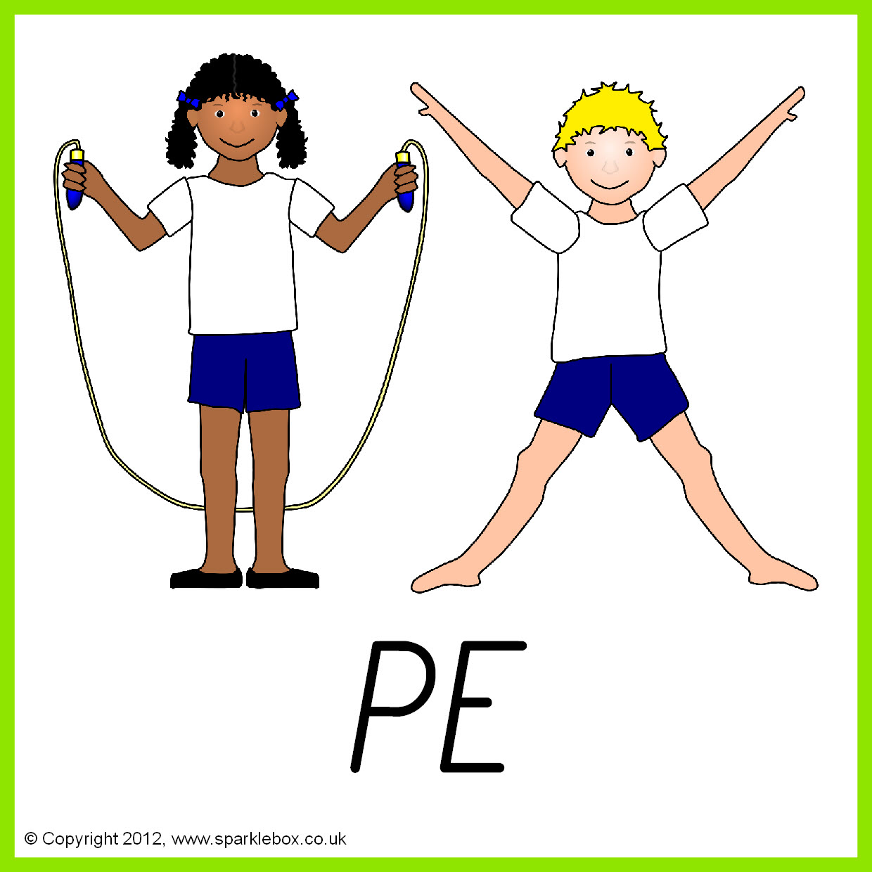

**Topics**

**Autumn 1** – Making a mobile.

**Autumn 2** – Basic food hygiene.

**Topics**

**Autumn 1** – Different types of families.

**Autumn 2** – Health and Fitness.

.

