Ready meal or cooked from scratch?
Comparison
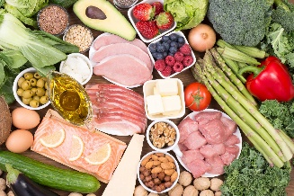
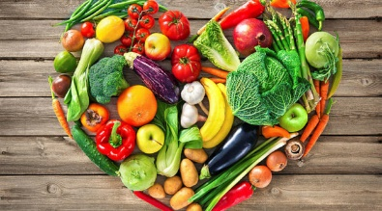

 | Ready meal | Cooked from scratch
Time taken to prepare and cook

Cost

Appearance | /10 | /10
Taste | /10 | /10

Consider which meal was:
Best value for money? __________________________________
Most convenient? _____________________________________
When would you be most likely to use a ready meal? ____________
___________________________________________________
When would you be most likely to cook this meal from scratch?
___________________________________________________
___________________________________________________

