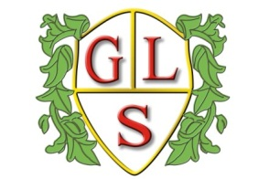
Class P1 Topics Autumn 2018

Science
Food and digestion

History
Ancient Greece (Autumn 1)

Geography
Rocks, fossils and volcanoes (Autumn 2)

ICT
E-safety (Autumn 1)
Coding (Autumn 2)

Spanish
Number to 20/Number Games (Autumn 1)
Basic conversation/ greetings (Autumn 2)

RE
What makes a community? (Autumn 1)
Celebrating Christmas (Autumn 2)

Art
Basic Drawing techniques (perspective, shading, colouring)

Design Technology
Making mobiles (Autumn 1)
Seasonal Cooking (Autumn 2)

PSHE
Health and Wellbeing ( whole Autumn term )

PE
Health related fitness (Autumn term)

