Home Learning Activities Class P1 18.5.20
Maths  https://www.bbc.co.uk/bitesize/articles/zfgm6v4  This is a lesson on multiplying a 2 digit number by a 1 digit number- I would say spend two days on this trying out the activities. |  | Maths  https://www.bbc.co.uk/bitesize/articles/zjy2xyc  if you feel you have got the hang of the last multiplications lesson- try this one… | Maths  Visit Maths Workout, Maths Whizz or Maths Warm Up and do 1 hour of activities.  (same as last week) | Maths  Find as many different ways as you can to make 200.
English  https://www.bbc.co.uk/bitesize/articles/z6rvbdm  This lesson could be spread out over 3 days.  Part 1  Watch the video and then try the short 4 question activity.  After that try writing some of your own sentences using ‘and’ | English  Part 2  Watch the ocean video and try out activity 2 | English  Part 3  Rewatch all the videos again and try activity 3 | English  Keep a daily diary of your time at home. What did you do today?  (continue from last week- this is an ongoing task) | English  Read some of your book  (continue from last week- ongoing task)
PSHE  It’s quite hard not seeing friends at the moment- so this week the next three days worth of lessons will be about your friends.  Think of one of your friends- draw a picture of them and write a little bit about why they are such a good friend | PSHE  Choose another friend to draw and write about | PSHE  This time, choose a grown up that you like but do not get to see at the moment and draw a picture of them then write about what you like about them so much- you could even make a scrap book of these drawings. | PSHE  Telephone/facetime a friend and have a chat.  (keep as a weekly task) | PSHE  Play a game with someone in your house.  (ongoing task)
PE  https://www.youtube.com/watch?v=80tkC_XrRcs&feature=youtu.be  This is a PE lesson all about quick movement | PE  https://www.youtube.com/watch?v=XaWOWew18WI&feature=youtu.be  Ever thought about trying street dance? Here is a video tutorial of a simple street dance- you could get the people you live with to join in! | PE  How many of something can you do?  For example, how many keepy ups can you do with a football, how many bounces on a trampoline can you do in a row before getting tired? How many times can you thrown or bounce a ball without dropping it?  *KEEP THIS ACTIVITY FROM LAST WEEK- CAN YOU IMPROVE ON YOUR TOTAL?* | PE  Do a circuit – 20 star jumps, 10 press ups, 20 tuck jumps, 30 second wall sit. Repeat 3 times.  Keep this routine from last time BUT- can you add an extra 10 reps to each exercise?  Or, if you follow a physio programme, do some of the moves from it. | PE  Lift some weights. Use real ones if you have them or if not, use tins! Do exercises you have learned!  Continue from last week- can you do more repetitions than last week?
ART  Have a look at these dot paintings below- why not have a go yourself? It doesn’t have to be an animal, it could be a building, car, person etc  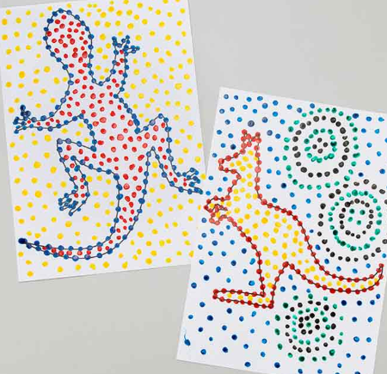 | Geography  https://www.bbc.co.uk/bitesize/articles/z48fvk7  Follow this link for a lesson (with resources) all about why we have different time zones in the world. | History  https://www.bbc.co.uk/bitesize/articles/zhry382  This link sends you to a nice lesson with video clips about Martin Luther King- I think in P1 we are mature enough to learn about some of the extraordinary things this man achieved! | SCIENCE  Komodo Dragons!  Can you find out as many facts as you can about these amazing creatures! | COMPUTING  Using e-safety rules, stay in touch and chat to your friends for an hour or two each day.  Continue from last week- it is important to maintain good relationships with friends.

****Grown-ups- please remember, do not put yourselves under lots of pressure to try and complete everything on this sheet. Do what you feel you can. If there is one particular area of interest, then do more on that and less on the other bits. I know how busy you all are in these strange times! Stay safe!****

