Topics

*Taught cross-curricular*

Multimedia: Sound and music/ Programming and algorithms

Topics

*Taught through Spanish themed afternoons*

Numbers to 5

All about Spain

Topic/SCERTS (Covers English, Science, DT, RE, Art, Geography and History)

**School**

English: Nursery rhymes and information books

Science: Describing rocks and watching plants grow

Art: Images

DT: Playground structures and a healthy lunchbox

RE: What do people in our school teach us about god? The Easter story

Geography: Create simple maps

History: Schools now and then

*PSHE is taught through SCERTS*

Languages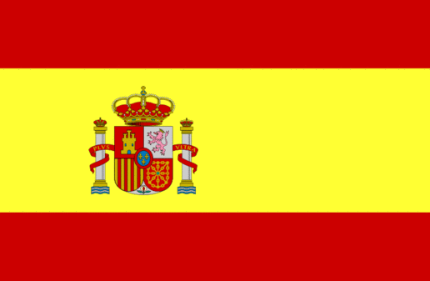

Computing

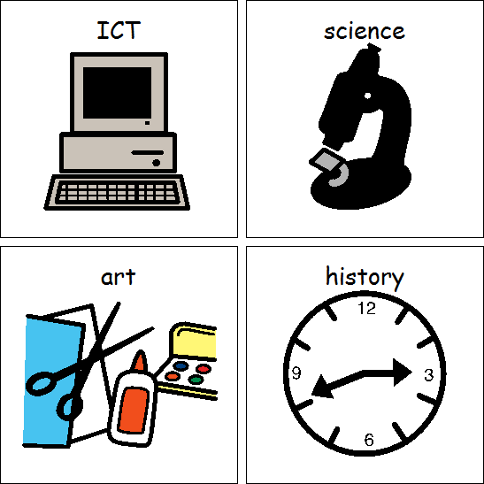

Games

Core skills

PE

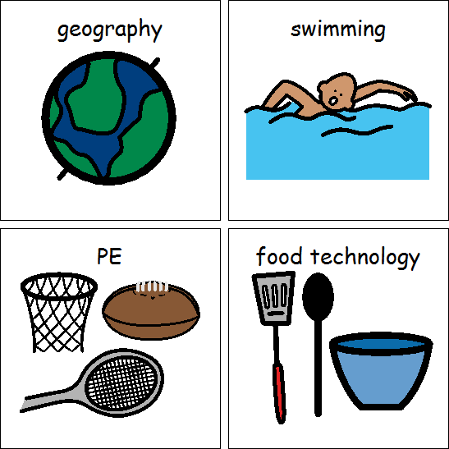

Topics

Number

Measures

Shape and Space

Maths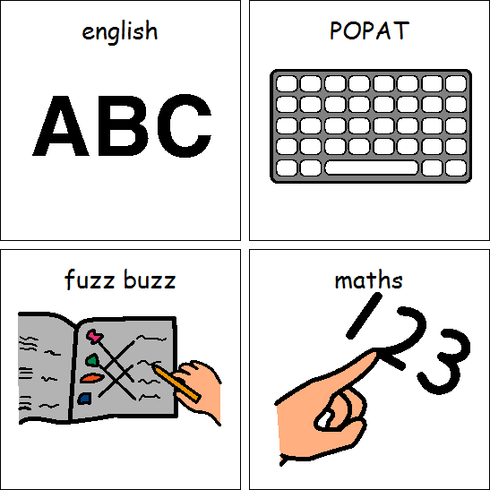

Class 2BA Spring 2022