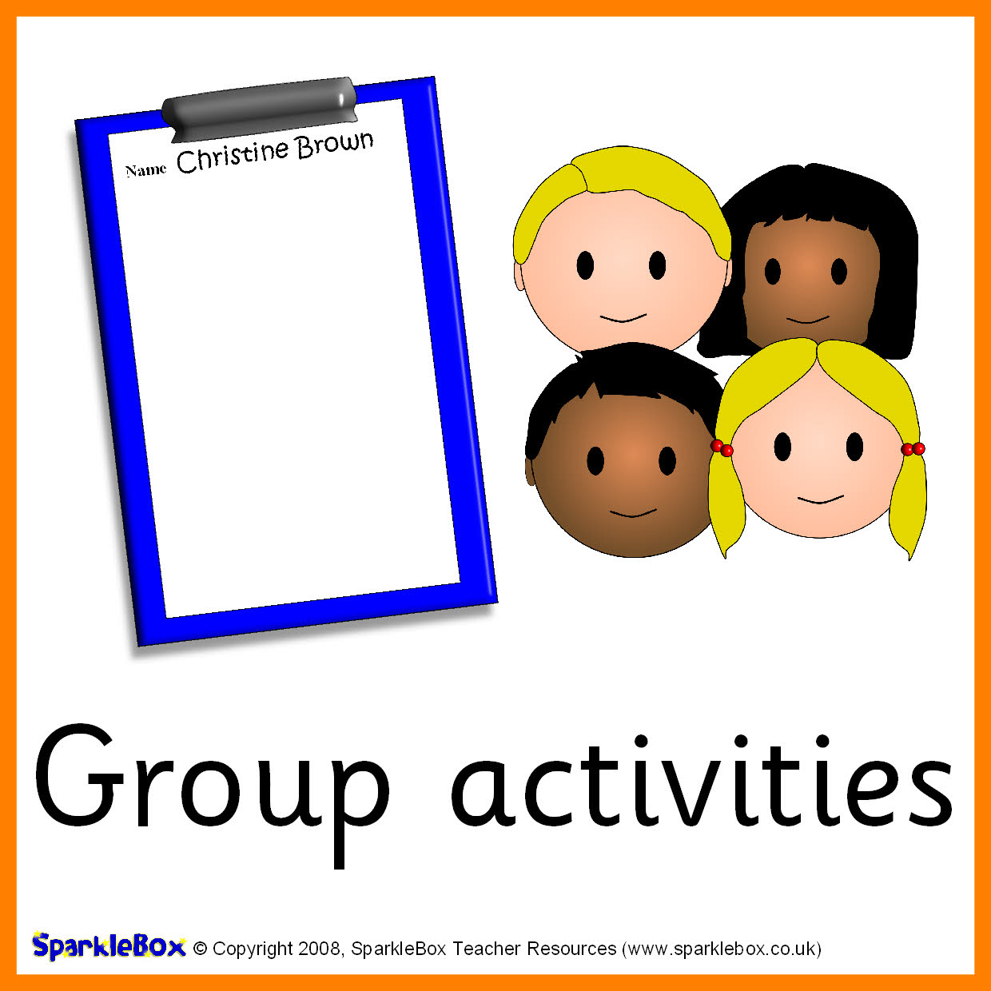

Class 3N Topics 2018/19

Reading, writing and using numbers,

Colours,

Shape,

Size, capacity, weight etc

Addition and subtraction,

Money

Time

Objects of interest

Seasonal / Cultural non-fiction

Modern rhyme & action verse

Poems & chants

Alphabet books, rhymes etc

Labels/captions for info

Letters and sounds

Reading / POPAT

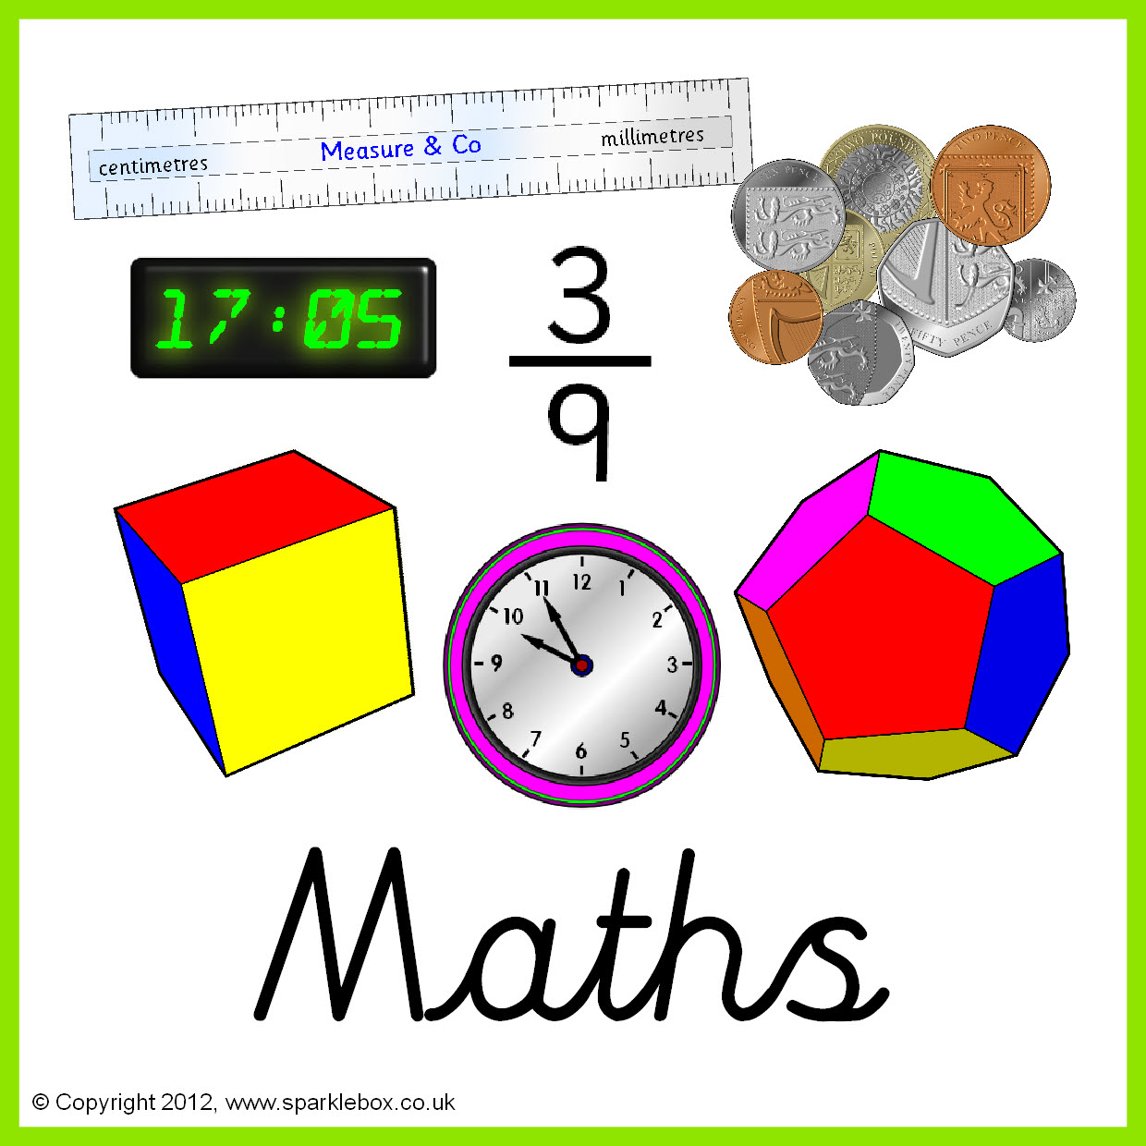

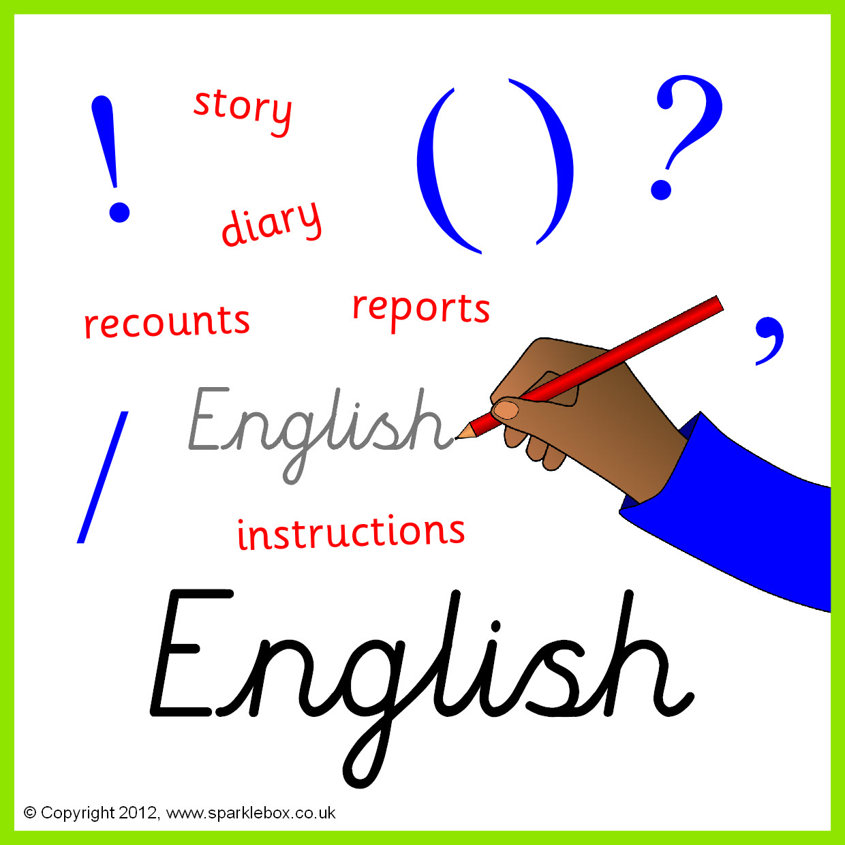

Natural world

Seasons

Regions & climate

Mini beasts

Foods

Using the touch screen

Inputting text

Using iPads / cameras

Cause and effect programmes

Using equipment in the sensory room

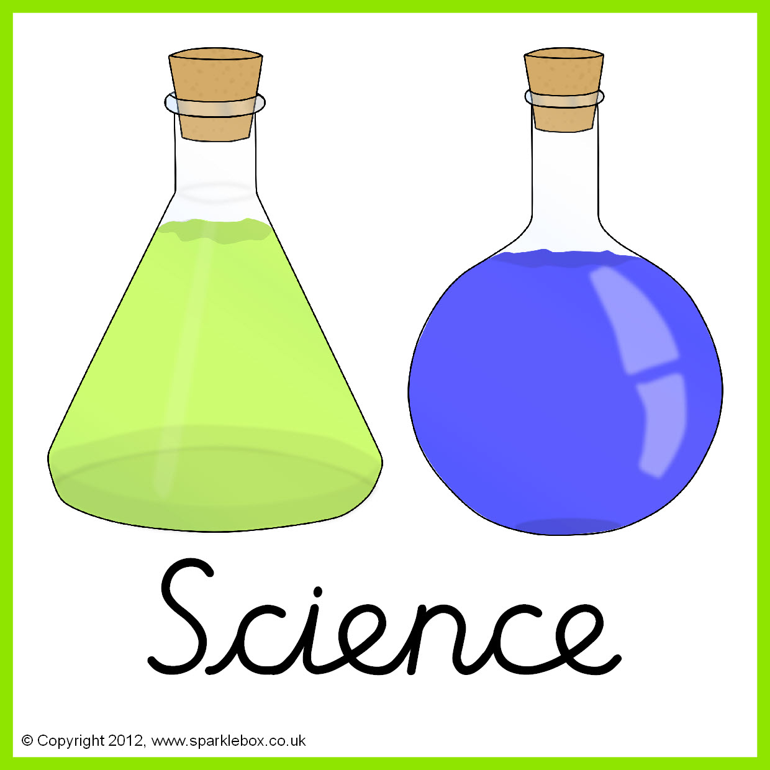



Autumn

Polar region

The Jungle

Transport

Mini beasts

Food

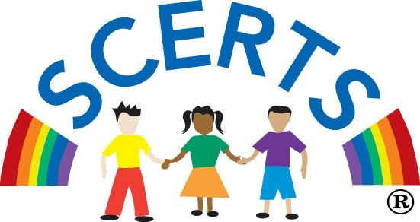

Essential skills e.g. new & old / my family/ my school / sequencing / handling artefacts etc

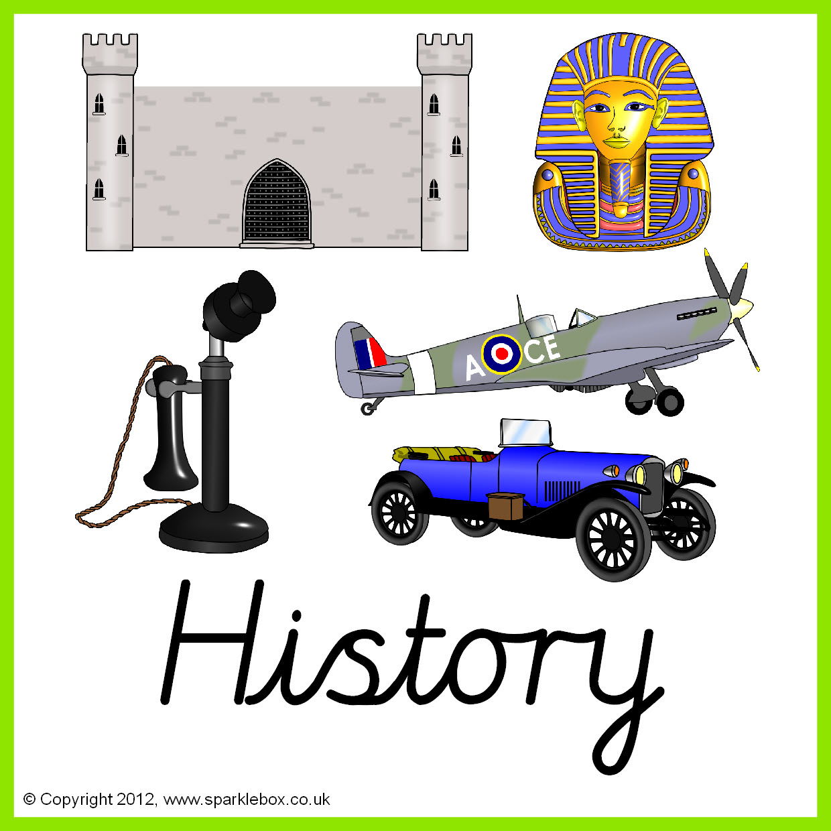

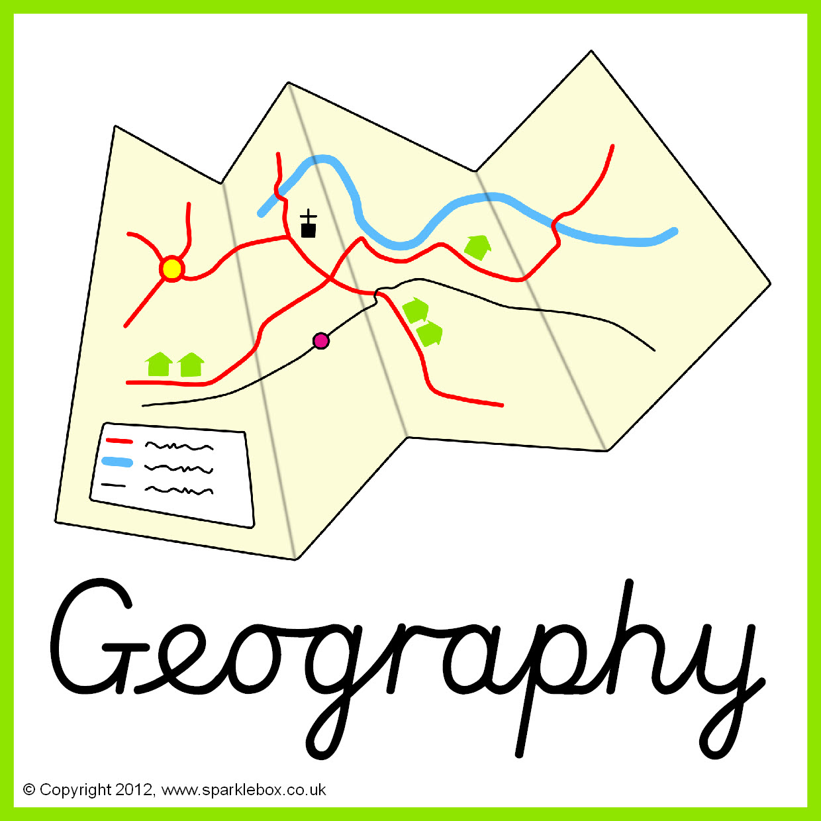

Essential skills e.g. moving around school / the local environment / using geographical language e.g. road, hill / visiting places / my home

Celebrations across different religions

Being a friend

Being kind to others

Taking part in assembly / school performances

Essential skills e.g. moving safely, following instructions, jumping, rolling etc

Personal Care

