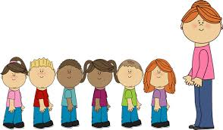

Using PECS, Makaton and words to ask for things.

Using nouns and verbs to describe what we can see.

Phonics

Aaaghh spider

Caterpillar shoes

Creepy crawly calypso

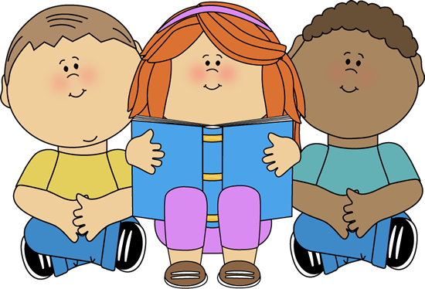

Fine motor development tasks.

Gross motor development.

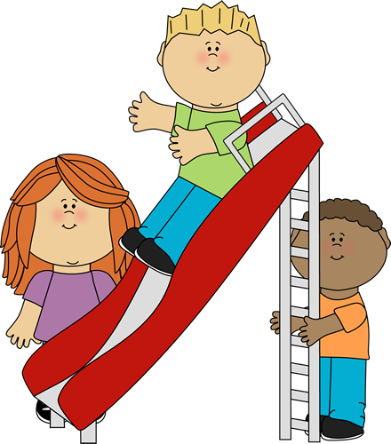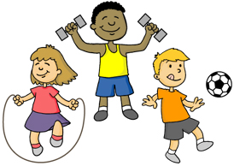

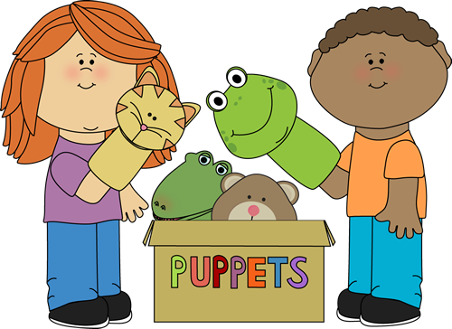

Developing friendships and initiating interactions with other children.

Sharing and taking turns.

Understanding that we are all different.

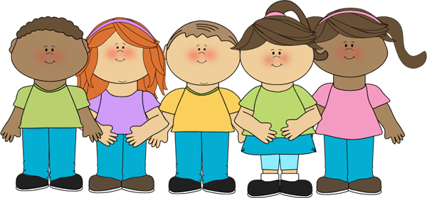

Physical Development

Communication and language.

Class 1 Staff

Mrs C Skermer

Miss H Chadwick

Mrs G Phillips

Mrs M Morris

Our curriculum is based on the EYFS strategy. We encourage the children to explore and learn through play.

Class 1S Summer 2022

Minibeast crafts.

Animal patterns

Dance.

Music.

Exploring using all the senses.

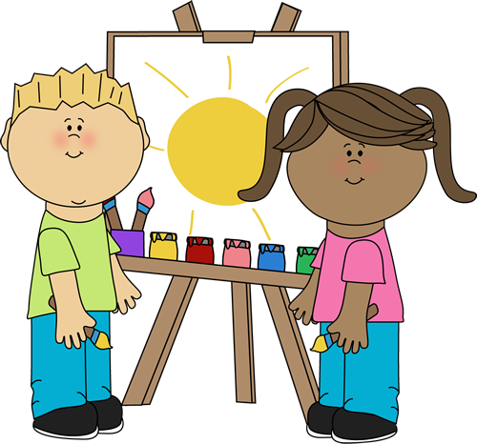

Minibeasts

Dead or alive

Life cycles

Operating a computer.

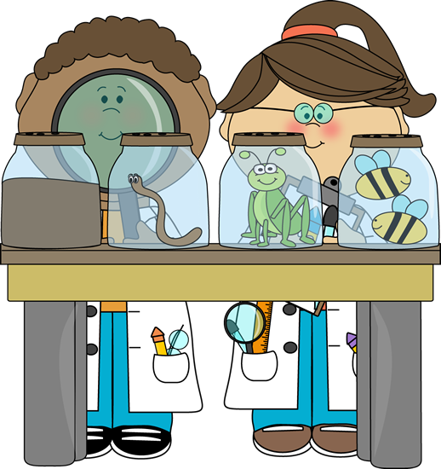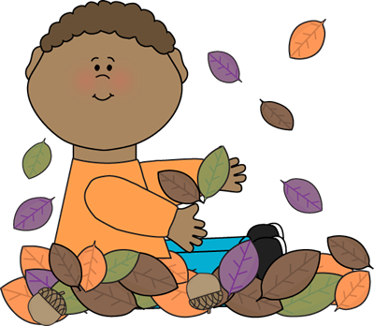

Counting objects and addition.

Organising and sorting objects.

Patterns, shape, size and measuring.

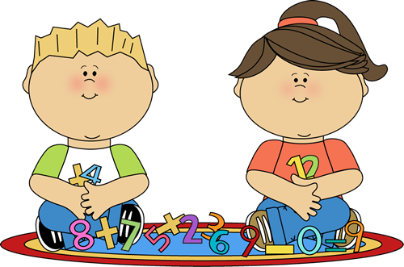

Personal, Social and emotional development.

Expressive Arts

Knowledge and understanding of the world.

Mathematics

Literacy

A Unique + Positive + Enabling = Learning and

child relationships environments development