Fox Class Spring Term 2022

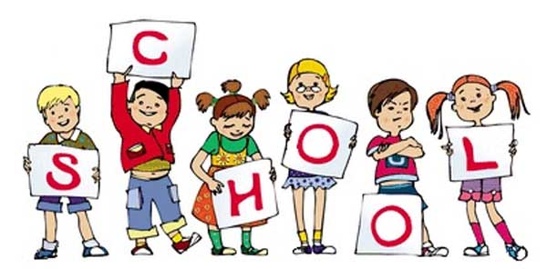

Badger class staff.

Mr A. Sidhu

Mrs E. Burton

**Topics**

**Spring 1 –** Statistics and Time.

**Spring 2 –** Measures and Money.

**Topics**

**Spring 1 –** Poetry – Haiku, Limericks, Shape and Calligram.

**Spring 2 –** Balanced Arguments.

**Ongoing** - Spelling and Phonics, Guided Reading, Guided Writing, Handwriting.

Speech and language work.

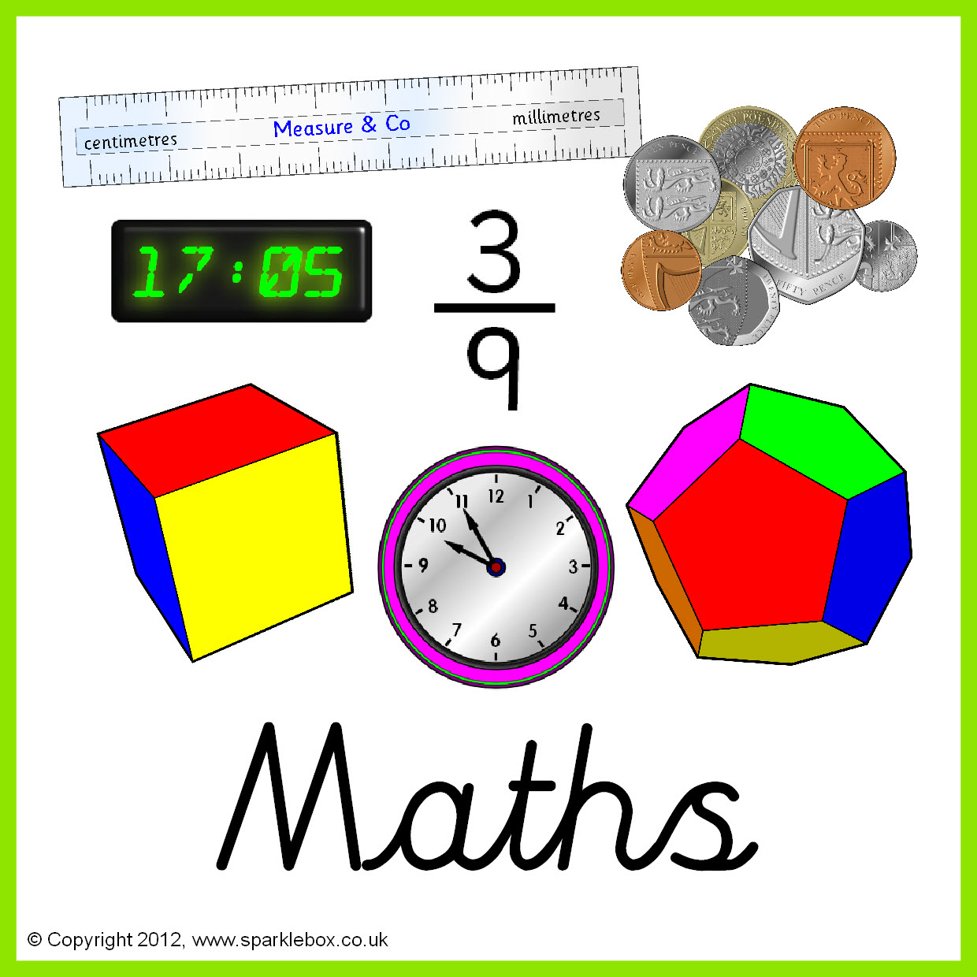

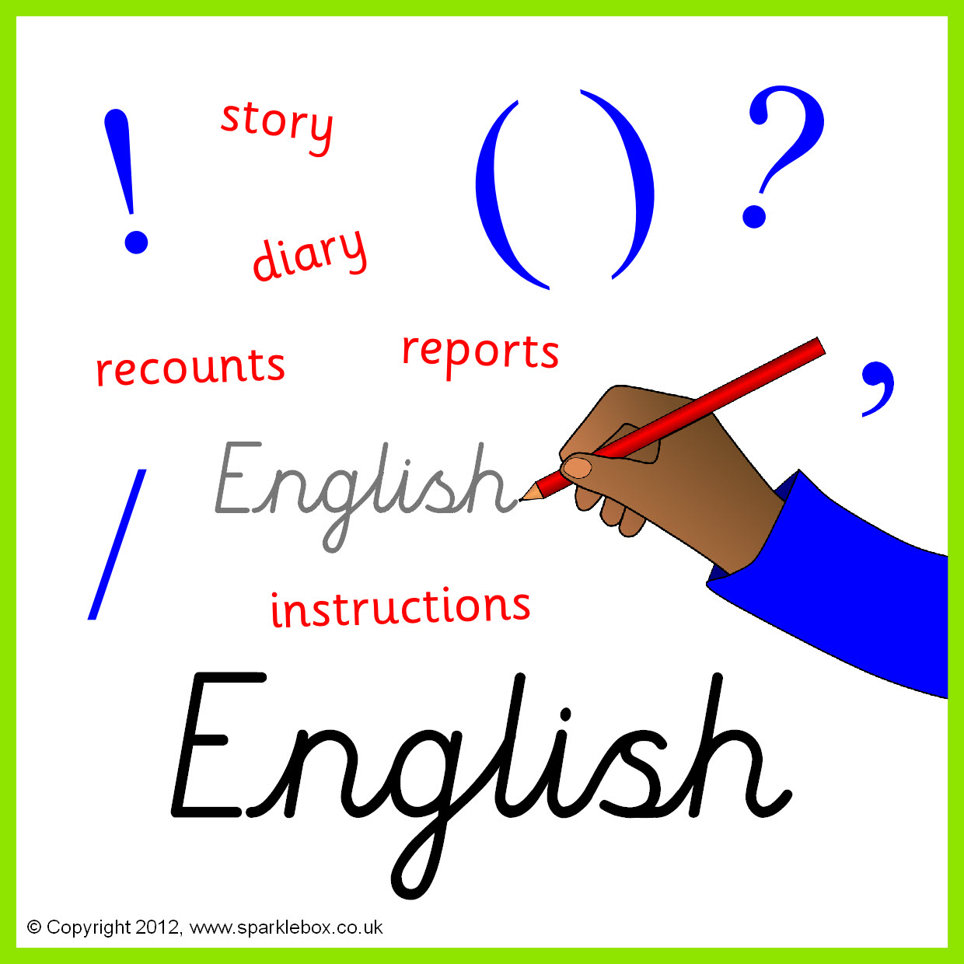

**Topics**

**Spring 1** – The characteristics of living things.

**Spring 2** – Waves (Observed, sound, light and energy).

**Topics**

**Spring 1** – Multimedia: Sound and Music presentation.

**Spring 2** – Data

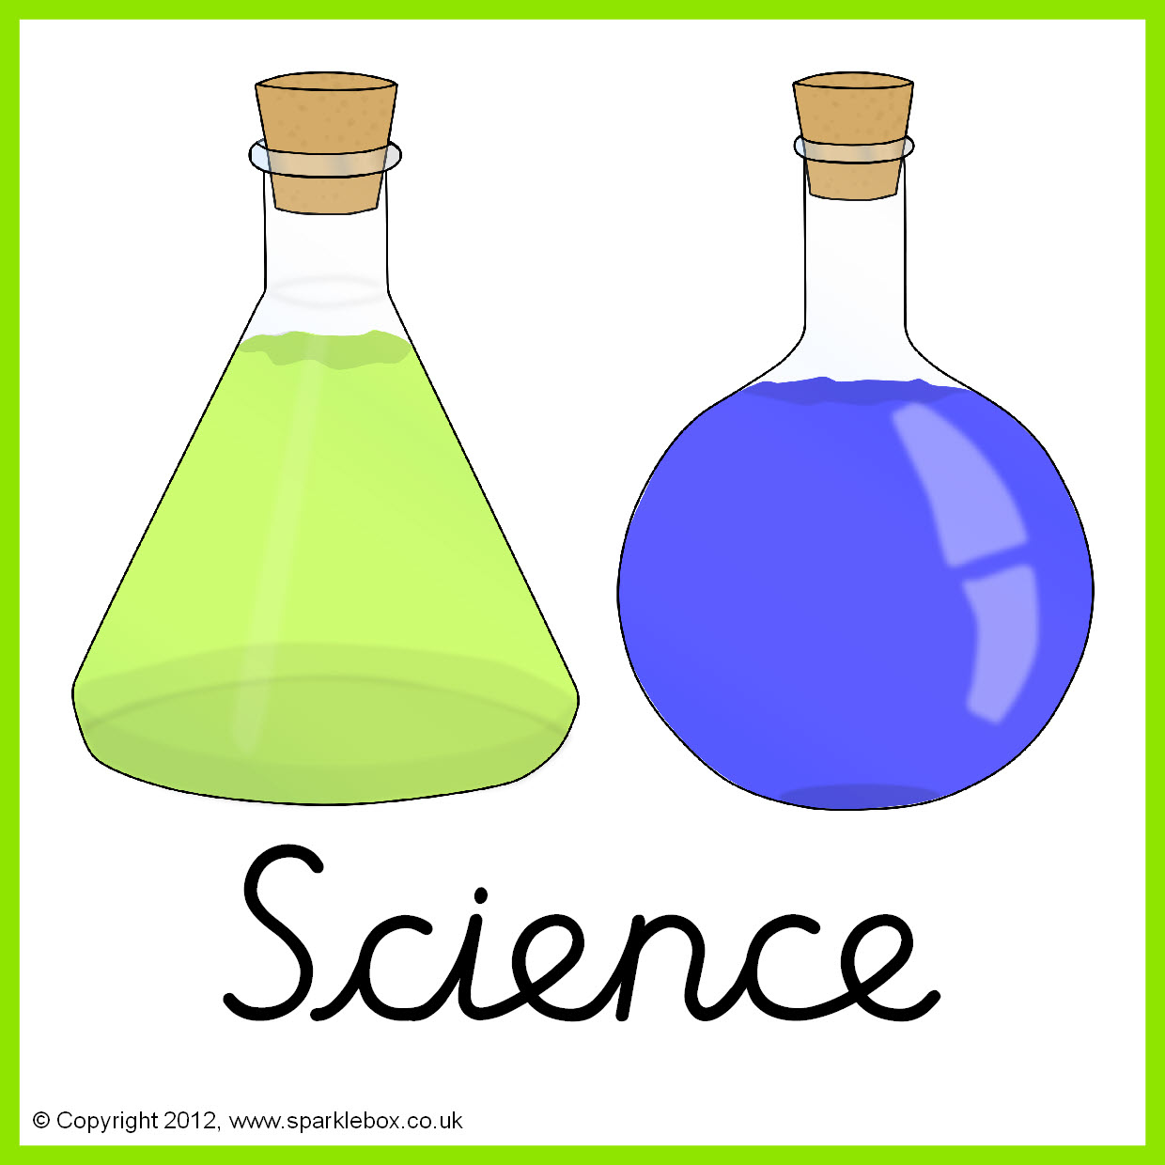



**Topics –**

**Spring 1 –** Journeys

**Spring 2 –** World of Animals

**Topics** -

Island Life







**Topic**

Egyptians

**Topics -**

**Spring 1 –** Colours – Flags, UK, Spain and another Spanish speaking country.

**Spring 2 –** In my house – your family and your pets.



**Topics -**

**Spring 1 -** Rounders

**Spring 2 –** Badminton

**Topics**

**Spring 1 –** Judaism and Buddhism

**Spring 2 –** Easter story, Heroes and villains in the community.

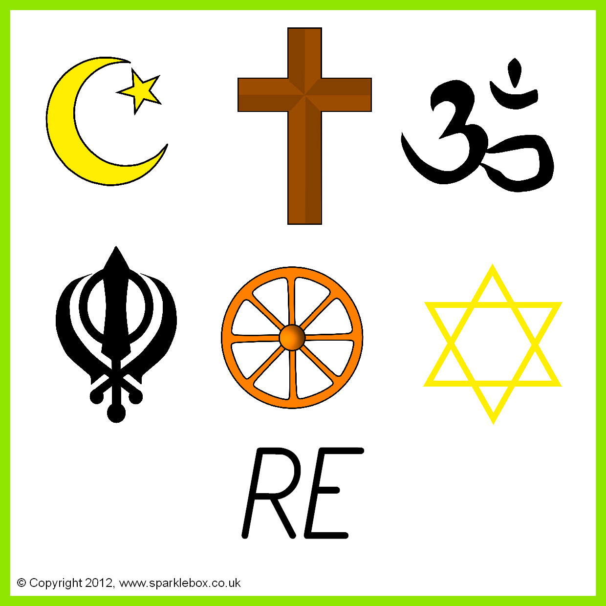



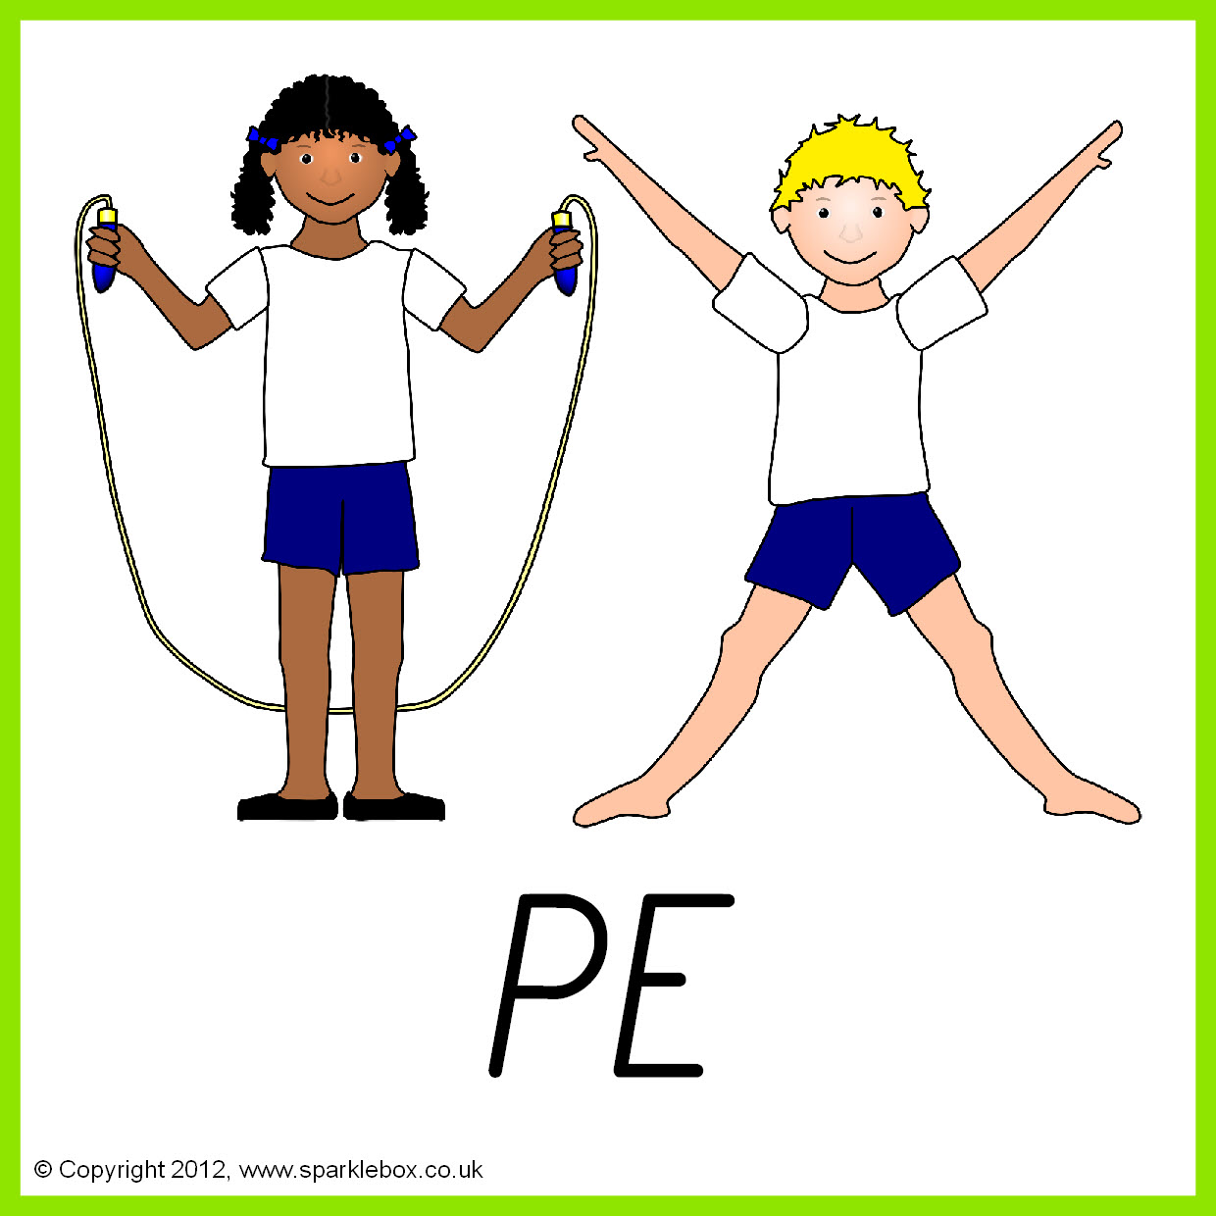

**Topics -**

**Spring 1 –** Electrical: How things work in the living room.

**Spring 2 -**  Meals in a hurry.

**Topics**

**Spring 1 –** Relationships with others.

**Spring 2 –** Mental Health

.

